What can we learn about the world/ knowledge/ meaning of life from the great philosophers?
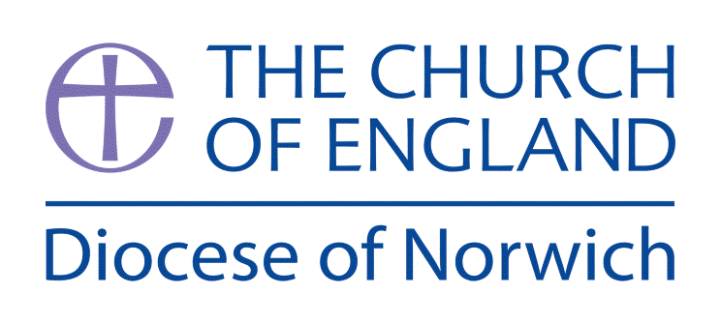
Religious Education and Worldviews
Exemplification Planning to support the Norfolk Agreed Syllabus
Year Group: 5 Enquiry: 3

ENGAGE | Unpack the enquiry question  Find out about Socrates and Plato  Explore the concepts explained by Socrates and Plato
ENQUIRE | Explore Plato’s key ideas about life as physical and metaphysical  Explore the Christian concept of salvation  Ask question about the world and meaning of life for Christians  Compare similarities and differences between Plato’s concept of eternal soul and the Christian concept of salvation.
EXPLORE | Compare the Christian view of life after death to that of Buddhism and reincarnation.
EVALUATE | Explore that some people find it hard to believe in a supernatural power (God) and they question if it is real and the world / knowledge is real as a result.  Discuss ideas in Christianity and Buddhism about ideas of the after life
EXPRESS | Review previous work on Plato’s cave.  How might the world look different if the prisoner had met a Christian? A Buddhist? What might he learn from them about their view of the purpose of the world?  Discuss the answer to the enquiry question.
Assessment Ways of Knowing
Philosophy
• Questioning and Inquiry: Encouraging children to ask challenging questions about existence, morality, and knowledge. This helps them develop a deeper sense of curiosity and critical thinking.

• Discussion and Debate: Facilitating structured debates and discussions where children can articulate their thoughts, listen to others, and engage with different viewpoints. This enhances their reasoning and communication skills, shaping their ideas and viewpoints (reflexivity).

• Logical Reasoning: Teaching children to construct and evaluate logical arguments. This includes understanding conclusions and the connections between them.

• Ethical Thinking: Introducing complex moral dilemmas and encouraging children to think about ethical principles such as justice, fairness, equity and responsibility. This helps them develop a nuanced understanding of morality.

• Reflection and Self-Awareness: Encouraging children to reflect on their own beliefs, values, and experiences, and how these shape their understanding of the world. This fosters personal growth and empathy

Key information we will learn:
- The ways different philosophers or religions understand abstract concepts, including varying views about the existence of the soul in classical Greek Philosophy.
- The complex nature of concepts such as truth, reality and identity found in Buddhism, Christianity and Plato.
- The work of one or two key philosophers such as Socrates/Plato and Descartes.
- Consideration of consequences of action in relation to karma.

What we will aim to do at the end of our learning:
By the end of our learning we will
- Explain some of the ways different philosophers or religions understand abstract concepts, including varying views about the existence of the soul in classical Greek Philosophy.
- Explain different philosophical and religious answers to questions about the world around them and the existence of the ‘self’ and or soul.
- Have an understanding of the Analogy of the Cave and what it says about existence and knowledge.

Key words I will use and need to know:

Corporeal Karma Reincarnation

Eternal Philosophers Soul

Incorporeal Philosophy Self

Background Knowledge for Teachers
- An introduction to the ways different philosophers or religions understand abstract concepts, including varying views about the existence of the soul in classical Greek Philosophy Greek Philosophers
- The complex nature of concepts such as truth, reality and identity found in Buddhism, Christianity and Plato. You can explore some of these concepts at https://ethics.org.au/ethics-explainer-platos-cave/ www.theschooloflife.com/thebookoflife/know-yourself/ www.abdabrs.com/buddhism-beliefs-and-teachings.html
- The work of one or two key philosophers such as Socrates/Plato and Descartes. Explore Plato in this video www.youtube.com/watch?v=VDiyQub6vpw
- Consideration of consequences of action in relation to karma. Explore Karma in this video www.youtube.com/watch?v=YMat0aJ-8fc and the consequences of actions here www.bbc.co.uk/programmes/p02n5v2q
- Hedonism explained for children can be accessed here: https://youtu.be/UBKrTh1Jb98

Pupil Assessment Statements

Philosophy

• Questioning and Inquiry: I can ask thoughtful and challenging questions about life, beliefs, and what is right or wrong to help me think more deeply.

• Discussion and Debate: I can share my ideas clearly, listen to others, and take part in respectful discussions and debates about different beliefs and opinions.

• Logical Reasoning: I can give reasons for my ideas and explain how they are connected. I can also think about whether arguments make sense.

• Ethical Thinking: I can think about difficult choices and talk about what is fair, just, and responsible, using examples from real life and religion.

• Reflection and Self-Awareness: I can reflect on my own beliefs and experiences and understand how they shape the way I see the world and other people

Things to do and find out at home:

Learn about Socrates and what he has helped us to understand – watch the video www.youtube.com/watch?v=7y8EC6QoNaY and make notes on who Socrates was.

Read about Plato here: https://kids.britannica.com/kids/article/Plato/476303

Read about Socrates here:
https://kids.britannica.com/kids/article/Socrates/476319

Read about Descartes here:
https://kids.britannica.com/students/article/René-Descartes/273969

Below is an exemplification of a way you might approach this enquiry question. You may feel that you need to adapt the planning to suit the needs of your pupils or feel that not all activities are necessary to explain a concept. However, it is important to ensure that a balance of ideas are encountered to enable pupils to explore the question and also consider their own personal viewpoint.

RE Planning Cycle Template
- Engage
- Unpack the enquiry question – make sure the children know what world / knowledge/ meaning of life / philosopher mean.
- Introduce the philosophers –Socrates Plato – watch the following videos to induct the children into who they are: Who Was Socrates? 🧠| The Man Who Loved Questions! 👣| PastPorts Kids Presents (Socrates), Who Was Plato? 🧠| The Boy Who Loved Big Questions! 🤔 | PastPorts Kids Presents
- Introduce the concept of Socrates – misunderstanding and ignorance led to evil / bad things. Link this this to the concept of knowledge – play Chinese whispers to demonstrate how a something can be easily distorted and become untrue.
- Examine the work of Socrates present in the work of Plato and the ‘Analogy of the Cave’ discussing the idea that true knowledge, for Plato/Socrates comes from some other place, a kind of heavenly realm where all true knowledge originates. The idea could be illustrated by creating a shadow puppet theatre to demonstrate how distorted ‘shadows’ can become and how they can be misinterpreted. Misunderstanding and ignorance are the only reasons for evil in the Socratic view of the world. The Cave: An Adaptation of Plato's Allegory in Clay
Unit Focus/ Year Groups:
Yr5 Enquiry 3: What can we learn about the world/knowledge/ meaning of life from the great philosophers?
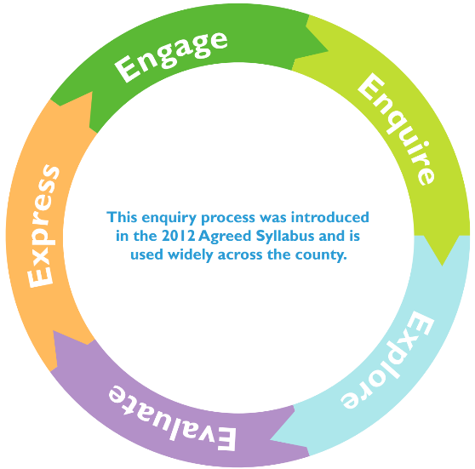
3. Explore
- Compare the Christian view of life after death to that of Buddhism and reincarnation. Consider the path to enlightenment, the four noble truths and the eightfold path (=Dharma). Each offer an answer to the meaning of life for Buddhists. www.bbc.co.uk/bitesize/topics/zh4mrj6/articles/zdbvjhv www.bbc.co.uk/bitesize/topics/zh4mrj6/articles/zvtxgwx
- Explore the idea of no self and no soul in Buddhism through the story of Kisagotami and the Mustard Seed (see notes). https://buddhiststories.wordpress.com/2012/11/03/kisa-gotami-and-the-mustard-seed/ Draw out why the Buddha didn’t just tell her the answer.
- Descartes and the Dream of Thinking (1641, France) Watch the video to consider Descartes and his writings around ‘Cartesian Doubt’. Examine the idea that if I can be deceived into thinking I and sitting in my chair at home then I must exist in order to be deceived. Is this counter to Buddhist teaching? Is Buddha right in assuming that you are not your mind and your mind creates your ego (idea of the self) which is also an illusion and you don’t need to think to know you exist? Discuss together, acknowledge it is complicated thinking that adults struggle with but have fun exploring ideas.
2. Enquire (Need 2B.6 to be added to website UC)
- Consider how Plato believed in two key ideas life was both physical and metaphysical – the eternal soul. How this links to Christianity and the concept of Salvation.
- Explore the stages of the cross from Understanding Christianity Unit 2B.6 and use resource sheet 6 alongside images of the stations found at: www.catholictradition.org/Children/stations-cross.htm consider the belief of Christian’s that when you die you go to heaven. Resource sheet 1 contains bible texts to accompany the images.
- What questions about the world and the meaning of life does it raise for Christians? Compare similarities and differences between Plato’s concept of eternal soul and the Christian concept of salvation.
4. Evaluate
- Explore that some people find it hard to believe in a supernatural power (God) and they question if it is real and the world / knowledge is real as a result. Use the Philosophy Foundation Thought Adventure Knowledge Resource and this video https://bit.ly/2ZikFpb.
- Compare the ideas from the knowledge task above with the faith Christians have in going to heaven and Buddhists have with reincarnation – also the idea of Heaven / Hell and Karma, Dharma and Nirvana. Why do they think these religions have such views? What does it tell them about the meaning of life for people of these religions? Create a Venn diagram to sort the beliefs and knowledge of the meaning of life.
5. Express
- Re watch the video on Plato Cave https://youtu.be/69F7GhASOdM
- Discuss what it means for the prisoner in the cave and the experiences he has when he leaves of the world and what life might mean?
- How might the world look different if the prisoner had met a Christian? A Buddhist? What might he learn from them about their view of the purpose of the world? How might he describe it to the other prisoners in the cave? Can the children make a response to show the different views of the world and it’s meaning by:
  - Creating two different pictures of the world through the different religions eyes and the significance of it.
  - List the main points and similarities and differences.
  - Show how knowledge and belief can be the same but also different and explain that knowledge can be through experience as well as in writing by writing their own version of the cave story or creating a story board or cartoon strip.
Supplementary Information:
It can seem a daunting task to teach this unit – however the best advice it to keep it simple and stick to the basic concepts:
- Start with the two Greek Philosopher Socrates and Plato. Here it is important to begin to explore the concept of knowledge and how Socrates never recorded in writing his own knowledge and ideas, Plato his student recorded lots in the form of essays, stories and poems – we interpret these to determine the knowledge he had as well as the ideas he developed about the world.
- Use Plato as a bridge of his thinking of life in the physical but also spiritual sense (metaphysical) and his ide of the eternal soul sitting parallel to Christianity believing in a similar concept with the idea our soul will go to heaven after we die of we have lived a good and meaningful life physically on earth.
- Link from this concept the Christian concept of Salvation – which provides the Christian context of the meaning of life as a Christian. Following the stations of the cross provides the story and insight into this belief in biblical teachings.
- As a direct comparison is Buddhism and the view that there is no one self or soul but multiples hence the concept of reincarnation. The linear study of the path to enlightenment through the four nobles and eightfold path (forming the Dhrama) need considering- determining the Buddhist view of the meaning of life.
- Revisiting knowledge and belief at this point is useful and using the Knowledge thought adventure from the Philosophy Foundation will equip pupils with the concepts of knowledge and belief the connections but also the faith some have in what they belove without fact.
- Once knowledge, belief and faith have been understood it is useful to then draw learning together and make evaluative comparisons and differences before looking at how to express a response to the big enquiry question.

Useful reading:
- Collins KS3 World Religions : Buddhism
- Understanding Christianity UKS2 Unit 2B.6 – Salvation
- BBC Bitesize Fact File on Buddhism and associated videos
- BBC Northern Ireland Buddhism Facts KS3 /4

