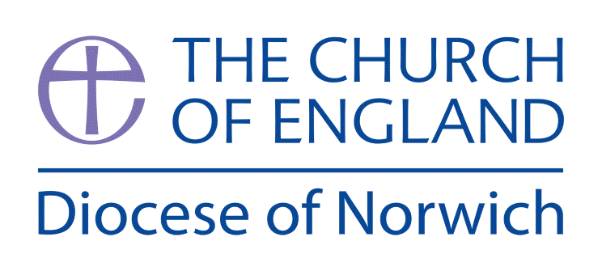
Religious Education and Worldviews
Exemplification Planning to support the Norfolk Agreed Syllabus
Year Group: 3 Enquiry: 3
What is philosophy? How do people make moral decisions?

ENGAGE | What is ‘philosophy’  Discuss the difference between knowledge and wisdom;  Where does knowledge come from and how can they be sure it’s ‘true’?
ENQUIRE | Introduce the two ways of finding out something: physically observable (empirical) and not reliant on physical evidence (theoretical).  Use humanist example and box activity to help understanding  Children write about an empirical or theoretical reason
EXPLORE | Explore Question How do I know how to behave?  Explore Christian viewpoint of the Bible as a source of authority including exploring parables of Jesus.  Explore humanist Ethics Viewpoint
EVALUATE | Introduce the idea of a Philosophical Question: How do I make moral decisions?  Evaluate a humanist and Christian basis for moral decisions.
EXPRESS | Look at examples of moral stories  Pupils choose a moral dilemma and present their own moral stories explaining their choices and an explanation of the moral message.
Assessment Ways of Knowing
Philosophy
• Questioning: Encouraging children to ask deeper questions about the world, such as "Why do people believe in different gods?" or "What is the meaning of life?" This fosters curiosity and critical thinking.
• Discussion and Debate: Promoting structured discussions and debates where children can express their thoughts and listen to others. This helps them understand different viewpoints and develop their reasoning skills.
• Reasoning and Argumentation: Teaching children to construct basic logical arguments and provide simple reasons for their opinions. This includes understanding cause and effect and making connections between ideas.
• Ethical Thinking: Introducing more complex moral dilemmas and encouraging children to think about right and wrong, fairness, and justice. This helps them develop a sense of ethics and empathy.
• Reflection: Encouraging children to reflect on their own beliefs and experiences, and how these shape their understanding of the world. This fosters self-awareness and personal growth.

Key information we will learn:
- Difference between knowledge, belief and opinion.
- The complex nature of concepts such as truth, reality, happiness, identity, hope, justice.
- The nature of a philosophical question.
- Awareness of variant perspectives about whether some things can be proven.
- The influence on moral decision making of factors such as experience, family, history, culture or community (including religious communities).
- Utilitarianism or Hedonism as a way of making moral decisions.

What we will aim to do at the end of our learning:
By the end of our learning we will
- Talk about the difference between knowing and believing.
- Decide if a reason or argument based on a religion or belief makes sense to them and is expressed clearly, analyse arguments and how they work.
- Recognise that it is difficult to define ‘right’, ‘wrong’, ‘good’ and ‘bad’.

Key words I will use and need to know:
Humanism Morality Philosophy
Logical Belief Knowing
Wisdom Behaviour Rules
Theoretical Moral Questions

Pupil Assessment Statements

Philosophy

• Questioning: I can ask big questions about life, beliefs, and the world around me to help me understand more.
• Discussion and Debate: I can share my ideas and listen to others in discussions and debates, even when we don’t agree.
• Reasoning and Argumentation: I can explain my thoughts clearly and give reasons for my opinions by making links between ideas.
• Ethical Thinking: I can think about what is right and wrong, fair and unfair, and talk about how people make good choices.
• Reflection: I can think about my own beliefs and experiences and how they help me understand other people and the world.

Background Knowledge for Teachers
- Difference between knowledge, belief and opinion, you can watch a short video about this Opinion, Doubt, Knowledge, and Belief (Aquinas 101)
- The complex nature of concepts such as truth, reality, happiness, identity, hope, justice – google these phrases, look them up in a dictionary and find out what each one really means.
- The nature of a philosophical question, watch this video to get children thinking about questions https://youtu.be/q4kFHoJdLx4
- Utilitarianism explained for children can be accessed here: https://youtu.be/93bCouvAVbQ
- Hedonism explained for children can be accessed here: https://youtu.be/UBKrTh1Jb98

Supplementary Ideas:

Philosophy for Children https://p4c.com has some excellent resources to support this unit. You can access the following:
‘It’s just a matter of opinion’ - https://p4c.com/its-just-a-matter-of-opinion-2/
The “How True was My Answer?” Game - https://p4c.com/future-truth/
RULES AND VIRTUES https://p4c.com/rules-and-virtues/
Thinking Circles https://p4c.com/thinking-circles-2/
Believing and doubting game https://p4c.com/use-the-believing-and-doubting-game-2/

Things to do and find out at home:

Find out what philosophy is by watching this video: https://youtu.be/pZcDe5fHlv8

Explore ethical dilemmas by watching this video: EP 1: Ethics for Kids: What Is Ethics & Ethical Dilemmas

Explore identity and what it means by watching this video: https://youtu.be/eRzRAh2M2Ao

Talk to your mum or dad about some of the 100 philosophical questions for children at the end of this knowledge organiser.

Below is an exemplification of a way you might approach this enquiry question. You may feel that you need to adapt the planning to suit the needs of your pupils or feel that not all activities are necessary to explain a concept. However, it is important to ensure that a balance of ideas are encountered to enable pupils to explore the question and also consider their own personal viewpoint.

RE Planning Cycle Template
- Engage
Watch the short video (2mins) that introduces children to what philosophy is: www.youtube.com/watch?v=pZcDe5fHlv8 Look at the word ‘philosophy’ and translate it from Greek to English (or other languages spoken in your setting) to see that it means ‘love of wisdom’.
Discuss the difference between knowledge and wisdom; e.g. I know a tomato is a fruit but I am wise enough not to put it in a fruit salad. Follow the session plan from Philosophy links website explore knowing and believing: https://389b63a7-ab3d-4047-80f7-f828b2b645a6.filesusr.com/ugd/340eca_35759eb92850494ba712b1a32990af73.pdf

Unit Focus/ Year Groups: (Yr3 Enquiry 3)
What is Philosophy? How do people make moral decisions?
(Christianity / Humanist)

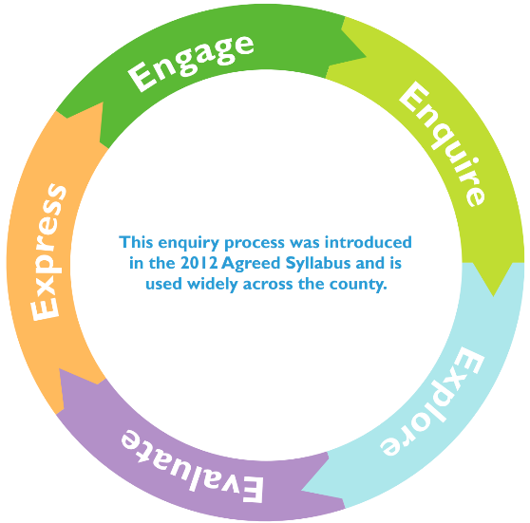
4. Evaluate
Explore the idea of morality coming from lessons learned in your own life or from history.

Look at the Humanist approach to morality to explore morality without the presence of a supernatural being. Look at what might be employed to make moral decisions. Watch a short video of Humanists explaining how they work out right and wrong: https://youtu.be/nqsT04Uy4mA undertake the moral dilemmas activity - https://understandinghumanism.org.uk/wp-content/uploads/2021/10/Moral-dilemmas-11.pdf Bring out understanding of Utilitarianism and Hedonism and how they might affect decision making. (See videos from Knowledge Organiser teacher knowledge)

Compare this to what would happen if Christians introduce the idea of the new commandment of Jesus from John 13:34-35 ‘Love one another. As I have loved you, so you must love one another’. What would this mean in practise? Explore this idea as a basis for moral decisions. Does acting with love always lead to a good outcome? You may even want to talk about good intentions versus good outcomes. Can you apply this principle to the moral dilemmas explored through Humanism – does it change any of the outcomes? What is the same?
5. Express
Look at Aesop’s Fable – the Fox and the Stalk – watch the video here: https://youtu.be/XsAcoXIGFcs
Use this to explore the activity from Understanding Humanism- https://understandinghumanism.org.uk/wp-content/uploads/2021/10/The-fox-and-the-stork.pdf Draw a parallel to the Christian verse from the Bible Mark 12 v31 The second is this: ‘Love your neighbour as yourself.’ You might want to look at v29 that ‘Love the Lord your God’ is the first commandment.
You may wish to also look at cultural tales or proverbs. Some pupils may find social stories or puppets make it easier to comment on the behaviours of others. Example of Bambi and Thumper’s friendship might be helpful here.
Ask the children to choose a dilemma from the list provided and create a modern day Aesop’s fable / new Bible Parable/ social story. They can present this in a way they wish e.g. draw, write, act. They need to explain what they have included to illustrate and teach from and what the moral message is.
3. Explore
Use the question how do I know to behave? Write down ideas. Split into two categories What are the facts? How do I make decisions? Save religious reasons for later.
Start the session by considering how true an answer might be and how do we work this out – play the P4C How true is my answers? Game see accompanying resource.
Think about Christianity – the Bible is the source of authority – i.e. where the teachings of the beliefs for Christians come from. Watch the video about the children talking about how the bible helps them etc. Resources - RE:quest But this is a book of a collection of stories can we prove them? Or do Christians have a faith / trust and therefore believe? Watch the video of a Christian talking about the authority of the bible. Resources - RE:quest Look at the Gospels from the new testament and how these are the ‘teachings of life’ Christians follow. Look at some of the following parables as a double entry journal activity to work out their teachings: Good Samaritan / Hidden Treasure / Prodigal Son / Building on the Rock and Sand / Pharisee and Publican. (You could do this as a class activity – silent discussion).

Explore Humanists ethics – explore moral dilemmas, start with watching how humanists decide what is right and wrong by watching the short video by Stephen Fry https://youtu.be/pZnDImejvj8 and complete the activity: https://understandinghumanism.org.uk/wp-content/uploads/2021/10/Moral-dilemmas-5-7.pdf
2. Enquire
Introduce the two ways of finding out something: physically observable (empirical) and not reliant on physical evidence (theoretical). Demonstrate this by looking at the PPT from Understanding Humanism – Understanding the world (slides 1-9 focus on curiosity, questions and evidence) access it here: https://understandinghumanism.org.uk/wp-content/uploads/2021/11/Understanding-the-world-5.pptx

Bring out a box with a question mark on it. Ask the children what could be in there and how they might find out. The children may say they could open the box and see, or weigh the box (empirical) or they may have a theory about what a teacher might put in a box (theoretical). You may want to use the categories ‘Knowing’ and ‘Believing’ instead. Can they prove their ideas? Is the concept of ‘belief’ actually relevant in this task? Can the children write about an empirical or theoretical reason?

