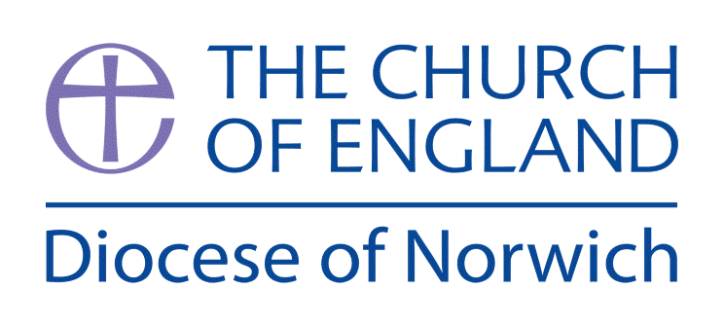
Religious Education and Worldviews
Exemplification Planning to support the Norfolk Agreed Syllabus
Year Group: 2 Enquiry: 3
Why do people have different views about the ideas of God?

ENGAGE | Look at the big question.  What do the children understand by the word God?  Introduce the idea different religions have different ideas about God and some people do not believe there is a God and they are known as atheists.
ENQUIRE | Introduce the key vocabulary  Talk about the word God as a name.  Generate I wonder questions about God.
EXPLORE | Explore different views about God  Christian  Muslim  Humanist
EVALUATE | Evaluate the way Christian and Hindu believers may respond to t  their beliefs about God.
EXPRESS | Compare the views they have learnt about God, Christianity, Islam, Humanist and Hinduism.  Express their learning by answering the enquiry question. Talk about why the believer sees God in the way they do and how this helps the way they live their life.
Key information we will learn:
- The word ‘God’ is a name.
- The key beliefs about God from at least two different religions/worldviews.
- How a person’s behaviour is connected to their view of God.
- Two different stories/narratives that illustrate beliefs about God.

Assessment Ways of Knowing
Philosophy
• Questioning: Encouraging children to ask questions about the world around them. Linking question to observation and learning to deepen their curiosity and a sense of wonder.

• Discussion: Promoting open discussions where children can express their thoughts and listen to
others, helping them understand different
perspectives.

• Reasoning: Helping children learn to give reasons or their thoughts and opinions, developing their ability to think logically.

• Reflection: Encouraging children to reflect on their own beliefs and experiences, fostering self awareness and encourage them to find similarities with others and begin to respect of differing worldviews.

• Moral Thinking: Develop an understanding of the basic concepts of right and wrong, fairness, and
kindness, helping children develop a sense of morality and how this can be influenced by religion and belief.

What we will aim to do at the end of our learning:
By the end of our learning we will
- To give a reason why a member of at least one religious community might believe in God.
- To give a reason why a person might not believe in God.
- To give an example of what a member of a religious community might believe about God.
- Make connections between people’s beliefs of right and wrong and their belief about God.

Key words I will use and need to know:
Agnostic Allah Atheist

Brahman God Humanist

Theist

Background Knowledge for Teachers
- This unit references Ref UCP (Understanding Christianity) 1.1, Understanding Humanism – Humans Unit (5+) and (ages 5-7) NATRE resource: What do Hindus understand about the idea of a supreme being?
- The word ‘God’ is a name. More information on this can be accessed here: https://en.wikipedia.org/wiki/God_(word)
- How a person’s behaviour is connected to their view of God. A useful reference tool (not for children) can be accessed here: https://quadrantinternational.net/musings/how-people-perceive-god/
- Two different stories/narratives that illustrate beliefs about God, some good examples can be found in the following websites: Why Are There Two Different Creation Stories in Genesis?

Pupil Assessment Statements

Philosophy
• Questioning: I can ask questions about the world around me and use what I see and hear to help me learn more.
• Discussion: I can share my ideas and listen carefully to what other people think, even if it’s different from me.
• Reasoning: I can explain why I think something and give reasons for my ideas.
• Reflection: I can think about what I believe and how I feel, and I can notice when others believe different things too.
• Moral Thinking : I can talk about what is right and wrong, fair and unfair, and how being kind and helpful is important to everyone.

Things to do and find out at home:

• Take time to explore the different views of God from Hindus, Christians, Muslims and Humanists. Help your child make some notes of the similarities and differences.
• Get your child to draw some of the things God might do.
• If your child could choose what God looked like and they could do – what would this be? Draw and write about their ultimate God at home.

Below is an exemplification of a way you might approach this enquiry question. You may feel that you need to adapt the planning to suit the needs of your pupils or feel that not all activities are necessary to explain a concept. However, it is important to ensure that a balance of ideas are encountered to enable pupils to explore the question and also consider their own personal viewpoint.

RE Planning Cycle Template
Unit Focus/ Year Groups: 2 Enquiry 5
Why do people have different views about the idea of God?
Christian/ Muslim/ Humanist

- Engage
Look at the big question. What do they understand by the word God? Look at the Understanding Christianity big frieze and Panels Creation, Fall, Incarnation, Salvation, Kingdom of God. Get the children to look at each panel and make observations about what is happening and what it might tell you about God.
Creation – God the Creator, The Fall – God the Judge, Incarnation – God on Earth being a human, Salvation – God the saviour, here to save us and help. Now they know some of the different concepts of who God is – what do they think God might look like? Would God look different in different places on the big frieze?

Use the letters for God. Ask them to draw or write about what they think God is like inside the letters. Where did they get their ideas from? How do they know? What clues about God did they use from the big frieze? Compare each child’s ideas then introduce the idea different religions have different ideas about God and some people do not believe there is a God and they are known as atheists. A person who with not decided is called an agnostic. Finish by looking at the video from Understanding Humanism: https://www.bbc.co.uk/bitesize/topics/znk647h/articles/zmqpkmn
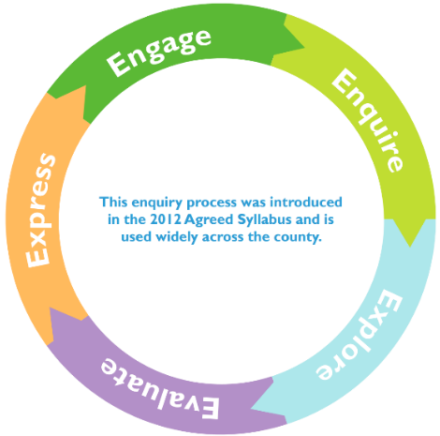
2. Enquire
Look at the responses the children gave to each panel of the big frieze, recap on the different ways Christian’s see God. Recap on the belief of Humanists. Unpack the idea that the word God is a name. Show the children a series of images (PPT attached) use the language from the vocab list to link to each image and ask the children to generate I wonders about each image or observations. Alternatively you could use true tube to listen to people talking about their view of God.
Focus on three core areas Christianity, Islam and Humanism. These will form the core teaching in the Explore and Evaluate stages of the enquiry.- Truetube voices talking about their beliefs
4. Evaluate
Use the case study from Grace resource 2.2 (see document NATRE What Christian’s believe about God) Talk about Grace being a Christian and these are her views about God. Draw out that Grace believes God made the world, that God loves us, that she can talk to God, that she can feel close to God and that God is a mystery. Use the questions from p7 to discuss and talk about their ideas. Use the resource 2.5 Listen to the song God beside, God Behind, God ahead by Fischy Music God behind God beside and discuss using the questions. Bring out the idea of Christians prayer and talking to God. What kind of prayers might they pray? Praise, sorry, ask and thank you. Here is a useful video on prayer. https://youtu.be/ZrdlXOk_QdQ

You may also wish to consider the Catholic viewpoint of praying to Mary using this video. https://youtu.be/HW0DzGEoa1Y

Compare this to how Hindus Explain who Brahman? Use the (ages 5-7) NATRE resource: What do Hindus understand about the idea of a supreme being? Activity 2 One Supreme Being + Resource Sheet 4.1. Children choose one of the analogies, draw a picture of it and annotate to show how Hindus would see this representation of Brahman.

Complete the resource 2.3 to explain their own ideas about God, (see document NATRE What Christian’s believe about God)

3. Explore
3.1 Christianity – Use a video to introduce the idea of Christianity: What is Christianity? - BBC Bitesize to introduce children to the concept of Christianity. Explore the story of the prodigal son – Draw out the forgiveness and love shown by the father. Wonder: What might this teach Christians about God? Is God like a father? How? Use UCP resource 1 Ask pupils to make ‘hidden meaning boxes’, On the outside show the literal story of the prodigal son and inside the hidden meaning about what God is like.
3.2 Islam – Use the (ages 5-7) NATRE resource: What do Muslim’s believe about God and complete Activity 3 – How do Muslim’s know what God is like? How might the 99 names help Muslims know their God?
3.3 Humanism – Explore the information sheet Where do we come from? (Understanding Humanism – Humans 5+), discuss how Humanists still manage to know good and bad and be good people without the need for a God to teach them. Choose and complete one of the Good and Bad activities from this unit to illustrate Human nature.

5. Express
Compare the religious views of God previously explored. Ask the children to revisit their work from the previous sessions. What do they now think about different ideas about God(s) and why? What has / has not changed?

Assess the children in the final express piece by answering the enquiry question: Why do people have different views about the idea of God?

Children to choose two different concepts or representations of God from different religions and worldviews explored in the enquiry. Can they talk about why the believer sees God in the way they do? Can they explain how this helps them live their life?

