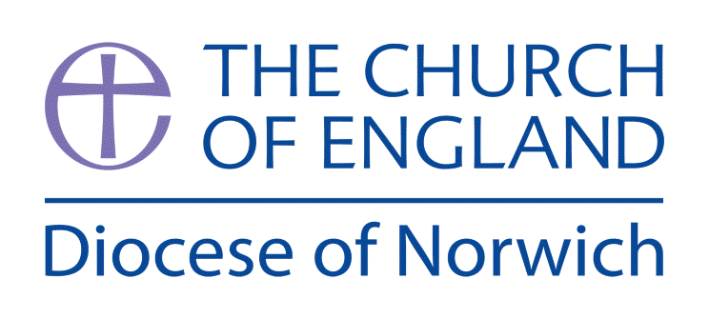
Religious Education and Worldviews
Exemplification Planning to support the Norfolk Agreed Syllabus
Year Group: 1 Enquiry: 5 Christian/ Hindu
How did the universe come to be?

ENGAGE | Introduce the Big Question and explore the universe  Pupils to use their senses to explore the world around them and ask questions
ENQUIRE | Find out about the Christian accounts of Creation in Genesis 1-3  and the Hindu creation stories  Discuss what these story tell us about what Christians and Hindus believe about creation?
EXPLORE | Compare the similarities and differences between the creation stories and what Christians and Hindus believe about creation.
EVALUATE | Think about what it might feel like to be a creator.  Explore the way Christians may respond to their belief that God created the world.  Focus on thankfulness through praise, prayer and Harvest
EXPRESS | Reflect on the learning.  Discuss how they might answer the enquiry question.  Ask pupils: If someone believes God/ Brahma made the world, what might they say about it? What might they say to this Creator?
Assessment Ways of Knowing
Philosophy
• Questioning: Encouraging children to ask questions about the world around them. Linking question to observation and learning to deepen their curiosity and a sense of wonder.

• Discussion: Promoting open discussions where children can express their thoughts and listen to
others, helping them understand different
perspectives.

• Reasoning: Helping children learn to give reasons or their thoughts and opinions, developing their ability to think logically.

• Reflection: Encouraging children to reflect on their own beliefs and experiences, fostering self awareness and encourage them to find similarities with others and begin to respect of differing worldviews.

• Moral Thinking: Develop an understanding of the basic concepts of right and wrong, fairness, and
kindness, helping children develop a sense of morality and how this can be influenced by religion and belief.

Key information we will learn:
- The creation stories within Christian and Hindu traditions.
- Non-religious ideas about how the origin of the universe.
- Reasons why people look after the world.
- Examples of how people look after the world.

What we will aim to do at the end of our learning:
By the end of our learning we will
- Ask at least one question about the origin of the universe.
- Give a simple reason, using the word ‘because’, for the origin of the universe.
- Know that, for some people, religions provide an answer to the question of the origin of the universe (creation stories).
- Know that beliefs about the origin of the universe influence how individuals treat the world around them.

Key words I will use and need to know:
Brahma Care Christian
Creation God Hindu

Origin Universe Vishnu

Pupil Assessment Statements

Philosophy
• Questioning: I can ask questions about the world around me and use what I see and hear to help me learn more.
• Discussion: I can share my ideas and listen carefully to what other people think, even if it’s different from me.
• Reasoning: I can explain why I think something and give reasons for my ideas.
• Reflection: I can think about what I believe and how I feel, and I can notice when others believe different things too.
• Moral Thinking : I can talk about what is right and wrong, fair and unfair, and how being kind and helpful is important to everyone.

Background Knowledge for Teachers
- The creation stories within Christian and Hindu traditions. A good BBC video for Hindu creation stories can be found here: www.bbc.co.uk/programmes/p02gj232
In Hinduism, Vishnu is revered as the preserver of the universe, tasked with maintaining cosmic order and protecting humanity from chaos. He is a central figure in the Hindu trinity (Trimurti), alongside Brahma and Shiva. Vishnu is known for his ten avatars, or incarnations, which he descends to Earth in times of crisis to restore balance and protect dharma (righteousness). His avatars include Matsya (the Fish), Kurma (the Tortoise), Varaha (the Boar), and others, each playing a crucial role in the preservation of the universe.
- Understanding Christianity Resources KS1 Unit 1.2 Creation has further information around this enquiry question.
- Christian viewpoints are explored on RE Quest Resources - Resources - RE:quest
- Non-religious ideas about how the origin of the universe. The Understanding Humanism Resources understanding the world can be found here Understanding the World » Understanding Humanism
- Reasons why people look after the world. Explore the Our World: Our Planet teaching resource from the Diocese of Norwich - https://www.dioceseofnorwich.org/app/uploads/2021/05/Eco-School-Booklet-2021-v5.pdf

Things to do and find out at home:

Draw a picture of the world – what would you include in it if you were creating it from scratch?

Look at different creation stories from around the world – good websites are: https://historycollection.com/16-incredible-ancient-creation-stories-from-around-the-world/

Explore some of the rituals and practices of Hindus here: www.bbc.co.uk/bitesize/topics/zh86n39/articles/zmpp92p

Below is an exemplification of a way you might approach this enquiry question. You may feel that you need to adapt the planning to suit the needs of your pupils or feel that not all activities are necessary to explain a concept. However, it is important to ensure that a balance of ideas are encountered to enable pupils to explore the question and also consider their own personal viewpoint.

RE Planning Cycle Template
- Engage
Introduce the Big Question and discuss the word Universe – what does it mean. Use music and a video of space and earth from space to help the children wonder about the universe. Here is an example of travelling in space Travel the Universe While Relaxation ★ Space Ambient Music & then looking at earth from space Song of Earth - NASA Voyager Recordings Look at images of the universe (star constellations) then drill down to planets and then to earth. Talk about a few space facts to help them understand the enormity and complexity of the universe but don’t get distracted into a science lesson. A good website to use for this is: www.sciencekids.co.nz/pictures/space.html What ‘I wonders…’ do these raise?
Spend some time experiencing nature. If possible, walk barefoot on grass or sand. Look closely at flowers and insects. Lie underneath some trees and watch the sunlight filter through the leaves. What words can pupils use to describe the experiences, and their feelings? What ‘I wonders…’ do these experiences create?
Introduce the concept that different religions have stories to explain how the world and the universe came to be. That we will be focusing on Christianity and Hinduism and what these religions believe to have happened.
Unit Focus/ Year Groups: Year 1 Enquiry 5
How did the universe come to be? (Christian / Hindu)
Ref Understanding Christianity Unit 1.2 Who made the world?

5. Express
Ask pupils: If someone believes God/ Brahma made the world, what might they say about it? What might they say to this Creator? Their comments might start with ‘I like… Thank you for... I wonder why... Please can you... It’s amazing that…’ Record these ideas on sticky notes and include them in a display.
• If pupils could ask the world-maker any questions, what questions would they ask?
• To make a connection between Christian ideas of God as Creator and the importance for everyone (not just Christians) of being grateful for what we have, you might like to try this experiential activity:
Have some fruit (grapes, for example) in the class. Get pupils to think about how the fruit grew. It needs light, water, to bud, to flower, bee pollination, fruit growing, harvesting, transporting — and here we have the fruit. So when the pupils eat one, how should they eat it? Quickly, without a thought? Or slowly, touching, feeling, tasting — aware of all the sensations, appreciating how wonderful it is. Ask them to hold the fruit, to stroke it, to sniff it; they should put it in their mouths and feel their teeth and tongue on it before biting — and feeling the juice spurt. Which words do pupils use to describe this experience? Compare with how we usually tend to eat without noticing. It might make us be a bit more grateful for our food.
• How does this idea apply to all the food pupils eat? Get pupils to take two tokens or pebbles into the dining hall. Before eating, place one token in the centre of the table and talk to other pupils about how important it is to enjoy the food, and why. For example, ‘I will really enjoy... because...’. After the food has been enjoyed, think about one person they really need to thank for it: for example, dinner supervisors, cooks, farmers, shopkeepers, and God. They put the token in the middle of the table, or give it to the relevant person if they’re present, and say, ‘I want to thank... because...‘.
• Remind pupils of the link between the Christian’s / Hindu’s answer to the key question, How did the Universe come to be? (i.e. God), and the importance of being thankful and taking care of the world.
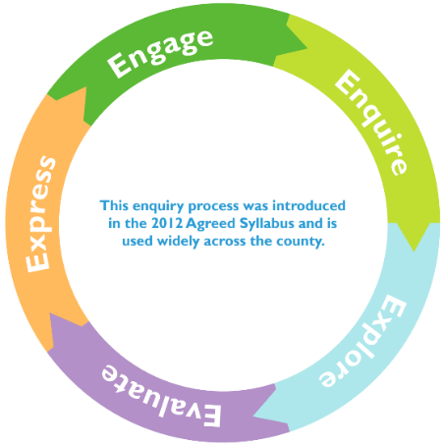
4. Evaluate
In these sessions we will explore the impact of believing that God/ Brahma created the world. Spend a small amount of time creating something
(Lego, drawing, painting etc.- or use a previous example. Discuss together. How would you feel if it was spoilt by someone? Would you expect
people to care for it? Also reference that some people don’t believe the world has a creator but still care about the earth.

If God/ Brahma made the world, how should people live? What do pupils think? One way is by being thankful to God, the Creator.
• Talk about how Christians think that God provides everything we need to survive (land, water, air, sunlight, food to grow, living animals and people), so humans should thank God above all. This Creator is so amazing that Christians want to praise God as well as thank him, saying how wonderful they think he is. Ask pupils to come up with some thank-you and praising sentences that Christians might say. They can use sentence-starters like ‘Creator God, thank you for… O God you are amazing because…’ Record these on sticky notes.
• One time of year when Christians think about God as Creator and say thank you is Harvest. Your school will probably have a Harvest Festival. How is this a way of saying thank you? Look at some harvest prayers and hymns. Ask pupils to choose the line in a song which they think is most important for Christians, and say why.
• Recall the idea that Christians believe God created the world, so they should be thankful. One key way for Christians to show thankfulness to God is for them to be generous to those with less. In Matthew 10:8, Jesus said to his followers, ‘Freely you have received, freely give.’ Talk about how Christians might share the resources offered at harvest. Find out what some churches do with their harvest offerings: for example, taking it into the community, or giving it to food banks. What does the school do, and why?
• If Harvest is an annual event, how do Christians remember to be thankful to the Creator every day? One way is by saying ‘grace’ before meals. Find out some grace prayers, and see if pupils can make up some ideas for Christians. What difference does it make if you say something every day? Pupils are often told to say please and thank you. Why is that?
2. Enquire
2.1 Christianity
Explore the Christian accounts of creation in Genesis 1-2. You can read from a children’s bible, use a Godly Play vesion: Creation or here is an example Creation (Genesis 1-2) What is their response to the story — feelings, ideas, questions? Then focus on this question: what does the story tell us about what God is like? (For example: big, amazing, powerful, exciting, clever, patient.)
Explore the story in different ways. For example, choose two or three of the following:
• choose music to express each of the days of creation; get pupils to do dance moves that reflect the music and what is created.
• draw and role play: imagine pupils are the first animals, birds or fish!
• look at the poem creation (Steve Turner In The Beginning: the Creation story retold by Steve Turner and learn to recite together — the rhythm and repetition helps, which is partly why the Genesis account is structured with all the repetitions (it was morning..., it was evening..., the third day...). Talk about the idea if God speaking and it happened. Let there be light!
• Get pupils to come up with key words for the story (two or three per day), draw them, and order them, so that they can practise retelling the story. Put these alongside some images for each day, recalling them each time you tell the story.

2.2 Hinduism (See Knowledge organiser for teacher information)
Explore one of the Hindu stories of creation (eg, Vishnu and the Lotus Flower). A good version of this can be accessed here https://youtu.be/ixY4pfb4iuE (you may choose to stop before the end part about Shiva as destroyer.) What does this story tell us about what Hindus believe about creation? What do the children find interesting? Why? Ask the children to retell the story using some of the key vocabulary on this knowledge organiser. Explore the story using similar ideas as to the Christian creation story (above). You may wish to explore this story together. https://youtu.be/ixY4pfb4iuE (Some of the vocabulary will need unpacking) Talk about Vishnu as the preserver oflife. See notes.
3. Explore
Collect together all the words pupils can come up with to describe the two Creation stories, compare the similarities and differences.
Ask the key question: Who made the world? (in each story)
The answer that Christians (and others) give is, ‘God did’. Not everyone thinks this, of course. Have a look at the Understanding Christianity resource ‘big story’ frieze; ask which part of the picture shows creation and say how (they will need to look closely!). Point out that ‘Creation’ is just the start of a ‘big story’ for the Bible and, Christians say, for humans too! At some point
At some point mention some people do not believe there is a creator.
Spend some of the session recapping on comparing the two creation stories heard and the similarities and differences.

Evaluate
Consider using some of the stewardship resources from the Our World: Our Planet EcoRE booklet published by the diocese and available here: https://www.dioceseofnorwich.org/app/uploads/2021/05/Eco-School-Booklet-2021-v5.pdf

