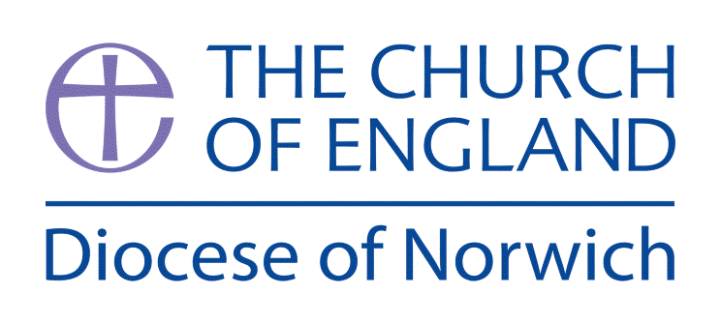
Religious Education and Worldviews
Exemplification Planning to support the Norfolk Agreed Syllabus
Year Group: EYFS Philosophy
Should Noah Trust in God?

ENGAGE | Introducing the story of Noah and the Ark  Asking questions about the story
ENQUIRE | Creative responses  Ask I wonder questions  Explore the concept of trust
EXPLORE | Explore the core knowledge and concepts through play
EVALUATE | Consider Noah’s philosophical dilemmas  Making choices- What is right or wrong?  What do we learn about God in the story of Noah?  Explore the ways Noah trusted God. Consider why Noah chose to trust God.
EXPRESS | Consider their own personal viewpoint in the story  Encounter a range of activities to allow children to respond to the big question and show their knowledge and understanding
Assessment Ways of Knowing
Philosophy
- Questioning: Encouraging children to ask questions about the world around them, fostering curiosity and a sense of wonder.

- Discussion: Promoting open discussions where children can express their thoughts and listen to others.

- Reasoning: Helping children learn to give simple reasons for their thoughts and opinions.

- Reflection: Encouraging children to reflect on their own beliefs and experiences, fostering self-awareness and begin to understand what others believe.

- Moral Thinking: Introducing basic concepts of right and wrong, fairness, and kindness, helping children develop a sense of morality.

Key information we will learn:
- Noah and the ark is a story Christians believe shows how God was not happy with people on earth.
- God sent a rainbow after the flood to remind everyone that he would forgive people rather than flood the whole earth again.
- The story comes form the Bible, the special book for Christians.
- Noah had to trust God and believe in what he asked him to do.
- Noah’s family had to trust and believe in Noah.
- God tested Noah’s trust and belief.

What we will aim to do at the end of our learning:
By the end of our learning we will
- Talk about what it means to trust someone.
- Be able to talk about the choices that Noah made in the story.
- Recognise that we make choices when we are deciding whether to trust someone and have to decide what is right or wrong.

Key words I will use and need to know:
God Trust Build Good

Noah Listen Question Bad

Flood Believe Animals Right

Ark Persuade Sin Wrong

Pupil Assessment Statements

Philosophy

Questioning: I can ask questions about the world around me
because I am curious and want to learn.

• Discussion: I can share my ideas and listen to what my friends think too.

• Reasoning: I can say why I think something or why I like something.

• Reflection: I can think about what I believe and how I feel and learn that others might believe different things.

• Moral Thinking: I can talk about what is kind, fair, and what helps everyone feel happy and safe

Background Knowledge for Teachers
- The Story of Noah and the flood can be found in Genesis 6:5-9:17. This is from both the Jewish Torah and the Christian Bible.
- Although the story contains difficult ideas it is important to both Jewish and Christian people because it gives insight into how God intends people to live, which can guide those who want a close relationship with God. There is an emphasis on promises and a covenant between God and his people. The story shows people not only correct beliefs, attitudes and behaviours that are appropriate for a relationship with God but they also show what they can expect from God.
- God chooses Noah to be saved because he was completely good whilst everyone else was thinking and acting wickedly. God is sorry to have created beings who act this way and so chooses to wipe them from His creation. Some see this as a fresh start as if God was starting creation again.
- The rainbow at the end of the story is important as it is a symbol of God’s promise (covenant) with Noah that he will never again flood the whole earth.
- Christians would say that following God includes trusting God, obeying God, believing that God promises to stay with them and forgive and believing that God will do this.
This information is a summary taken from Understanding Christianity Unit 2A.2 Unit

Supplementary Resources:
• All Afloat on Noah’s Boat – Tony Mitton / Guy Parker-Rees (ISBN 1-84616-206-8)
• Noah and the Great Big Boat – Antonia Woodward (ISBN 978-0-7459-7681-5)
• Noah Godly Play Script and Resources downloadable from the Diocese of Norwich RE Resources. Example video here. Godly Play: Noah's Ark
• Saddleback Kids Video of the story of Noah’s ark https://www.youtube.com/watch?v=qzYjy6lhRag&t=1s
• Songs-
Noah built the ark https://www.youtube.com/watch?v=pQLpFQWVmIw
Who built the ark? (song) https://www.youtube.com/watch?v=6IpGyQ6lsM8 or this version www.youtube.com/watch?v=3Ei5nSfKFws
The animals went in two by two (song) www.youtube.com/watch?v=7EWpBIii4XQ

Below is an exemplification of a way you might approach this enquiry question. You may feel that you need to adapt the planning to suit the needs of your pupils or feel that not all activities are necessary to explain a concept. However, it is important to ensure that a balance of ideas are encountered to enable pupils to explore the question and also consider their own personal viewpoint.

Things to do and find out at home:

Explore the concept of being Trustworthy https://www.youtube.com/watch?v=0Tq23MjAW3I&t=1s

RE Planning Cycle Template
Unit Focus/ Year Groups: EYFS Enquiry
Philosophy Enquiry Question: Should Noah trust in God? Theme: Trusting in God, Good and Bad, Right and Wrong
Theme: Trusting in God, Good and Bad, Right and Wrong
- Engage
• Use the Godly Play activity and Godly Play set (available from the Diocese of Norwich Resource Centre or create your own) to introduce the children to the story of Noah and the Ark. Start the I wonders with ‘I wonder why Noah trusted God?’ encourage the children to think of I wonders…
• Show the children the Saddleback Kids video of the story of Noah’s Ark – model a question we might ask Noah, encourage the children to ask questions? https://www.youtube.com/watch?v=qzYjy6lhRag&t=1s
• Use the All Afloat in Noah’s Boat book to tell the story of Noah to the children, pause and ask questions at the point of Noah hearing God’s message, Noah telling his family his plans, when the flood came, when the dove was sent to find land.

5. Express

A range of activities to allow children to respond to the big question and show their knowledge and understanding:
• Use a series of pictures showing the choices Noah had in the story e.g. listening to God’s message / ignoring it. Choosing to trust in God, not trusting etc ask the children to sort what they would do and ask them why they made the choices they did. (Record responses and photograph how they sorted the choices out as evidence)
•. Give the children the scenario of If God asked you to… what would you do? What might they learn from Noah?
• God asked Noah to save the animals. What do you think would be important to save?
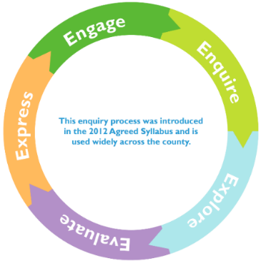
2. Enquire
• After using the Godly Play resource set up a creative response in continuous provision and encourage children to retell the story and ask I wonders…
• Watch the Treasure Chest Story about Trust Treasure Champs. 29: Trust - 'The Three Fishes' - BBC Teach Ask the children to think about what might have happened if Noah didn’t listen and trust God? Explore What if scenarios linked to the story e.g. what if the ark didn’t float? What if the animals didn’t get on? What if the rain didn’t stop after 40 days?
• After hearing the story from All Afloat in Noah’s boat – explore the concept of trust. Who do the children trust? How do they choose to trust someone? What do they expect from someone they trust? Have they been trusted to do something by another person or friend? How did they feel? Is it easy to trust? Explore how you know when to trust someone.
In the story of Noah was it right for him to trust God? Was God good or bad?

4. Evaluate
In this part of the learning cycle we will pretend to be Noah and think of the philosophical dilemmas he faced:
- Discussion – what is right and wrong? God’s message to Noah made him decide – would you listen and do the same? Noah chose to trust God, who do you trust and why?
- Use the ending of the story and the rainbow symbolising God’s promise that he will never bring a flood to cover the earth again. God will instead forgive people when they do wrong things. Write on a picture of a rainbow to explore together What they would like to say about God in this story.
- Noah was told by God to build a boat, In Genesis 6 v14-16 he was told to make it out of cypress wood, make rooms in it and coat it with pitch inside and out. He was told how big it had to be ‘three hundred cubits long, fifty cubits wide and thirty cubits high’ A cubit is an ancient length based on the distance from the elbow to the tip of the middle finger. In today’s measurements 45.7cm. He was told to put a door in the side of the ark and make lower, middle and upper decks The boat had to hold a pair of every living creature on earth. If you have a space big enough you may want to walk out the size to help them understand that it was enormous and would have taken a long time to build. Bring out that Noah had to show a lot of trust in God was telling the truth as it would have looked very strange to build such an enormous a boat where there was no water.
- Use this link to help the pupils imagine the size and what it may have looked like. This is an model of the boat built in America so people can imagine the size. Life-size Noah’s Ark | Ark Encounter Try to ensure they understand this is a replica not the actual boat. What would you include in your boat design and why?
- If Noah was building a boat today still using God’s instructions, what might it look like (use images of modern boast to support this). What choices would you make? Do you think Noah made the same choices?
- Give the children the storyboard pictures of the story – can they order them and retell the story? Can they say what Noah had to decide at each stage of the story?

3. Explore
Begin to explore some of the core knowledge and concepts by:
• Role Play – set up a role play corner as Noah’s workshop, drawing plans of the ark, choosing the equipment, building the ark.
• Pairs activity – finding pairs games of animals, counting in 2s.
• Floating and sinking objects – which shapes and objects float, and which sink?
• Big Construction – can you build Noah’s boat as a team?

