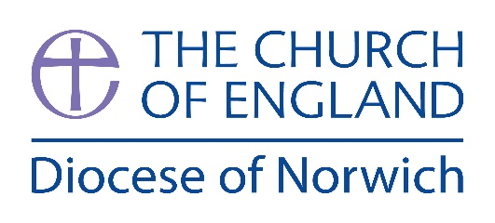

EXCITING OPPORTUNITY
TWO FULL TIME PRIESTS
PRIEST-IN-CHARGE & TEAM VICAR, HUNSTANTON AND SAXON SHORE BENEFICE

An exciting opportunity for 2 full-time priests!
The Hunstanton and Saxon Shore benefice is prayerfully seeking an experienced Priest in Charge and Team Vicar to make Christ known and to help us discern our vision to be a church for all, across the town and villages. These coastal parishes are situated within an Area of Outstanding Natural Beauty in northwest Norfolk.
There is an active ministry team of an Assistant Priest, 5 retired clergy with PTO, and lay led support.
There are two well appointed clergy houses within the benefice.
These two posts are complementary, offering flexibility based on your gifts and experience. Together you will:
- Lead and develop worship that is rooted in tradition yet open to renewal
- Encourage lay leadership and nurture discipleship
- Share in pastoral care across town and villages
- Engage creatively with schools, community groups, and visitors
- Support mission initiatives that reflect the unique opportunities of coastal life
You will be part of a supportive team that values collaboration, prayer, and mutual encouragement.
For an informal discussion about these posts, please be in touch with the Archdeacon of Lynn, The Ven. Catherine Dobson on 01362 709200 or email archdeacon.lynn@dioceseofnorwich.org
More information can be found on the Pathways website.

Closing date: 9th June (9.00am)
Interview date: 22nd July

