The Bishop’s Lent Appeal 2026 Collective Worship Suggestions for Primary Schools

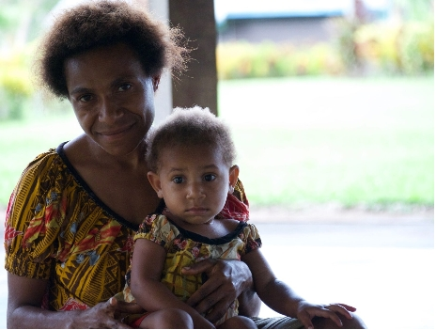
Aim - To create an understanding of family life and education in Papua New Guinea, the place of the church and how we can help.

Introduction to Papua New Guinea

Where is Papua New Guinea?
Papua New Guinea is to the north of Australia and is 0.6 degrees south of the equator. It is an Oceanic country with offshore islands in Melanesia in the South West Pacific Ocean.
It is one of the most culturally diverse countries in the world with 848 languages. Its 7 million people live in mainly rural populations and in the few towns and cities.
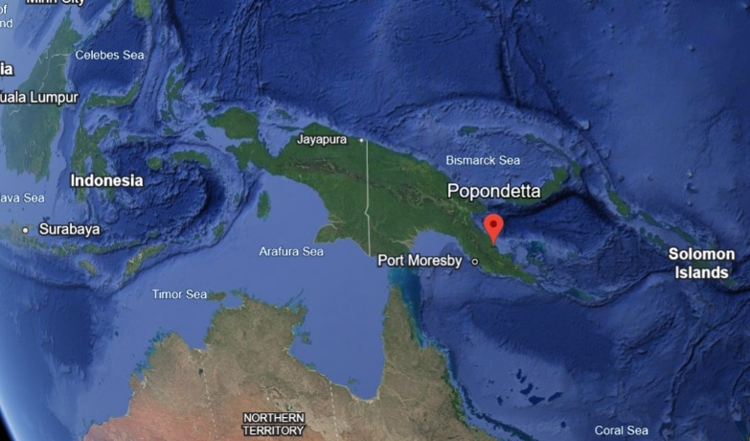
The country is situated on the Pacific Ring of Fire and there are earthquakes and active volcanoes. It is surrounded by coral reefs and in the highlands there are dense rainforest and a rugged terrain across the mountains, the highest of which is Mt Willhelm at 4,509 metres.

Bishop’s Lent Appeal 2026

The Diocese of Norwich has strong connections with Papua New Guinea, every other year the Lent Appeal supports communities in Papua New Guinea.
This year the Bishop of Norwich’s Lent Appeal is raising money for the people of Papua New Guinea through direct help supporting children from clergy families to complete their education at the Martyrs Memorial School, an Anglican school near Popondetta.
In September 2025, a group led by the Bishop of Norwich, the Rt Revd Graham Usher, took part in a pilgrimage to Papua New Guinea, visiting a training college for ordinands and the Martyrs Memorial School.
Reflecting on this visit, Bishop Graham said:
“Education is key to empowering young people to find life in all its fulness, as well as play a part in the future wellbeing of their families and communities.
“I was struck, when I visited Papua New Guinea, how many clergy children have to miss a year of school because their parents can’t afford to send them.
“Your support will step in to support families at such times of need, so as to provide a continuous education.”
Find out more at
https://www.dioceseofnorwich.org/the-bishops-lent-appeal-launch-2026/
How can we help?
There are many ways to help and find out more…
- Plan activities to raise money which will go to the Bishop’s Lent Appeal
- Talk with each other, friends and families about Papua New Guinea to have an understanding of life in this place so different to our own
- Write prayers and use in Collective Worship, and possibly send them to the Bishop of Norwich
- Locate Popondetta on a map or Google Earth
- Collect information about Papua New Guinea and display in your school. Find out more about schools, including Martyrs Memorial School and the role of the church.
- Find out about the martyrs in Papua New Guinea.
- Create a video which could be sent across the world to Martyrs Memorial School in Papua New Guinea.
- Find out about the colourful clothes people wear and the food they eat.

Songs and Prayers
All Over the World
By David Winter
All over the world,
Everywhere , where the sun shines,
And where the white snow gleams;
In the green, green forests and by the streams,
Hands are busy, plans are laid,
And slowly, slowly, somewhere, somebody’s house is made.
Chorus
Everybody’s building, everybody’s building,
Everybody’s building, day by day,
Everybody’s building, everybody’s building,
Everybody’s building, in a different way.
All over the world,
Everywhere,
Where the sun shines,
And where the darkest night
Holds back the coming of the morning light,
Bricks are laid and wood is sawn,
And slowly, slowly,
Out of a dream a house is born,
Chorus
All over the world,
Everywhere,
Where we're living,
Wherever children grow,
And their lives are shaped as the moments go,
Minds are building, plans are laid,
And slowly, slowly,
Somewhere somebody's life is made.
All over the world,
Everywhere,
Where we're living,
Wherever children play,
For the things they do and the things they say,
For good or ill, ground is laid,
And slowly, slowly,
Somewhere, somebody's life is made.
Chorus
Words: David Winter. Taken from Come and Praise, BBC Publications
Prayers
Father, we thank you for our wonderful world, full of light and colour.
We thank especially for our own families and friends and for all those we love.
In a country on the other side of the world, there are people just like us who need some help. In Papua New Guinea we have the chance to make a real difference to children we have never met. We can use our thoughts, prayers and resources to enable children to continue their education at Martyrs School.
In Jesus we are all one big family.
Let us find some ways to help and spread your love to children in Papua New Guinea.
Amen

Dear Lord,
We know that Papua New Guinea is a place far away from our own homes. But it is the home to children and families who love you and praise you. In their church and community help them to feel your love around them and to know that we are thinking of them from so far away.
We pray for Martyrs School and for the children who attend every day. We pray for all the staff and for parents too.
We pray for new ideas for the children and young people that they may learn to explore and find out how more about your wonderful world.
We pray for pilgrims who visit from our churches in the Diocese of Norwich, travelling halfway across the world to meet with Christians just like us.
Lord, we ask this in your name.
Amen
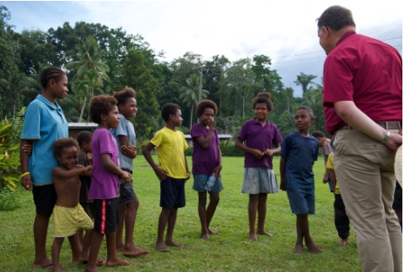

Compiled by Reverend Sue Martin, Diocese of Norwich on behalf of the Norwich Diocese Papua New Guinea Link Group

