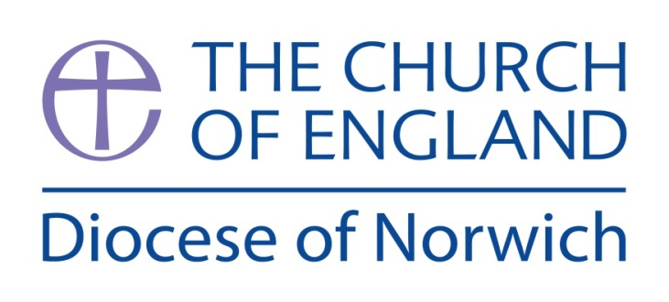

The Supervision and Support of
Authorised Worship Assistants

Introduction

Authorised Ministry

Authorised ministry is representative of the church. It should therefore be supported by the church with appropriately structured learning opportunities. It is also accountable to the authorising organisation within the church.

With the flourishing of lay ministry comes the responsibility for the church to provide support through oversight and reflective practice, within a structured relationship of supervision. As with licenced ministries, it is valuable and important for all Authorised Worship Assistants to have regular supervision.

Supervision is a structured relationship that should enable, support and give confidence to Authorised Worship Assistants. It does so by helping those in an authorised ministry to

- develop the skills for being effective in and developing this ministry
- inhabit the role and identity, appropriately exercising both authority and humility
- help the church to discern God’s call for shaping and evolving a particular ministry

The Selection and Appointment of AWAs

It is important that there are appropriate procedures in place for selecting, appointing and authorising those in Lay Ministry. Details can be found in the AWA Booklet (Authorised Worship Assistants (AWAs) in the Diocese of Norwich) Authorised Worship Assistants — Diocese of Norwich and The Safer Recruitment Practice and People Management Guidance 2021.’ DBS checks & recruitment — Diocese of Norwich

- Who gives Supervision?

Usually the Incumbent has the role of Supervisor but Authorised Worship Assistants may be supervised by another licensed minister such as a curate, experienced Licensed Lay Minister, or assistant priest.
During a vacancy, it is important that arrangements for a suitable supervisor are made before the Incumbent leaves.

What is Supervision?

- A regular, planned, intentional, and boundaried time which requires preparation
- Supervisor and AWA together look at the AWA’s ministry
- A relationship characterised by trust, confidentiality, and support
- Attentive to fitness to practice, training, or skill development, managing boundaries etc
- Understanding of the context of the ministry

Supervision has three functions, and meetings should contain aspects of each.

1 It should be formative/educative. Study opportunities are available through courses and reading. In addition, especially in the early days of AWA ministry, supervision sessions provide invaluable opportunities for learning about ministry in that particular context.
- Teaching. This may also take place within a group of AWAs in the parish or deanery.
- Guidance on how to interpret or handle situations.
- Helping develop self-awareness and reflection that lead to different perspectives on things that have happened, or awareness of different ways of doing things.
- Sharing resources and developing liturgical skills.
- Encouraging change and growth: deeper self-knowledge, spiritual maturity.

2 It should be normative. This refers to the Incumbent’s and Church’s responsibility for the care and cure of souls and includes issues of safeguarding and good practice in the exercise of ministry.

3 It should be restorative/supportive, offering encouragement and an opportunity to share concerns. Part of this will involve praying together and for each other. Supervision will also provide a safe and confidential place to talk through the challenges and difficulties of the role.
Some issues raised in supervision sessions might be referred on to spiritual direction sessions or counselling.

A supervision meeting is not a planning or business meeting, organising diaries and schedules. It is best for such meetings to be either with someone different, or at a different time.

Expectations of Supervision

Supervision sessions should
- be regular (Frequency will depend on various factors such as the length of experience of the AWA, the amount of ministry undertaken, and whether services are alongside the supervisor. A minimum of twice a year is suggested.)
- reflect on your own experience and practice as well as what the supervisee is doing.
- review ministry and reflect on practice.
- ensure the ministry being exercised gives an appropriate challenge ie an energising challenge, without being daunting.
- consider how to keep others in the church informed of the ministry and any support needs (prayer, finance or other people).
- keep a watching brief as to supervisee’s work/family/church/study/…. life balance
- help both supervisor and supervisee to recognise either strategic change in the church’s ministry needs or personal change (such as in growth in confidence and personal development or changed family responsibilities.)

6) Group Supervision

Supervision may sometimes be alongside other members of a ministry team, especially where there is an emphasis on teaching, but there should always be some one-to-one supervision.

Where a group of people exercise the same ministry, it is can be both effective and time saving to have supervision in groups. With a supportive dynamic, groups can help people reflect on both similar and different experiences. However, this can make accountability difficult, and AWAs may feel vulnerable raising more personal issues, so it is important that not all supervision sessions are group supervision.

7) Learning Portfolio

A learning portfolio is a log that gives evidence of learning through a training course and/or through experience and reflection. It is a good practice for all in Authorised Ministry to establish and keep such a portfolio of learning. This might involve:

- A brief account of some practical situations, which has been explored in supervision, noting what was learned through reflecting on it. This might have a sheet after engaging in ministry (e.g. a service you have led) with the following sections.
What happened/what did I experience?
What did I learn from this?
What will I do differently next time?
What further support or resources do I need next time?
What is my next step in this area of learning?

- Identification of learning needs or training undertaken, eg books and articles that have been useful and courses/meetings attended

The purpose of portfolios is to identify learning achieved, and areas for growth and development. It provides a record for annual reflection and the content will form part of the renewal of authorisation every three years.

8) Three Year Review

For Authorised Worship Assistants, a review will help the bishop to evaluate whether it is appropriate, both for the candidate and, also, for the church to renew authorisation for the next three years.

A review may sometimes lead to a new ministry with new challenges e.g. LLM (formerly known as Reader Ministry) or to a less demanding ministry.

Suggested reading for Supervisors

Jane Leach and Michael Paterson, Pastoral Supervision: a handbook (2015)

Michael Paterson, Between a Rock and a Hard Place: Pastoral Supervision Revisited
and Reviewed (2020)

Jessica Rose and Michael Paterson (ed.) Enriching Ministry: Pastoral Supervision in
Practice, (2014)

Wider reading on Supervision

Robin Shohet, Supervision as Transformation: A Passion for Learning (2011)

Peter Hawkins and Robin Shohet, Supervision in the Helping Professions
(fifth edition 2020)

A webinar on AWA Supervision is run each year by Jane Keeton, Diocesan Counsellor and Advisor in Pastoral Care.

Please make enquiries to:
The Revd Sue Hemsley Halls, Diocesan Authorised Worship Assistants co-ordinator
sue.hemsleyhalls@dioceseofnorwich.org
01508 528326

