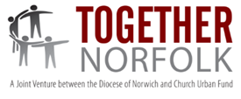
Development Worker
Great Yarmouth
Together Norfolk exists to support the
work of local Christians in their community by providing churches with support to develop & deliver social action initiatives. Are you someone who can:
- Help churches to have a greater & more sustainable impact in tackling poverty?
- Extend existing awareness of deprivation & responses of church & community?
- Work collaboratively to develop effective networks?
You will work with clergy, leaders, projects & people to engage & enable churches to make a greater contribution to the social & spiritual transformation of communities.
Location: Home/ Office based in Great Yarmouth area
Salary & Hours: Band D (£25,123 pro rata)
28 hours per week (Neg.) + contributory pension
Closing date: 9 Jan Interviews: 28 Jan
Visit: www.dioceseofnorwich.org/about/other-vacancies

