RE Planning Cycle
What do Hindus Believe?
How do they express their faith? Year 5 – Enquiry 5

1. Engage
Session 1/2 – Introduce the big question, making links to previous Hinduism units and supported by images, discuss what they may remember. Complete a KWL grid.
Further supported by True Tube https://www.truetube.co.uk/resource/alien-abduction-hinduism/

Depending on time: Children could research and feedback on the key concepts of Samsara, Karma and Ahimsa or the class teacher could summarise key details. The following websites will support this:
https://www.primaryhomeworkhelp.co.uk/religion/hinduism.htm
https://kids.britannica.com/kids/article/Hinduism/353249
https://www.hinduamerican.org/hinduism-101/how#:~:text=In%20Hinduism%2C%20there%20are%20four,the%20royal%20path%20of%20meditation

Explain that beliefs can impact people’s views. Looking at the concept of re-incarnation
Discuss ‘If animals may have once been people (and vice-versa) how might this influence how a believer in reincarnation behaves?’ (This could be completed in groups and fed back, as a debate or individual responses for a working wall)

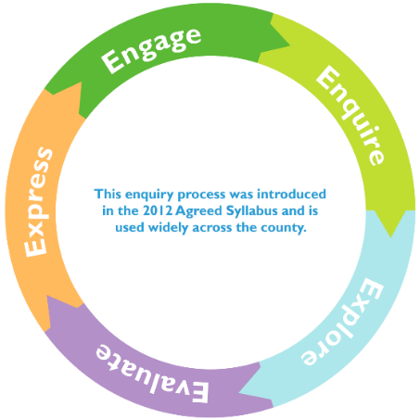
4. Evaluate
Session 6 - Explore the story of Arjuna and Krishna in the Bhagavad Gita.
A summary is here: https://kids.kiddle.co/Bhagavad_Gita
Evaluate how a belief in Dharma (duty) impacts Arjuna’s decision.

Explore the Vedas and the Ramayana to explore the concept of Dharma (duty).
The Ramayana tells the story of the life of Rama (an incarnation of the God – Vishnu)
e.g. The Diwali story and the spiritual victory of light over dark: https://www.youtube.com/watch?v=pp59n0So-XE
Can children make links with other stories with morals that they have heard and experienced?

To evaluate, given a set of circumstances/situations based on their knowledge of Hindu beliefs, what would the children expect them to do and why?

Session 7 - Look to the concept of Brahman, rather than a person, neither male or female but an untainted power. Supported by https://www.youtube.com/watch?v=ET7mXLBH-TE
Whilst making links to earlier sessions, discuss Atman - which means ‘soul or spirit’. This relates to the key Hindu belief that when a person dies the atman will move to another being. Supported by https://www.bbc.co.uk/bitesize/guides/zmgny4j/video children could evaluate how these beliefs would impact Hindu life choices and actions.

Explore the concept of the ‘Self’ Atman and the ‘Supreme Self’ Brahman through an illustration of a drop of water in the ocean. With a picture prompts, the children could come up with their own definitions/understandings such as ‘a grain of sand in the desert’, or ‘a drop of salt in the ocean’.

5. Express
Session 8a – Link back to prior learning, particularly in Session 5.
Recap the concept of Ahimsa - the ethical principle of not causing harm to other living things.

Children need to show an understanding of whether Gandhi’s actions were in fact examples of the Hindu ideal of Ahimsa. The children will require prior knowledge of his key activities such as his fight against colonial rule, racial discrimination and the concept of untouchability.

Create a debate where children work on for / against arguments. Children could be directed to one particular side of the argument so that a quality debate could be held within the classroom.

Session 8b
Using the ideas and examples collated from the previous session, children to write either a for, against or balanced argument about why Gandhi was a good/bad example of the Hindu ideal of Ahimsa.

2/3. Enquire and Explore
Session 3 – Discuss the goal of Moksha in Hinduism, discuss what this means and how a believer might attain this. Use the video to support explanation.
https://www.bbc.co.uk/teach/class-clips-video/religious-studies-ks2-my-life-my-religion-hinduism-cycle-of-birth-and-rebirth/zn68qp3

To re-enforce this concept the children could create a continuous board game where they go round-and-round a board until they have collected enough good Karma to achieve Moksha. Children could create rules, with ways to gain and lose Karma etc.

Session 4 - Start with a recap of learning so far.
Use a video such as https://www.youtube.com/watch?v=X-yJM5jjhiI to allow children to see some similarities and differences to their lives and that of Hindu children.
Explore in discussion what the children think it is to ‘live a good life’ in Hinduism.

Re-introduce the concept of Moksha.
Explain that through a spiritual quest, Hindus aim to experience the divine (God) and to do this there are Four Primary Paths: Devotion (Bhatki Yoga) Service (Karma Yoga) Knowledge (Jhana Yoga) and Meditation (Raja Yoga)
Depending on the cohort the video (https://www.youtube.com/watch?v=gNcx8H7pcMg) could be used to support the class teacher to explain, as snippets to provide examples or simple shared with the class.

Sum up learning by creating lists of rules and activities that could be followed to achieve the Four Primary Paths.

There are a number of complex concepts to look into within this unit that may be supported by the following resources:
https://www.thenational.academy/teachers/programmes/religious-education-primary-ks2-l/units/hinduism-0000/lessons

2/3. Enquire and Explore
Session 5 - Explore the life and work of the great Hindu figure Mahatma Gandhi and the impact of Ahimsa on his peaceful protests during the British rule of India. Use resources such as the ‘Mahatma Gandhi – Biography’ within the Knowledge Organiser and the following video https://www.bbc.co.uk/bitesize/topics/zjkj382/articles/z4fwy9q

Children could complete a fact finder about Gandhi, or a summary of one of his key stands such as the salt march or fasting. All discussions around his actions and the concept of Ahimsa will link to the Express Stage.

Discuss the reality of India today as a Hindu nation and see whether the caste system is still observed.
Using the BBC article support, explain how it came about, how it works and the relevance to today in India. https://www.bbc.co.uk/news/world-asia-india-35650616

