RE Planning Cycle Template
- Engage
Show a range of pictures of birthday celebrations. What do you think is happening in these pictures? Celebrations, like birthdays, mark important occasions and are a time to remember important events too. What things do you think might be worth holding a celebration about? What other things do you celebrate in your family or school or religion? Why are they worth celebrating?
Unit Focus/ Year Groups: Year 5 Enquiry 4
What difference does the resurrection make to Christians?

5. Express
Children to write a newspaper report as if they were present at the resurrection (choose one gospel account), explaining the Christian belief in the Resurrection of Jesus for non-believer readers.

In addition, explore under a sub-heading the theory that the disciples made up the idea that Jesus rose again to convince people He was more than a man – why might this be true? Why might it be false? ‘Interview’ some relevant witnesses e.g. Peter, Judas, Roman soldier, Pilate etc. *4

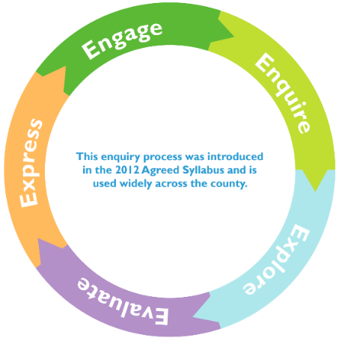
2. Enquire

Watch https://www.youtube.com/watch?v=nleiAfrp2kY&t=25s . Look at statements about Easter (see) and discuss questions such as ‘Why is Easter the most important festival for Christians?

Introduce the ‘Big Question’ with ‘I Wonder Wall’. C

Compare the different Gospel accounts of the death and resurrection of Jesus, ie, Matthew, Mark, Luke, John. *1 Children could explore one account in a group and report back to the whole class, listening to the contributions of other groups and noting similarities/differences in a chart.

ollect questions that they have (KWL Chart) to look at again in Evaluate part. Note the children’s questions on an ‘I Wonder Wall’ and add answers and evidence throughout the enquiry.

4. Evaluate

Return to questions from Session 2. Have they all been answered? Add answers to the ‘I Wonder Wall’ and highlight connections. Ensure children are able to confidently use the Key Words. Use Silent Debate technique to Evaluate their understanding of Easter being a focus on sacrifice or atonement. *3

3. Explore
Read Luke 24 and create a drama script for it, then complete hot-seating for different characters within it and identify the evidence within it for the resurrection.

Study the significance of both Good Friday and Easter Sunday and how they are also celebrated in different ways by Christians. Look at church services, songs (When I survey the wondrous cross / Because He lives), verses. How do these two days express Christian beliefs? – compare and contrast.

Is Easter a festival of new life or sacrifice? https://www.youtube.com/watch?v=cZ4gQniUVO8
Children to collect evidence for a Silent Debate (Evaluate next lesson) on Sacrifice and Atonement: How God deals with evil without destroying humanity *2 https://www.youtube.com/watch?v=G_OlRWGLdnw&t=294s
Forgiveness: https://www.youtube.com/watch?v=5E3nsg2ANqI

Supplementary Resources
Enquire
Session 2 Resources on Exemplar Questions:

Why is Easter the most important festival for Christians?

What surprises pupils about what these young Christians say about Easter?

What did pupils already know?

How can they find out about the significance of Easter in their own community?

What questions would you like to ask some Christians about Easter?

(Resource taken from Wiltshire Agreed Syllabus)
Explore
Songs: When I Survey the Wondrous Cross by Isaac Watts https://www.youtube.com/watch?v=tRfcehP0SLU
Songs: Once Again by Matt Redman https://www.youtube.com/watch?v=SXe6RL_f6co)
Verses: Isaiah 53:4-6, Mark 10:32-33, John 3:16-17, Romans 5:6-8, Matthew 27:50-54, John 11:25-26
Evaluate
Silent debate - https://www.teachertoolkit.co.uk/2017/04/23/silent-discussion/
Key Words
Crucifixion
Easter Sunday
Eternal life
Forgiveness
Good Friday
Gospel
Redemption
Resurrection
Sacrifice
Salvation
Impact
*1 Describe the similarities and differences between the Gospel accounts of Jesus’ death and resurrection.
*2 Describe the connections between sacrifice in the OT and NT and the link to Jesus as the ultimate sacrifice.
*3 Describe the significance of resurrection and how it shapes how Christians see the world and others.
*4 Describe how the resurrection effects how Christians might live their lives.

