RE Planning Cycle Template
- Engage
Introduce the BIG Question, and unpick the key vocab i.e. religion, belief and then reminder about Christianity – what do they remember?
Can they name the sacred text for Christians? Introduce the Bible as a source of authority for Christians.
Use https://www.youtube.com/watch?v=dv8dHsxjLd8&t=2s to introduce The Bible.
Record questions and I wonders on post-it notes for RE working wall.

Unit Focus/ Year Groups: Year4 Enquiry 1
Where do religious beliefs come from? (Christianity)

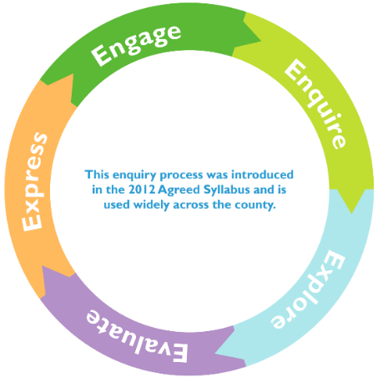
3. Explore (up to 2 weeks)
The Law – use this video https://www.youtube.com/watch?v=3BGO9Mmd_cU to show that the laws from the OT were fulfilled by Jesus, the Messiah. When asked about the greatest commandment, Jesus said, “You shall love the Lord your God with all your heart, and with all your soul, and with all your mind. And the second is You shall love your neighbour as yourself.” Children to complete a mindmap to show links between OT and NT and parable chosen in Session 4. (Use the feeding of the five thousand as a demo to the class first).

4. Evaluate (2 weeks)
Week 1 – introduce the idea we are going to meet a Christian and we want to find lots out about what they believe in and why? Prepare the children to write questions to ask the following week. Take questions from pupils and make a agreed list to share with the visitor.
Invite a visitor to talk about how they became a Christian (either visit the church or ask local incumbent to come in) and how their own beliefs have been shaped by their chosen denomination/community and life experiences.
Return to questions from Session 2. Have they all been answered?

5. Express (2 weeks)

Children to make an information poster about the Bible and what Christian’s believe and do as a result of it. Can they give modern day examples of how Christians live their lives based on this source of authority.

2. Enquire (2 weeks)
Use the diagram ‘Sources of Authority’ to explain that religious belief is influenced by more than one source. In this unit, we will be looking at how some of these link together. However, Christians will always read the Bible to check a source against the truth they believe in. How do Christians use the Bible? https://request.org.uk/bible/introduction-to-the-bible/how-do-christians-use-the-bible/# Look in detail at one of the Parables of Jesus (do one as an example with the whole class -e.g. feeding of the five thousand to demonstrate how to navigate a double entry journal) give the pupils The Prodigal Son, use the Double Entry Journal technique to answer What does this parable teach Christians?

