RE Planning Cycle Template
- Engage (1 week)
Unpack the question – what do pupils know about Muslims? Do they know the name of Allah? Do they know Allah has more than one name? can they estimate how many names he might have? Why do they think he has 99 names? Post it note pupil ideas / questions and responses for a working wall to look at the enquiry question.

Explore BQBA Activity 1 – The word for God in Islam.

Unit Focus/ Year Groups: Year3 Enquiry 4
What do Muslims believe about God?

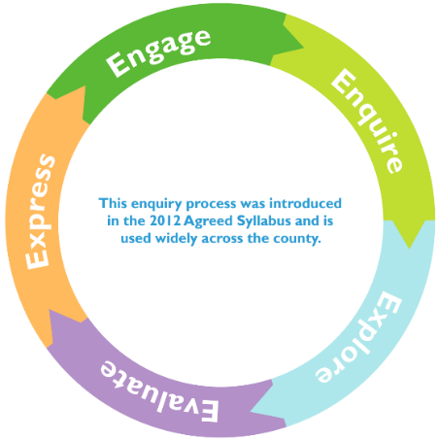
4. Evaluate
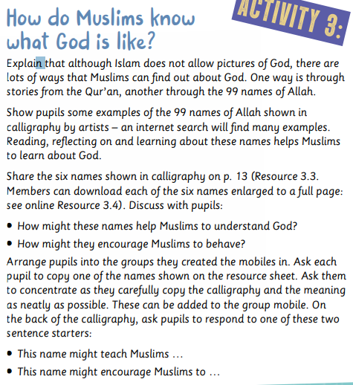
5. Express (up to two weeks)

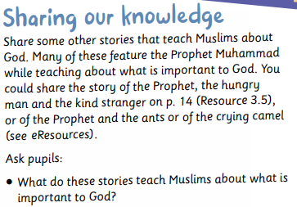
Artwork – select enough choices from the 99 Names of Allah for your class to have one each. Children to create a piece of artwork that represents the characteristic of the name they have been given. Create your own Class Gallery.

3. Explore (2 weeks)
Islam is a monotheistic religion. In its basic form, Tawhid is the assertation that there is only one God. Watch https://www.bbc.co.uk/teach/class-clips-video/religious-education-ks2-my-life-my-religion-the-quran/z4p8mfr Afterwards, collect questions that they have (add to RE working wall on post-its) to look at again in Evaluate part.

The Qur’an - Introduce the Qur’an to the children, demonstrating how to treat it with care and respect. https://www.bbc.co.uk/bitesize/clips/z4fgkqt

Mindmap Surah 112-4 from the Qur’an (see Resources).
This passage sums up the nature of God and is one that many Muslims will learn by heart.

2. Enquire (2 weeks one week = make mobile activity)

Explore how we know about Allah through the story of prophet Ibrahm. Use PPT to introduce the story (p12 of the resources unit) and explore the symbols of the crescent, star etc.

