RE Planning Cycle Template
- Engage
Either take the children on a ‘looking for Christmas walk’ in your local area or use the attached PPT to identify some of the signs that show Christmas is coming. If you use the PPT then use the explanatory notes for each slide as appropriate.

Relate some of the signs the children identify with their lived practice and discuss what they have experienced as a build up to Christmas in their life.

At the end of the session introduce the big enquiry question, ask them what they know about the words nativity, Christians and Jesus. How are the three words linked? Why are they important words at Christmas for Christians?

Unit Focus/ Year Groups: Year 2 Enquiry 2
What does the nativity story teach Christian’s about Jesus?

5. Express

Recap on the key learning from this enquiry – think about what we learn about Jesus from the Luke’s story in the bible and from the actions and celebrations of today Christian’s undertake. Make a list of the key points with the children. Present the enquiry question to the children and explore how they might answer it using the menu of responses below:
- Draw a picture that shows the key facts about Jesus Christian’s learn and remember at Christmas.
- Make a poster of the key characteristics of Jesus learnt from the Christmas story.
- Choose three or four things Christians do at Christmas that show the importance of Jesus to them. Draw each one and write about them or make a 4 slide PPT.

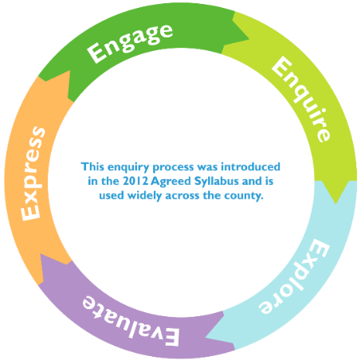
2. Enquire

Look at the PPT images of baby Jesus – how do the children know he was important? Explore the significance of the holy family (slide 3), angels (slide 3), animals (slide 4), shepherds (slide 5) and the magi (slide 6).

Introduce the concept that whilst the pictures may show Jesus as a baby – Christian’s believe he was very special – that he was God on Earth, and this is known as incarnation.

Explain how Christians believe that God came to earth to be with people and show them how to live. That when he arrived it was not as a big man but as a baby. He had a mummy called Mary and a daddy called Joseph. They felt very proud to be Jesus’s parents on Earth. How do the children feel when they have a younger sibling or cousin or family friend? What do they do we do to prepare to have a baby? How was this different to how Mary prepared to have Jesus?

Children to draw and write about how Mary & Joseph prepared for Jesus compared to how a mummy & daddy prepares for a baby today.

4. Evaluate

In the first part of evaluate – revisit the PPT used to identify signs of Christmas – can the pupils make links between these and the story of Jesus birth? Expand this to look at Christmas cards – which ones have Elements of the Christmas story, and which don’t? why might some people not choose ones with a Christian Christmas story message? Explore the secular traditions with Christmas (see supplementary notes attached to this plan).

Invite your local vicar in to discuss how the local parish church prepares for Christmas – what vestments does he/she wears? What happens in church leading up to Christmas? What might they see and why? Alternatively, there is a good BBC video here: https://youtu.be/IO6hjEjPxoM this will also allow you to introduce and discuss the word ADVENT. Children need to understand this is the time Christian’s prepare for Christmas – a time of waiting and anticipation – looking forward (to the birth of Jesus). What do they look forward to? How do they feel? Why? Ask the children to write a to do list for Christian’s to prepare for Christmas and write why they need to do each action. SEND / Lower Ability children can have the adaption of a matching task of to do jobs and reasons of doing these 9some could be in picture form). Extension activity – children to write facts they have learnt from the local vicar visiting about how their parish church prepares for Christmas.

In the second part of evaluate we consider the theme of thankfulness – Christmas is a time when Christians say thank you to God for coming to earth in human form as Jesus. They also say thank you for Jesus showing them how to live good lives as Christians. Think about what the children are thankful for at this time of year – make thank you paper chains – children write reasons to be thankful on strips of paper to form each chain link. An extension activity could be to explore the concept of gratitude at Christmas – what actions might they, their family members, teachers etc. have undertaken toward them they wish to say thank you for. A second chain could record ways they want to help others at Christmas who may be less fortunate than themselves.

3. Explore

Tell the children the story of Christmas from Luke’s Gospel -see PPT. set up your class or hall to undertake a simple Christmas trail to explore the main parts of the story – a good example of setting one up can be found here: www.rootsontheweb.com/i-am-looking-for/public-copies/stepping-stones-christmas-story-trail at each of the suggested stations children can draw and reflect on each part of the story and record this – you could make a booklet for each of the four stages or a poster or have individual pages to respond to each of the four stories. An alternative is to make a story cube, using four sides to tell each story and two sides for Jesus and God. Both approaches look for the children to talk about what they understand form the stories and the messages they provide.

Can the children link the messages from each story to what Christian’s learn and know about Jesus today?

Supplementary Resources
Birth of Jesus – Luke 2:1-20 (NIV)
Luke 2:1-20 can be accessed in different formats through Bible Gateway here: www.biblegateway.com/passage/?search=Luke%202%3A1-20&version=NIV
A good quality commentary of Luke’s telling of the Birth of Jesus can be found here: https://enduringword.com/bible-commentary/luke-2/

Secular traditions at Christmas:
Many Christmas traditions are celebrated by people of all faiths, including non-Christians and those who aren't religious. These traditions include:
- Decorating trees: The tradition of decorating evergreen trees originated in Germany in the 16th century. In India, people decorate mango or bamboo trees instead.
- Feasting: Christmas Eve and Christmas morning feasts are a popular tradition. In Latinx cultures, La Noche Buena, or "the good night", is celebrated with feasts, music, dancing, and fireworks.
- Exchanging gifts: A popular tradition on Christmas Eve or Christmas morning.
- Picnics and fireworks: In warmer climates, picnics and fireworks are popular

A good article for teacher knowledge is:
https://andrewfiala.com/the-joy-of-secular-christmas/#:~:text=We%20give%20presents%20and%20have,don't%20go%20to%20church.

Also the Humanist UK website has a good top ten list here:
https://humanists.uk/humanistlife/10-tips-for-a-happy-humanist-christmas/#:~:text=Eat%2C%20drink%2C%20and%20be%20merry,you%20don't%20like%20them.

