RE Planning Cycle Template
Explain to the children that in RE we will be answering and exploring the big question ‘Why is light an important symbol for Christians, Jews and Hindus?’
Ask the chn what things provide us with light? Why do we need light? How does it keep us safe? When do we need light? What are natural light sources? What are man-made light sources? How are different light sources made? Why are light sources important? Independent- Children to draw different light sources
Unit Focus/ Year Groups: Year2 Enquiry 1
Why is light an important symbol?

5. Express
write a reflective journal for where they can draw or write about their feelings regarding light, candles, and Shabbat. They can illustrate what peace and rest mean to them personally.
Recap all the different questions the children investigated and what they found out. Refer back to the big question ‘ Why is light an important symbol for Christians, Jews and Hindus?’ Ask the chn if we can now answer this question. Take feedback. Independent- chn to draw/write/make something that they have learnt from this unit of work.
Plenary- chn to share their independent work.

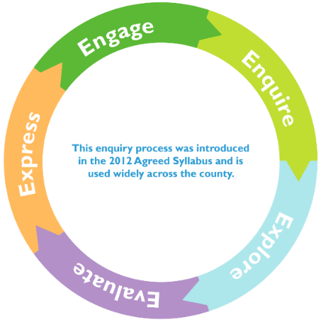
2. Enquire
Remind the chn of the work from last lesson. Ask children to share with their partner different light sources. Remind the children of the big question Why is light an important symbol for Christians, Jews and Hindus? Using different images, ask children to think of questions that will help us to investigate and explore the big question. explore a virtual tour of a synagogue, learning about its significance in Jewish worship and community. Discuss the symbols and artefacts associated with Hanukkah found in the synagogue
Godly Play- The Holy Family.
Tell the story of the Holy Family. Children then have responsive time, model the ‘I wonders…’

4. Evaluate
Read the Christmas Story. Talk about Jesus being the light of the world/to save us/Giving us hope etc.
Use the big Frieze from Understanding Christianity- Section ‘Incarnation’
Ask the children to look at frieze and ask question, talk about what they can see.
Give children a small piece of paper. Children to draw their own images of Christmas/Symbol of light.
Plenary- Share the different images to create class frieze.
Read the Story ‘Light the Lights’
Show the bbc video about Hanukkah: www.bbc.co.uk/bitesize/topics/znwhfg8/articles/zj446v4. Discuss different customs and traditions of Hanukkah. Talk about the meaning being Hanukkah and why Jews celebrate Hanukkah. How Hannukkah reflects Jewish beliefs about God as a provider with the symbolic meaning of lighting the Shabbat Candle.
Carousel of activities. 1) Make potato Latkes 2) Make a Driedel and play reflect how it reflects the Jewish tradition and provision of God’s life3) Make Hanukkah cards 4) Make a Menorah using art straws and tissue paper 5) Make coins and envelopes.
Plenary- Come together to share what the children have made. Ask the children ‘Why is light is an important symbol to Jews?’ Note children’s responses.
SRead the story of Rama and Sita. Talk about why the light is important. Independently 1) Write the story- use the story board. Think about how the story reflects Hindu beliefs about good and evil.
2) Make rangoli patterns out of chalk/pastels on black paper 3) Make Diya lamps (allow to set and decorate another day. Read Dipals Diwali book. Ask the children ‘Why is light important to Hindus? Ask the children ‘Why is light is an important symbol to Hindus?’ Note children’s responses

3. Explore
Explore what a Christingle service is and the meaning behind it. Look at different Christingles. Use www.childrenssociety.org.uk/how-you-can-help/fundraise-and-events/christingle/what-is-christingle to support this. Children to design and make their Christingle
Plenary- Come together to share what the children have made. Ask the children ‘Why is light is an important symbol to Christians?’ Note children’s responses.
John 8:12
“When Jesus spoke again to the people, he said, ‘I am the light of the world. Whoever follows me will never walk in darkness, but will have the light of life.’”
Talk about the meaning of this passage in the bible. Set up a relay race where students carry a “light” (a small flashlight). As they pass the light to a teammate, discuss how Jesus spreads light in our lives. This reinforces the message of sharing hope and positivity.
Organise a classroom discussion around giving and sharing, inspired by the ideas of provision in the Hanukkah story. Students can create a 'Kindness Calendar' to chart out acts of kindness they can perform for others, reflecting the theme of providing.

Supplementary Resources

