RE Planning Cycle Template
- Engage
Start by showing the children some images of Easter – do they recognise them? What is this Christian festival called? Can they remember what happened?
Show the children the Easter Story animations found here: https://request.org.uk/resource/restart/2017/03/14/holy-week-and-easter/

Use the PPT and animations as a recap of the easter story with the children.
Unit Focus/ Year Groups: Year1 Enquiry4
What does the cross mean to Christians?

5. Express

Can the children design and make an Easter Garden and remember the main symbols to include from the Easter story? If it was a modern-day garden – what might be different in it? Why?

You may wish to look at this link to see what Easter Gardens are and why Christian’s make them: https://youtu.be/-qVW9IjhIlU (CBeebies preparing for Easter)

Can the children explain the importance of the cross and what is means to Christians? Record their answers or take photos of their easter gardens and get hem to write why the cross is important.
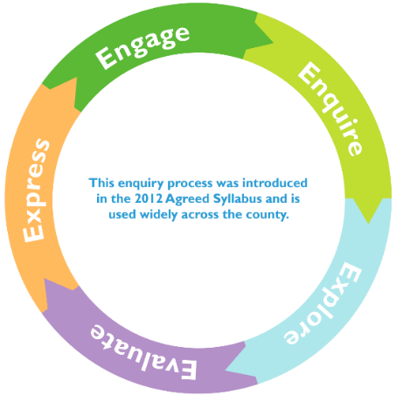
2. Enquire
Talk to the children about the signs of spring and new life – this is how we know Easter is coming. Go for a walk in the school grounds can you spot signs of spring?

Ask the children why they think Easter is important to Christians? Introduce the idea of symbols and explore some of the symbols of Christians (use PPT 2)

Explore why each of the symbols are important to Christians.

The following information will help with explanations: https://request.org.uk/resource/life/spirituality/christian-symbols/

Ask the children to choose one of the symbols and draw it and help them write s sentence to say why it is important to Christians.

3. Explore
Introduce the concept of the cross being the most important symbol of Christianity – link this to the easter story and Jesus dying on the cross.

Exploring different crosses and crucifixes explain their symbolism. Use a range of pictures or actual artefacts if you can get them or the PPT for this session.

Visit your local church and look at the different crosses found there. Explore the meaning of the cross as a Christian symbol here: https://youtu.be/lSwzDgvRl3k

Children to design a cross of their own that has a meaning to them. This could be a drawing, made out of clay or other materials – e.g. a Lego cross. Can they make a cross that represents them?

4. Evaluate
Return to Easter and remind the children that this is an important festival for Christians, and it is where we see the cross play an important part in the Easter story.

Look at the Easter story again and some of the traditions in lent such as Ash Wednesday that are used with the symbol of the cross, how the crosses in church are covered at Lent and that on Good Friday Christians often gather in church to pray at the bottom of the cross.

The following link is useful for videos linked to Holy Week:
https://request.org.uk/resource/restart/2017/06/05/bible-quest-holy-week/

The following link is useful for videos linked to Easter:
https://request.org.uk/resource/?view=resources&cat=3&resource_search_phrase=easter

ask the children to think of the reflections they might have during this time Christian’s call lent and Easter. Can they write them on reflection cards to place on the cross display you could make? When else might we reflect e.g. remembrance Sunday etc.

Supplementary Resources

