RE Planning Cycle Template
- Engage

Show the children a picture of an Easter Garden – children to explain what they can see [verbal discussion]. Adults to model vocabulary during the discussion [vocabulary will be focused on throughout the week of RE]. As the children are discussing the Eater Garden, ask the children to think about other places that they have seen some of the features [e.g the cross – visiting local church / reflective areas]. Reveal the big question to the children. Discuss the vocabulary in the question and link back to previous RE learning. Allow the children time to share what they already know about the big question and time to ask ‘I wonder’ questions about what they want to find out more about. During this time show the children a range of different Easter Garden / Easter images. [https://pixabay.com/images/search/religious%20easter/]
Unit Focus/ Year Groups: Why do Christians put a cross in an Easter Garden? [Reception]

5. Express

Look back at the big question. What have you learnt about Easter Gardens this week? Discussions as a class. All children to choose how they are going to create their very own Easter Garden. Have a range of different resources available around the classroom [playdough / construction materials / painting / small world / paper art etc]. All children to choose the way they are going to create their own Easter Garden to express what they have learnt about the big question. Adults to question children as they are creating the Easter Gardens, why have you included this? What does this represent? Why is this an important part of your Easter Garden? Is they anything new that you think should be added to the Easter Garden – why?

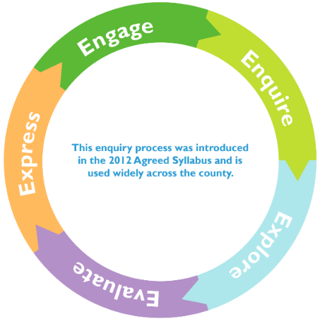
2. Enquire

Show the children a children’s Bible and explain that we are going to reading the Easter Story from the Bible. CT to read the story as TA uses different puppets / props to visually show the children the journey of the story. CT to switch from storyteller mode to teacher mode throughout. Stopping to discuss the Easter story. Ensure you refer back to the children’s ‘I wonder’ questions from the previous session.

At the end of the story CT to explain how Easter in the most important time in the Christian year. Why do you think this could be? Explain to the children that we are going to continue to learn about why Easter is an important time for Christians.

3. Explore
Explore the traditions of Easter. Watch video https://www.bbc.co.uk/cbeebies/watch/lets-celebrate-easter. Watch all the way through first time. After watching allow the children time to discuss with their partner, focusing on what they have just learnt about Toby’s Easter traditions. Watch the video again as a class, this time stopping to discuss at different points [adults to choose which parts their children need to focus on the most]. Lots of class discussion. Children to splits into smaller groups. All children to have a large piece of sugar paper in the middle of their circle. All children to start drawing some of their Easter traditions. Explain to the children as they are drawing they can talk to their friends in their group about the Easter traditions they take part in with their family. Adults to work they way around the groups, asking questions to deepen the children’s understanding of why they might take part in certain activities during Easter time.

Snack time – children to have hot cross buns, discuss the importance of the cross symbol on the top.

Independent Learning Time – children to create Easter cards / Act out Easter day in role play / create their own Easter Garden in construction area or in the outside area / Children to re-tell the Easter story in the small wold area

4. Evaluate

Read the Easter Story from the Bible [this can be a different children’s Bible than the previous session]. As you are reading the story stop at different point to discuss and ensure that the children understand the importance of certain parts of the story and why it is the most important time of the year for Christians. At the end of the story, discuss how Christians believe that Jesus died so God would forgive people for their bad choices. Ensure the children understand that Christians believe that Jesus sacrificed himself to help others.

Show the children different images of people who need help. Children to act out and freeze-frame how they would help the person. Children to verbally explain why and how they are helping.

Supplementary Resources

