RE Planning Cycle Template
Unit Focus/ Year Groups: Reception – Enquiry 2 –
Why do Christians perform Nativity Plays at Christmas?
- Engage

Introduce the children to the Bible and what it is? Look at what the Bible tells us about Jesus by reading the Nativity Story to them. You can also do this with small world props.
Explore why Jesus was a special body as he was a God in human form.
Read to the children some of the parables of Jesus and miracles he performed to show that he was a special person.
Activities: Children can draw a present they would give to Jesus and a present Jesus might give to the world. Children can role play the nativity story, make a nativity scene for a Christmas card. Children can retell the story using construction toys etc.
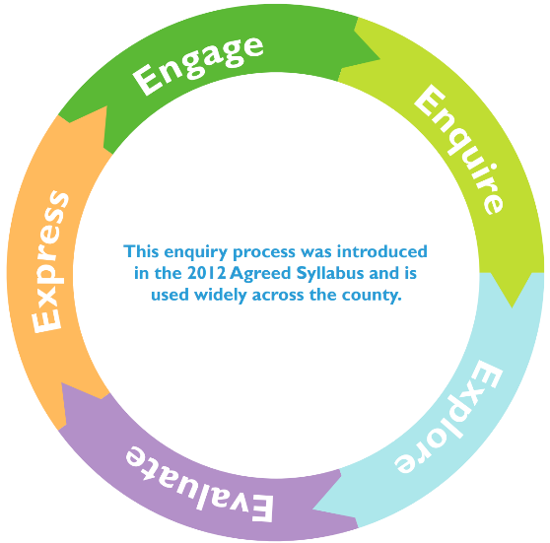
3. Explore
Explore why Christian’s celebrate Christmas – what do they remember and why?
Explore what people do in church at Christmas, why they celebrate Jesus birth? Relate this to looking at the wider world – How this differs from country to country.
Activity - Compare different nativity pictures – what is the same and what is different?

4. Evaluate
Explore the importance of the wisemen and how they might have brought Jesus precious gifts but he was the most precious gift of all.
Look at going on a special journey and giving a special gift. What gift might you give Jesus to show him how special he is?
Activity: Make a special box like the Wise men had and tell an adult what your special gift to Jesus would be.
5. Express
Watch the story of God made people.
What do they think God looks like? What skills do they think God needs to have to create people and why?
Activity: Using whichever materials they want create what they think God would look like and hold discussions as to the skills they think he would need.

2. Enquire
Are all nativity scenes the same around the world? Look at different representations of these. Children can then draw their own version of how they see the nativity.
Research – watch videos/look at different pictures of nativities from around the world. How do they think is the most important person within the nativity story?
Activity – Children could arrange the nativity figures in order of importance and explain why they have thought this to an adult -allowing opportunities for discussion.

