RE Planning Cycle Template
Engage
Teacher brings in a box. Admire the box together.
Whose box is it? Look for the teacher’s name. What’s inside? The teacher takes a ‘treasure’ out of the box and explains why it is important to them. Ask how we could keep a treasure safe. Why would we keep it safe? In the teacher’s box are more treasures-children’s names. Why are names ‘treasures’? The names stand for ‘us’ and we are all special in this class. Children choose and decorate own ‘treasure’ boxes. Label them with our names.

Unit Focus/ Year Groups:
EYFS: Word God important to Christians
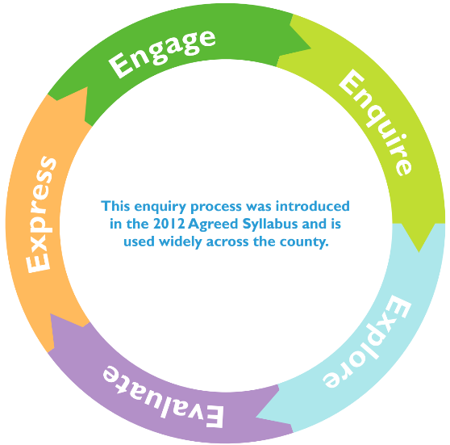
2. Enquirelarge letters V-I-P. Stands for ‘Very Important Person’. I wonder if we can think of any VIPs –people who help us, people on TV, friends or family. Why are they VIPs to us? Do we all have the same ideas? Make a VIP display with children painting large representations of their own VIPs. Introduce God being a VIP for Christians: Make shiny badges with the name ‘God’ on or paint the word ‘God’ on pebbles to put in treasure boxes.

3. Explore
Watch Creation story video and create whole class artwork for each day of the story. Sing creation song, backing track with words: https://www.youtube.com/watch?v=aoehyq6X650
4. Evaluate
Children create a picture to explain how GOD is a special person/ VIP for Christians
5. Express
Invite parents in for a cafe. Children share their special treasure boxes. Describe what they have learnt about God’s name being special for Christians and others. Show some things they have done and made.

