**Porch Prayers**

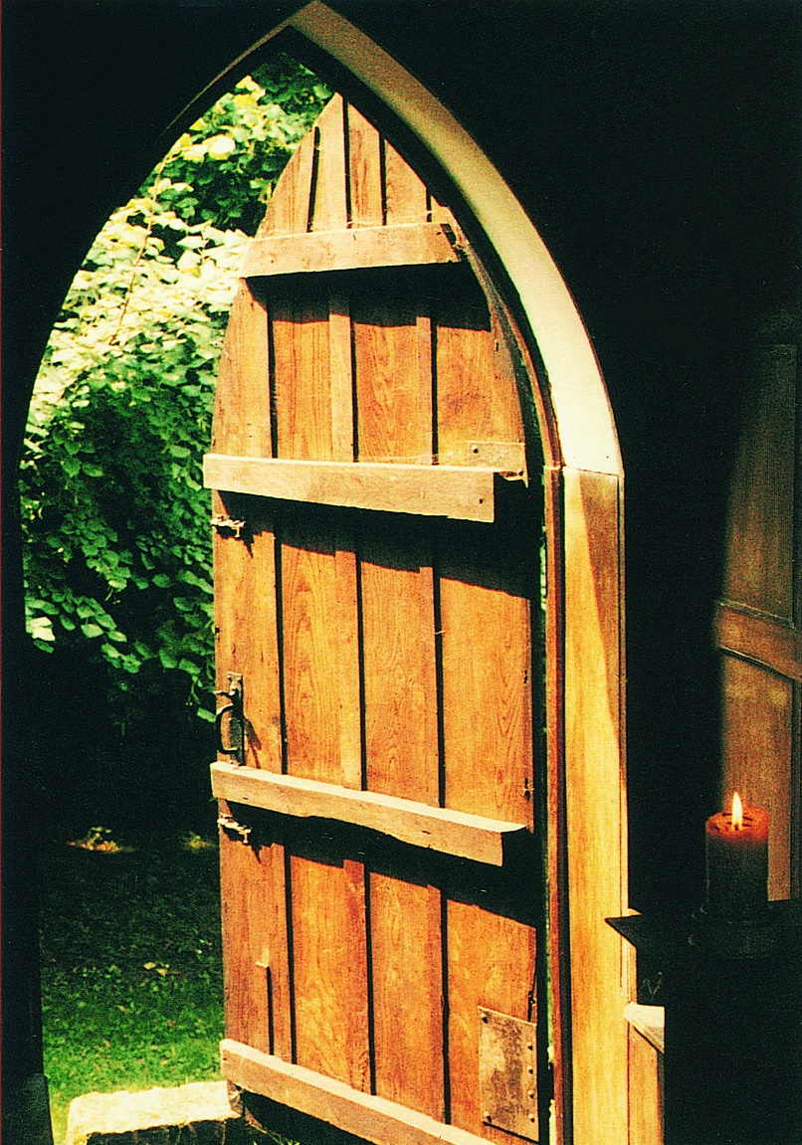

**ADDITIONAL**

**RESOURCES**

**A few alternative Scripture reading suggestions**

**Psalm 8**

1    O Lord our governor,

how glorious is your name in all the world!

2    Your majesty above the heavens is praised

out of the mouths of babes at the breast.

3    You have founded a stronghold against your foes,

that you might still the enemy and the avenger.

4    When I consider your heavens,

the work of your fingers,

the moon and the stars that you have ordained,

5    What are mortals, that you should be mindful of them;

mere human beings, that you should seek them out?

6    You have made them little lower than the angels

and crown them with glory and honour.

7    You have given them dominion

over the works of your hands

and put all things under their feet,

8    All sheep and oxen,

even the wild beasts of the field,

9    The birds of the air, the fish of the sea

and whatsoever moves in the paths of the sea.

10   O Lord our governor,

how glorious is your name in all the world!

**A reading from the 38th chapter of the Book of Job**

**1**Then the Lord answered Job out of the whirlwind:

**2** “Who is this that darkens counsel by words without knowledge? **3**Gird up your loins like a man; I will question you, and you shall declare to me.

**4**“Where were you when I laid the foundation of the earth?  
    Tell me, if you have understanding.  
**5**Who determined its measurements—surely you know!  
    Or who stretched the line upon it?  
**6**On what were its bases sunk,  
    or who laid its cornerstone  
**7**when the morning stars sang together  
    and all the heavenly beings shouted for joy?

**8**“Or who shut in the sea with doors  
    when it burst out from the womb,  
**9**when I made the clouds its garment  
    and thick darkness its swaddling band,  
**10**and prescribed bounds for it,   and set bars and doors,  
**11**and said, ‘Thus far shall you come and no farther,  
    and here shall your proud waves be stopped’?

**12**“Have you commanded the morning since your days began and caused the dawn to know its place,  
**13**so that it might take hold of the skirts of the earth,  
    and the wicked be shaken out of it?  
**14**It is changed like clay under the seal,  
    and it is dyed like a garment.  
**15**Light is withheld from the wicked,  
    and their uplifted arm is broken.

**16**“Have you entered into the springs of the sea  
    or walked in the recesses of the deep?  
**17**Have the gates of death been revealed to you,  
    or have you seen the gates of deep darkness?  
**18**Have you comprehended the expanse of the earth?  
    Declare, if you know all this.

**Psalm 67**

1    God be gracious to us and bless us

and make his face to shine upon us,

2    That your way may be known upon earth,

your saving power among all nations.

3    Let the peoples praise you, O God;

let all the peoples praise you.

4    O let the nations rejoice and be glad,

for you will judge the peoples righteously

and govern the nations upon earth.

5    Let the peoples praise you, O God;

let all the peoples praise you.

6    Then shall the earth bring forth her increase,

and God, our own God, will bless us.

7    God will bless us,

and all the ends of the earth shall fear him.

**A reading from the 6th chapter of St Matthew’s Gospel**

Jesus said, “Therefore I tell you, do not worry about your life, what you will eat or what you will drink, or about your body, what you will wear. Is not life more than food and the body more than clothing? Look at the birds of the air: they neither sow nor reap nor gather into barns, and yet your heavenly Father feeds them. Are you not of more value than they? And which of you by worrying can add a single hour to your span of life? And why do you worry about clothing? Consider the lilies of the field, how they grow; they neither toil nor spinyet I tell you, even Solomon in all his glory was not clothed like one of these. But if God so clothes the grass of the field, which is alive today and tomorrow is thrown into the oven, will he not much more clothe you - you of little faith? 

**A reading from the 25th chapter of St Matthew’s Gospel**

32“From the fig tree learn its lesson: as soon as its branch becomes tender and puts forth its leaves, you know that summer is near. 33So also, when you see all these things, you know that he is near, at the very gates. 34Truly I tell you, this generation will not pass away until all these things have taken place. 35Heaven and earth will pass away, but my words will not pass away.

**A reading from Paul’s letter to the Colossians**

**15**Christ is the image of the invisible God, the firstborn of all creation, **16**for in him all things in heaven and on earth were created, things visible and invisible, whether thrones or dominions or rulers or powers - all things have been created through him and for him. **17**He himself is before all things, and in him all things hold together. **18**He is the head of the body, the church; he is the beginning, the firstborn from the dead, so that he might come to have first place in everything. **19**For in him all the fullness of God was pleased to dwell, **20**and through him God was pleased to reconcile to himself all things, whether on earth or in heaven, by making peace through the blood of his cross.

**A reading from the 12th chapter of the Book of Job**

**7**“But ask the animals, and they will teach you,  
    the birds of the air, and they will tell you;  
**8**ask the plants of the earth, and they will teach you,  
    and the fish of the sea will declare to you.  
**9**Who among all these does not know  
    that the hand of the Lord has done this?  
**10**In his hand is the life of every living thing  
    and the breath of every human being.

**A reading from the 8th chapter of Deuteronomy**

**7**For the Lord your God is bringing you into a good land, a land with flowing streams, with springs and underground waters welling up in valleys and hills, **8**a land of wheat and barley, of vines and fig trees and pomegranates, a land of olive oil and honey, **9**a land where you may eat bread without scarcity, where you will lack nothing, a land whose stones are iron and from whose hills you may mine copper. **10**You shall eat your fill and bless the Lord your God for the good land that he has given you.

**11**“Take care that you do not forget the Lord your God by failing to keep his commandments, his ordinances, and his statutes that I am commanding you today. **12**When you have eaten your fill and have built fine houses and live in them **13**and when your herds and flocks have multiplied and your silver and gold is multiplied and all that you have is multiplied, **14**then do not exalt yourself, forgetting the Lord your God, who brought you out of the land of Egypt, out of the house of slavery, **15**who led you through the great and terrible wilderness, an arid wasteland with poisonous[[a](https://www.biblegateway.com/passage/?search=Deuteronomy%208%3A7-18&version=NRSVUE#fen-NRSVUE-5153a)] snakes and scorpions. He made water flow for you from flint rock. **16**He fed you in the wilderness with manna that your ancestors did not know, to humble you and to test you and in the end to do you good.

**17**Do not say to yourself, ‘My power and the might of my own hand have gotten me this wealth.’ **18**But remember the Lord your God, for it is he who gives you power to get wealth, so that he may confirm his covenant that he swore to your ancestors, as he is doing today.

**A few alternative suggestions of readings**

**from beyond the Scriptures**

from ***The Brothers Karamazov***

Love all God’s creation - the whole of it, every grain of sand. Love every leaf, every ray of light. Love the animals, love the plants, love everything. If you love each thing, you will perceive the mystery of God in all. Once you perceive this, you will begin to understand it better every day. and you will come at last to love the whole world with an all-embracing love. *Dostoevsky*

from ***Ode on Intimations of Immortality***

There was a time when meadow, grove and stream,

the earth, and every common sight

to me did seem

apparelled in celestial light,

the glory and the freshness of a dream.

It is not now as it hath been of yore:

Turn wheresoe’er I may,

by night or day, the things which I have seen

I now can see no more. *William Wordsworth*

***The Peace of Wild Things***

When despair for the world grows in me  
and I wake in the night at the least sound  
in fear of what my life and my children’s lives may be,  
I go and lie down where the wood drake  
rests in his beauty on the water, and the great heron feeds.  
I come into the peace of wild things  
who do not tax their lives with forethought  
of grief. I come into the presence of still water.  
And I feel above me the day-blind stars  
waiting with their light. For a time  
I rest in the grace of the world, and am free. *Wendell Berry*

***God’s Grandeur***

The world is charged with the grandeur of God.  
   It will flame out, like shining from shook foil;  
   It gathers to a greatness, like the ooze of oil  
Crushed. Why do men then now not reck his rod?  
Generations have trod, have trod, have trod;  
   And all is seared with trade; bleared, smeared with toil;  
   And wears man's smudge and shares man's smell: the soil  
Is bare now, nor can foot feel, being shod.  
  
And for all this, nature is never spent;  
   There lives the dearest freshness deep down things;  
And though the last lights off the black West went  
   Oh, morning, at the brown brink eastward, springs--  
Because the Holy Ghost over the bent  
   World broods with warm breast and with ah! bright wings.

*Gerard Manley Hopkins*

“I used to think that the top global environmental problems were climate change, ecosystem collapse and biodiversity loss. I thought that with 30 years of good science we could address these problems but I was wrong.

The top environmental problems are selfishness, greed and apathy & to deal with these we need a spiritual and cultural transformation.”

Gus Speth

*American environmental lawyer & advocate*

Hope imagines the future

and then acts as if that future is irresistible

Walter Wink

*American theologian and activist*

***The Summer Day***

Who made the world?  
Who made the swan, and the black bear?  
Who made the grasshopper?  
This grasshopper, I mean —  
the one who has flung herself out of the grass,  
the one who is eating sugar out of my hand,  
who is moving her jaws back and forth instead of up and down,   
who is gazing around with her enormous and complicated eyes.  
Now she lifts her pale forearms

and thoroughly washes her face.  
Now she snaps her wings open, and floats away.  
I don't know exactly what a prayer is.  
I do know how to pay attention, how to fall down  
into the grass, how to kneel down in the grass,  
how to be idle and blessed, how to stroll through the fields,  
which is what I have been doing all day.  
Tell me, what else should I have done?  
Doesn't everything die at last, and too soon?  
Tell me, what is it you plan to do  
with your one wild and precious life?

*Mary Oliver*

**The Good Ancestor**

Every day I walk the hundred years

to the hill where my great, great granddaughter sits.

I carry words of blessing

and reach to touch her back.

But feeling me near she turns

sad eyed and heavy with grief

“What was it like?” she asks

“when the great whales swam,

when the birds sang you awake

when the rains came soft

and the soil smelt sweet underfoot?”

And the blessings

catch in my throat.

On darker days she turns,

her famished face charred and eyes,

sunk in their bony orbits,

burn with curses.

And the blessings froth at my mouth

with the poisonous spume of betrayal.

On the darkest of all days

I walk the hundred years

and find no one there.

Let this day be the bright day.

Let today be the bright day

I lay my hand upon her back

and, feeling me there,

she turns and blesses me, saying

“Your love was fierce enough,

sweet ancestor,

your love was fierce enough.”

*Daverick Leggett*

“This can either be our final hour, or our finest… This is the decade and we are the generation… Stubborn optimism needs to motivate you daily. Take a deep breath and decide that collectively, we can do this. And that you will play your part.”

*Christiana Figueres*

*Costa Rican diplomat and environmentalist*

***Some alternative blessings***

*(all can be prayed together by the assembled company)*

May God bless us with wonder at creation’s glory.

May God bless us with fury at creation’s spoiling.

May God bless us with courage at this critical hour.

And may the blessing of God,

Father, Son and Holy Spirit,

rest upon us and on all creation,

this day and in the days to come.

Amen.

Deep peace of the running wave to you,

Deep peace of the flowing air to you,

Deep peace of the shining star to you,

Deep peace of the quiet earth to you,

Deep peace of the Son of Peace to you.

May the boldness of the Spirit transform us,

may the gentleness of the Spirit lead us,

may the gifts of the Spirit equip us

as we rise up to play our part

in caring for God’s extraordinary world,

and every living thing for whom it is home.

Stir us from apathy,

restrain us from excess  
and revive in us new hope  
that all creation will one day be healed  
in Jesus Christ our Lord.

Amen