**PORCH PRAYERS**

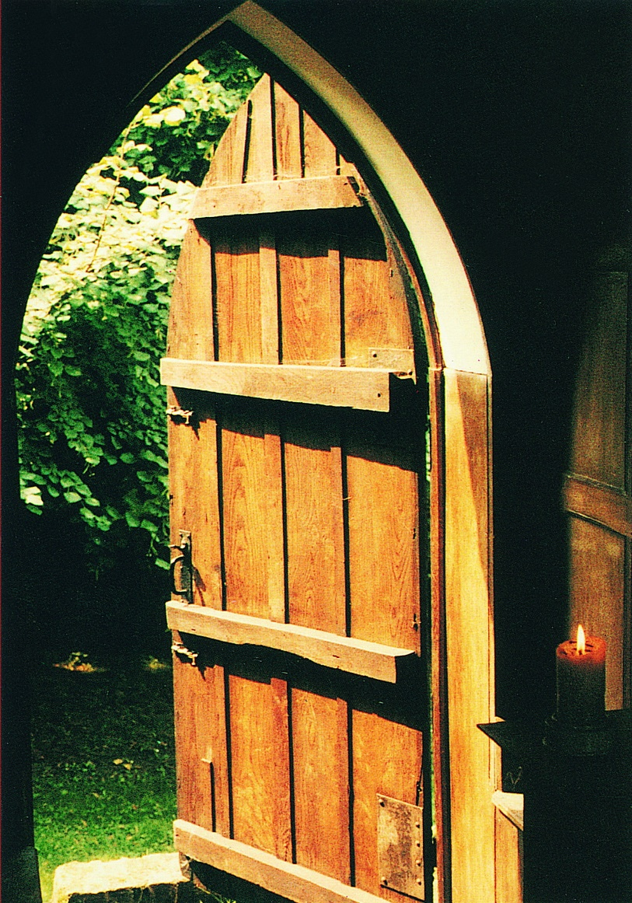

*All gather in the porch around a central table bearing an unlit candle and join in the following prayer of gathering and settling:-*

**God our creator,**

**gather us together**

**in this time of reflection:**

**still and settle us,**

**captivate and challenge us**

**as we pause and pray**

**and ponder together. Amen**

**Opening sentence and words of introduction**

*The earth is the Lord’s and all that is in it,  
the world, and those who live in it.* *Psalm 24. 1*

We gather in this porch

to pause, to pray and to ponder.

From this in-between place,

we can look *in* to the church,

the nurturing home of our faith,

and *out* to the world beyond,

where we are called to *live* that faith.

What awaits us as we look out?

Breeze? Birdsong? Soil? Sky?

Things that take root and grow?

Let us now, in the silence, our senses aquiver, look, smell, and listen to the natural world just a few paces from where we sit, tasting its beauty and vibrancy on the tip of our tongue…

***silence***

May this small corner of the globe be to us

a microcosm of God’s creation -

of its beauty and brokenness,

of its vigour and variety and vulnerability

***The candle is lit***

In the light of this candle, we reflect especially upon the peril faced by the whole created order…

Christ our Light,

as the climate warms,

shine into the suffering of people and planet

**ALL and illumine the work of scientists, activists**

**and all who work for change.**

Christ our Light,

as the climate warms,

shine into our feelings of fear and powerlessness

**ALL and guide us towards action and hope.**

Christ our Light,

as the climate warms,

shine your wisdom and grace

into confusion and denial

**ALL that humanity may unite in urgent struggle**

**for the good of planet Earth, our home.**

**Scripture reading:** *(see Additional Resources booklet for other options)*

Reader Listen for the word of the Lord

**All Our ears are open**

**Our hearts are open**

**A reading from Psalm 19**

1    The heavens are telling the glory of God

and the firmament proclaims his handiwork.

2    One day pours out its song to another

and one night unfolds knowledge to another.

3    They have neither speech nor language

and their voices are not heard,

4    Yet their sound has gone out into all lands

and their words to the ends of the world.

5    In them has he set a tabernacle for the sun,

that comes forth as a bridegroom out of his chamber

and rejoices as a champion to run his course.

6    It goes forth from the end of the heavens

and runs to the very end again,

and there is nothing hidden from its heat.

7    The law of the Lord is perfect, reviving the soul;

the testimony of the Lord is sure

and gives wisdom to the simple.

*In the silence which follows the reading, those gathered may be invited to go outside for a few minutes, returning with a single symbol of the natural world – a leaf, a blade of grass, an acorn, a handful of soil, for example – and placing around the candle on the table.*

***After a few moments, this or another reading may be read:***

*(see Additional Resources booklet for other options)*

**Pied Beauty**

Glory be to God for dappled things –

For skies of couple-colour as a brinded cow;

For rose-moles all in stipple upon trout that swim;

Fresh-firecoal chestnut-falls; finches’ wings;

Landscape plotted and pieced – fold, fallow, and plough;

And áll trádes, their gear and tackle and trim.

All things counter, original, spare, strange;

Whatever is fickle, freckled (who knows how?)

With swift, slow; sweet, sour; adazzle, dim;

He fathers-forth whose beauty is past change:

Praise him.

*Gerard Manley Hopkins*

We rejoice in the world’s beauty and yet, with heavy hearts, we acknowledge the way humanity has taken it for granted, abused and plundered it, brought it to the edge of a precipice…

God our Creator

as we ponder all that you have made,

**All We praise you**

God our Redeemer,

when we forget the world’s fragility,

**All Forgive us**

God our Sustainer,

when we are slow to seek its restoration,

**All Bring us to our senses**

**and stir us to action.**

O God, who called all life into being

**All The woods, the lanes and meadows are yours.**

Your presence is within and beyond us

**All In this place and every place.**

Every atom is full of your energy

**All Every face carries your image.**

Your Spirit gives each of us life

**All and stirs us to long for the healing of creation.**

Challenge us here, in this liminal place

**All which sits between soaring trees and soaring arches,** between grass and glass,

**All between** **birdsong and hymnsong,**

between the waters of cloudbursts

and the waters of baptism,

**All to weave our love for you**

in and around our love for all that you have made.

**All Call us to fuse our faith in the Creator**

with our growing fears for Creation.

**All Strengthen us to be bold, to take risks,**

to encourage and work with each other,

**All spirit-filled, embracing action, nurturing hope.**

In the name of God, we pray,

Creator, Redeemer, Sustainer.

**All Amen**

***Blessing***

*(see Additional Resources booklet for other suggested blessings)*

Let us go out into the world

as bringers of love,

as makers of peace,

as messengers of hope;

knowing that the blessings of God, the source of life,

of Jesus Christ, the way of life,

and of the Holy Spirit, the sustainer of life

are with us today, tomorrow and forever.

Amen