Automatic Door Locks

An automatic door lock facilitates the unlocking and locking of a door at set times each day.
The installation of an automatic door lock requires List B (Archdeacon’s) permission and the church’s insurers will need to be notified of the installation. Funding requests will be considered by the Benefact Trust.
Several PCCs in the Diocese have installed automatic door locks and the feedback is positive. Benefits include a marked increase in visitors, reflected in the visitor book and in donations. This, in turn, has prompted the installation of a contactless payment machine. In one case, it provided a solution to a key holder having to step back from their duties. An automatic door lock provides peace of mind knowing that the church is secure.
An internal button allows a safe exit for anyone locked in but it is useful to put a sign on the inside of the door with a phone number to call in case of any problems.
What are the advantages?
- In cases where it is difficult for volunteers to visit the church every day to open and close it an automatic door lock provides a great deal of flexibility.

- An automatic door lock allows a church to stay open to visitors in cases where it otherwise would not be able to. Visitors are not disappointed by a locked door and do not need to find the key from elsewhere.

- During power cuts automatic locks can rely on batteries for several hours, after which the lock would ‘fail safe’ in the unlocked position. Lights indicate that there is a fault with the lock.

- Security is increased by ensuring the church is reliably opened and locked at the same time each day. Ecclesiastical Insurance recommends that churches are kept open for security purposes as more visitors generate increased natural surveillance, which deters theft and vandalism.
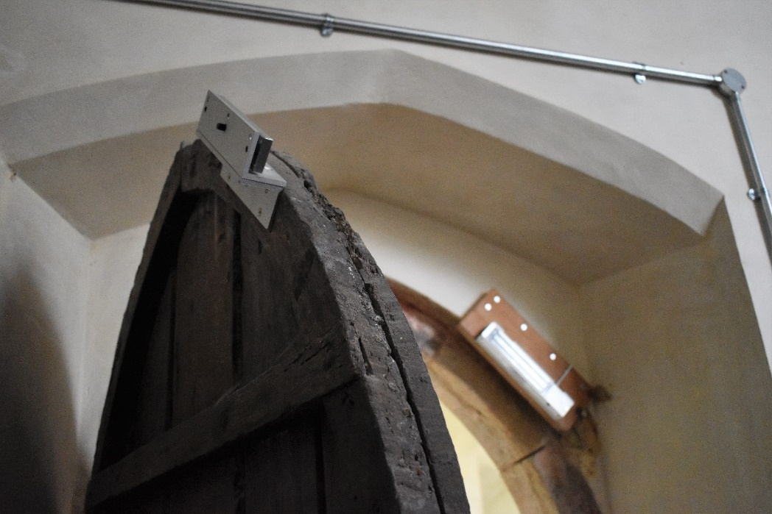

What are the disadvantages?
- Automatic door locks may fail.

- Batteries need to be changed.

- Installation and repair can be costly.

- The door itself may need to be modified, e.g. depending on the type of door and the way it closes it may be necessary for the lock and catch-plate to be mounted on or within an oak block mounted on the door.

- Automatic door locks can negatively impact the historic fabric.

- The system relies on visitors to the church closing the door in order for it to lock, although a closer can be installed on suitable doors. It is a good idea to put signs on the door asking for it to be closed and to make local people aware so that if they notice the door has been left open in the evening they can close it.
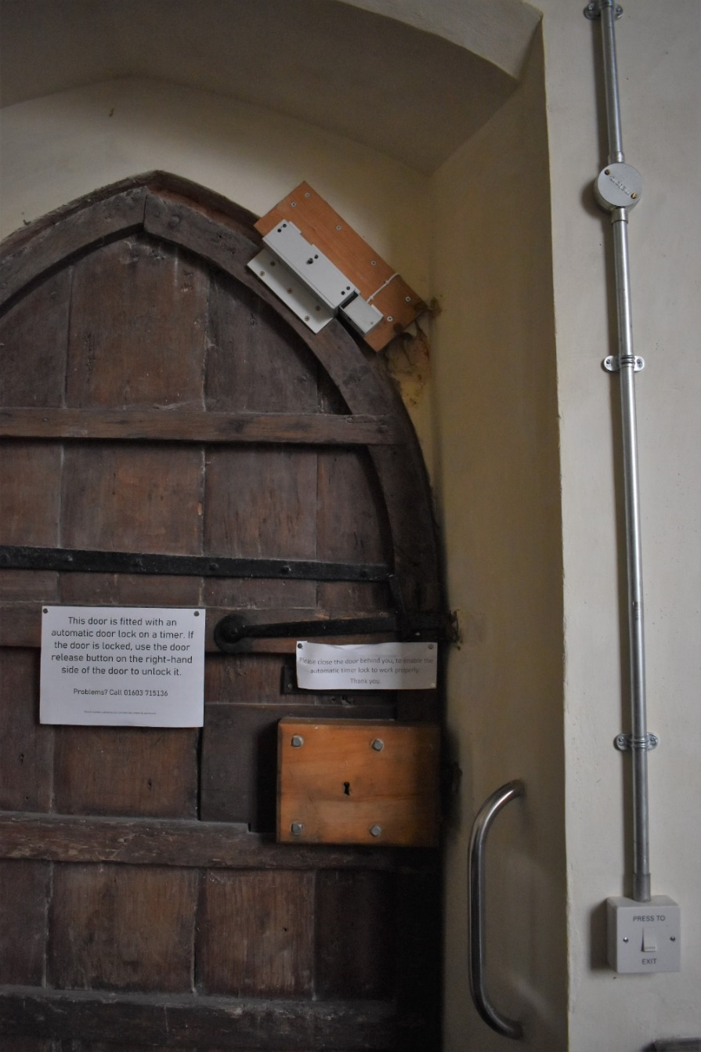

For names of contractors and for assistance with the Online Faculty System please contact Eliza Greenwell via eliza.greenwell@dioceseofnorwich.org or 07341 634798.

