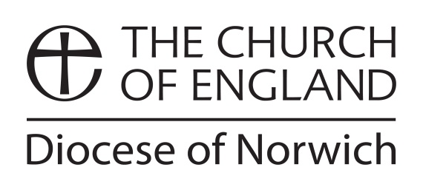

APPLICATION for CMD ALLOWANCE for LICENSED CLERGY

Before completing this form, please save this document and re-name the document by inserting your name at the beginning of the file name, for example: Peter Apostle CMD Allowance Application Form 2021.doc

Name
Address
Telephone
Mobile
E-mail
Current post

Method of payment:
You can either ask for payment to be made to yourself, or directly to the provider of the course\event, etc. The DBF will make all payments by BACS electronic transfer, so please fill in either A, B or C

A: Your account details:

Account Name
Account No
Sort Code

B: The details of the account you wish to have funds transferred to (and please attach any invoice received).

Name of organisation\agency
Account Holders Name(s)
Account No
Sort Code

C: Please transfer funds to the following Diocesan department:

Please complete as fully as possible the information requested in this form.

What is the CMD Allowance to be used for:
[Please provide as much detail as possible.]

What funds do you require?
[If you want the course or event provider to be paid directly by CMD, please supply all necessary information: name, address, title of course\event, BACS bank account details, etc.]

Date:

Please e-mail this form to:
Keith James, Archdeacon of Norwich and Continuing Ministerial Development Officer, archdeacon.norwich@dioceseofnorwich.org
and copy to
Marleen Madinda, Ministry Team Administrator marleen.madinda@dioceseofnorwich.org

(v. Feb25)
The above information provided by you will be kept securely and shared only with the finance department of the diocese and will be kept for 6 years. https://www.dioceseofnorwich.org/privacy-policy/

