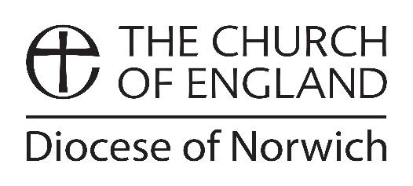

**Clergy Shared Parental Leave – Period of Leave Notice**

This form is for office holders who are or will be birth mothers (or adopting parent) wanting to give notice of their intention to take Shared Parental Leave.

Before submitting this form, the mother of the child must have given notice to curtail her maternity leave (CP-005-01 Clergy Shared Parental Leave - Notice of Curtailment Form) or returned to work and have submitted the Notice of Entitlement (CP-005-02 Clergy Shared Parental Leave - Notice of Entitlement Form) and be eligible to take SPL. Please refer to CP-005 Clergy Shared Parental Leave Policy for further information.

**You must give at least 8 weeks' notice of the start date of your requested leave (and pay, if applicable). You may submit a maximum of 3 Period of Leave Notices / Variation to Period of Leave notices.** This notice must be sent to the Archdeacon or DDO **and** the NDBF HR Manager and Finance Officer.

If a continuous period of leave is requested, you will be entitled to take that period of leave whether or not you receive confirmation or agreement from the Diocese of Norwich. If you request discontinuous periods of leave in this notice and it is not practicable for the Diocese of Norwich to accommodate your request, it may be refused or the dates for the leave postponed in agreement with you. Please refer to the Policy if your request is refused to understand your options.

|  |  |  |  |  |
| --- | --- | --- | --- | --- |
| **Name** | |  | | |
| **Requested Period of Shared Parental Leave** | | | | |
| **Start Date** | | **End Date** | | **Number of weeks** |
|  | |  | |  |
|  | |  | |  |
|  | |  | |  |
| **Requested Period of Shared Parental Pay (if applicable)** | | | | |
| **Start Date** | | **End Date** | | **Number of weeks** |
|  | |  | |  |
|  | |  | |  |
|  | |  | |  |
|  | | | | |
| Signed: |  | | Date: |  |