RE Planning Cycle Template
- Engage
Look at some images linked to key Christian events in the Bible with eh children and how these are depicted in art (see supplementary notes). Introduce the idea that art is used in lots of religions but in Christianity it is often used as a form of expression of what we think an event in the Bible might have looked like. It can also be used for decoration, worship and devotion, and reflection. Display a series of images and ask pupils to post it note what category they think the image could be placed it; can they suggest a reason why? (Image list in supplementary notes)
Unit Focus/ Year Groups: Year5 Enquiry 2
How has belief in Christianity impacted on art through history? (Who is Jesus Diocese of Norwich Teaching Resource supplements this unit)

2. Enquire
In this session we will look at how Christian art has changed over time and the use of art has adapted to represent the cultural, social and political changes in our world today. We will look at how we have a particular view of what Jesus may look like due to the western views we often hold, but the real representation of Jesus is different, as is the different interpretations from around the world.
Start by asking the question What do they think Jesus looks like? How might they depict him? Look at some images which one do they think would be most likely? Why? (See supplementary notes).
What do the children already know about Jesus? Write down the facts / substantive knowledge they know and how they know (ways of knowing) you might want to watch the BBC video on this to help: www.bbc.co.uk/bitesize/articles/zn2jxg8
Show children a series of images that show his birth, life and death. Establish his life span and who he was. Recap on the Christian concepts of incarnation and salvation that mark the start and end of his life on earth. Can they think of how this might be depicted in art- what would they include and why?
Refer to the Who Is Jesus diocese of Norwich resource to support this.

5. Express
The main objective of this session or sessions (depending on the recap and the choice of response provided for the children) is the enable the children to respond to the big question of How Christianity has impacted on art with a focus on the image and portrayal of Jesus? In a creative way. What we want is for them to use and demonstrate their new knowledge from their learning or from their personal reflections and create a response to incorporate this. The response must represent who they think Jesus is? and needs to provide reasoning as to why they think it, drawing on or making connections to what they have learnt.
Providing a menu of response choices will allow different learner styles and barriers to learning to be addressed, hopefully encouraging children to be comfortable and confident in what they create. We may choose to limit the options in some cases if children need greater direction and less choice. However, we need to be mindful writing may be a barrier for some and verbalising may be more productive for many.
Creative Response 1: Art Based Activity Ask the children to draw a detailed image or labelled diagram of who they think Jesus is. This can be a literal image or a representative image. They need to then explain this and verbalise their reasoning. The teacher will need to either record their reasoning in note form or digitally as evidence to support their creative response.
Creative Response 2: Characteristics Creation Using the concept of paint pots for creation from the first panel of Understanding Christianity’s Big Frieze – present he children with empty pots of creation and ask them to decide what characteristics and features they would include if they were creating Jesus. The Bible says he, like man was created in the image of God. But if they could choose what would they include – ask them to write on each pot the reason why and link it to what they have learnt.
Creative Response 3: Poster Create a wanted poster for Jesus – split your sheet in half and create a wanted poster with all of the good and purposeful attributes of Jesus with an explanation why. Now reverse this and create a wanted poster with the negative – what would it be like if he wasn’t the good person the Bible tells us he is?
Creative Response 4: Fact File Children can produce a fact or superhero profile of Jesus – identifying all of his attributes or superpowers and the impact he has on the world today. Can they use examples from their learning to justify what they have chosen? They may include specific examples from different denominations or for different cultures around the world.
Creative Response 5: Short Presentation Children to produce a PowerPoint or Presentation Board of ideas about who Jesus was and is to Christian’s, who he might be seen? What they think he is and why? They might include a wider worldview approach to this.


3. Explore
In this part of the learning sequence we are going to explore the stereotypes of Jesus – e.g. that he is white, that he lived in a westernised way, that he was perfect.
Use the images of Jesus depicted around the world and the nativity images from around the world – note the similarities and differences. (See Supplementary Notes)
Unpack the concept that social and cultural influences can determine how we see Jesus – look at the westernised catholic interpretation versus the geographical, political and cultural identity of the ‘real Jesus’.
Can the children create a modern-day version of the nativity in clay/ plasticine / drawing = what would they include and why? what might have changed and why?

4. Evaluate
In this part of the learning sequence we will evaluate why different groups of Christians may use different images of Jesus and see him in different ways. We will unpack the worldviews within Christianity and consider whilst the theology remains consistent the social and human influences and impact can be very different.

In order to do this we share with the pupils the seven images linked to different denominations within Christianity and how they dwell in some aspects or images of Jesus. Present these images as a silent gallery activity and ask children to post it note answers to one or more of the following questions for each picture:
- What do we notice that is similar and different?
- What questions do the images raise when we look at them?
- What messages are the images trying to convey to people? Why do you think this is?
In the second session we consider the stereotyping behind some images that provide cultural references that may not depict Christians in conventional ways.

Share the images of Christian Worldviews with pupils. Ask them to discuss what they notice, who they think these people are and what religion do they depict and why? share the information about each image. Ask the pupils if they think if the information is true? What surprises them? Do they think the image is an authentic representation of Christianity? Why?

Supplementary Notes:
Use this website for your own teacher knowledge: www.bbc.co.uk/bitesize/articles/zjqcf4j
Suggested Images to introduce how art may be used to depict key Biblical events and stories:
- The Nativity (Adoration of the Shepherds) www.nationalgallery.org.uk/paintings/barent-fabritius-the-adoration-of-the-shepherds
- The Crucifixion www.nationalgallery.org.uk/paintings/antonello-da-messina-christ-crucified
- Transfiguration www.nationalgallery.org.uk/paintings/duccio-the-transfiguration
- The Annunciation www.nationalgallery.org.uk/paintings/nicolas-poussin-the-annunciation

Images that can be categorised:




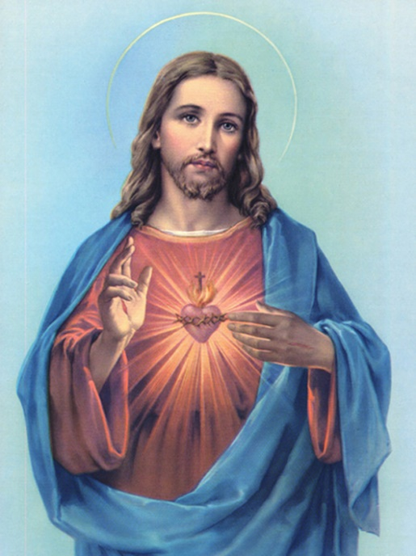
Reflection Decoration Devotion Worship
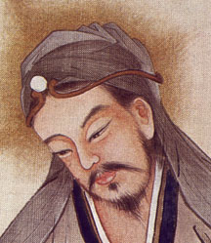
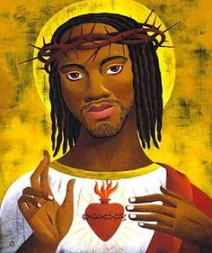
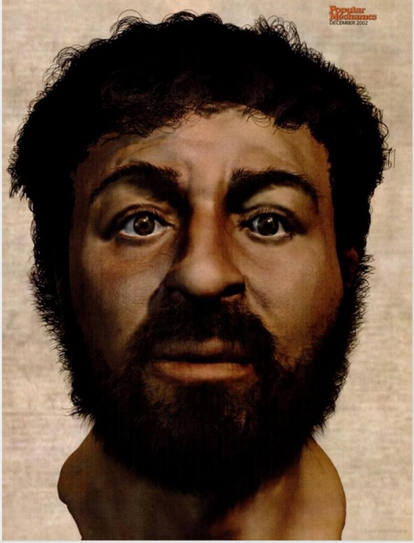
Images of Jesus:

Nativity Scenes from Around the World:

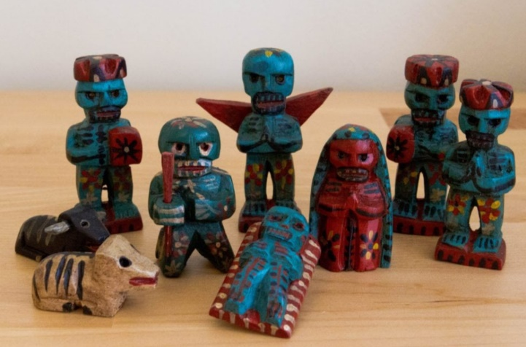
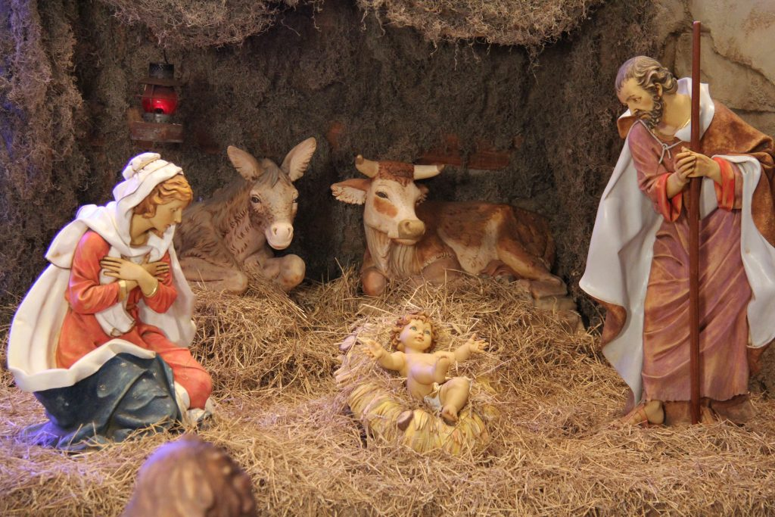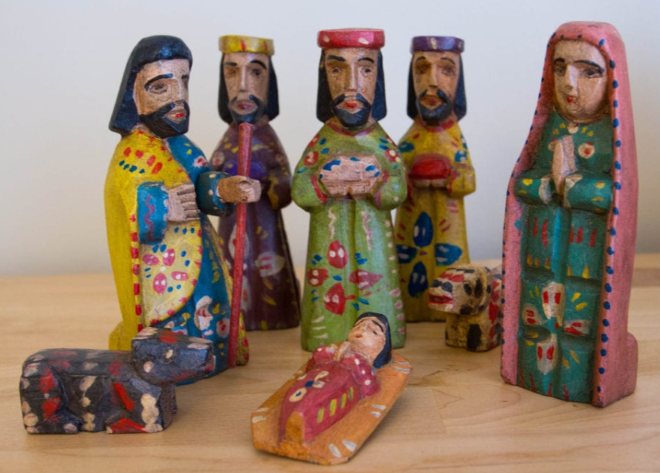
European Guatemalan Mexican

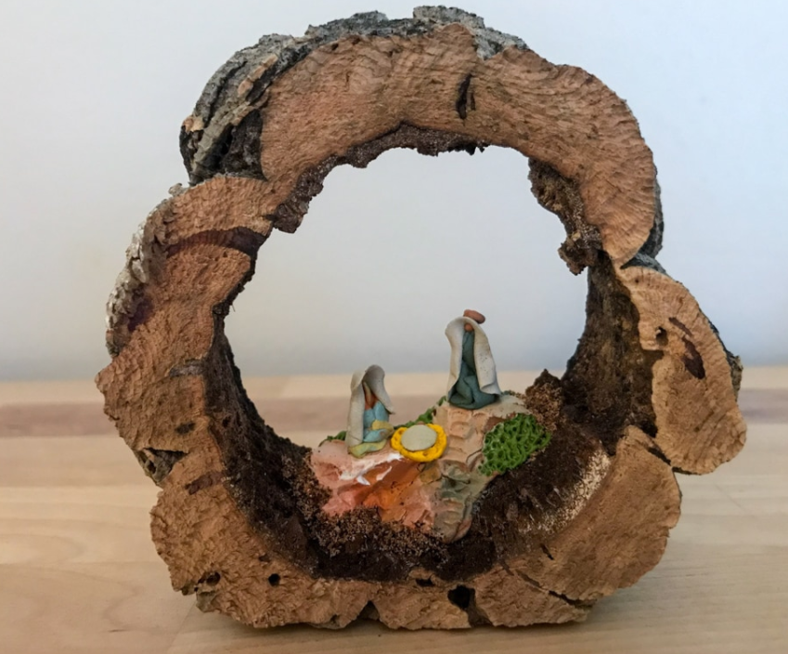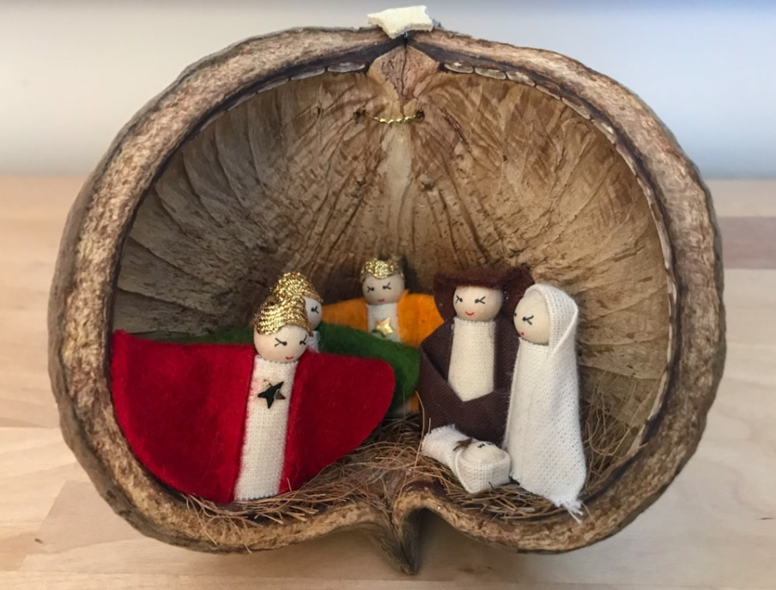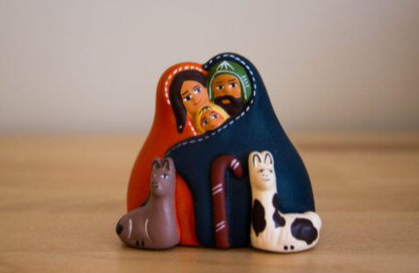
Portuguese Czech Peru

Notes:
- Carved painted wood nativity from Guatemala in traditional dress.
- Mexican painted nativity incorporating the Day of the Dead imagery.
- Peruvian nativity is ceramic, traditional dress and has llamas rather than sheep.
- Portugal’s is very simple and incorporates an arc of cork – the national product.
- Czech is traditional dress and in a seed pod – made by master craftsmen.
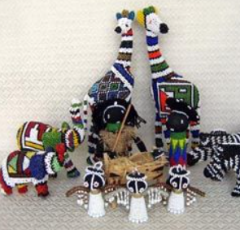
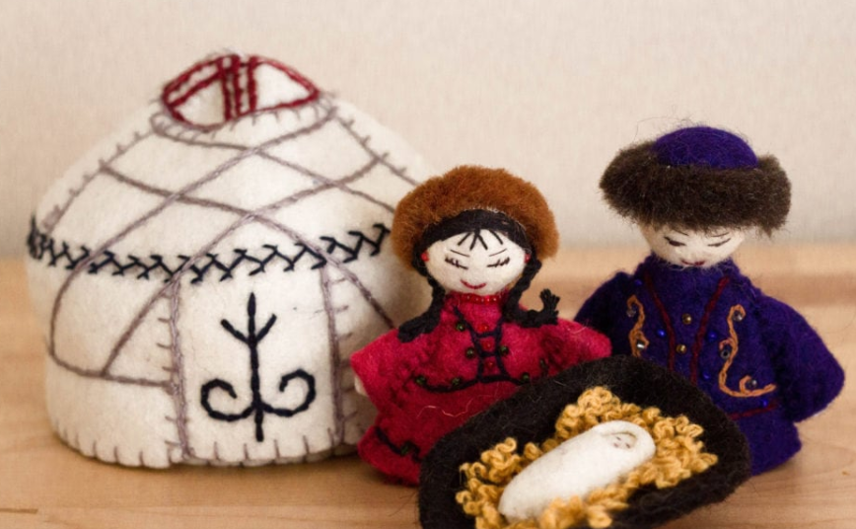
Kyrgyzstan African

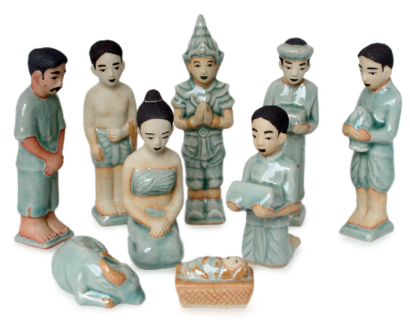

South African

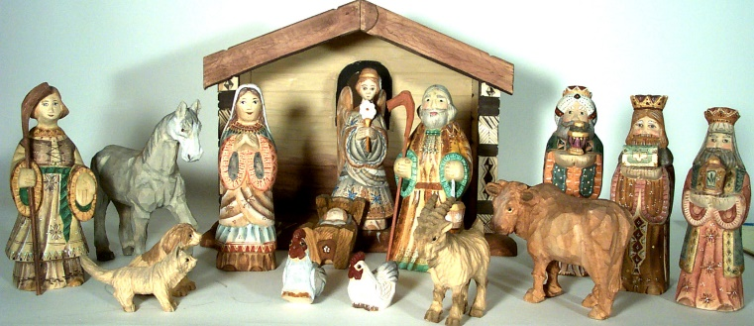
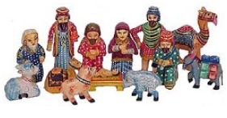

Thai Indian Russian

Notes:
- Kyrgyzstan, is made from felted wool a national product and only depicts the holy family with a yurt as the place of Jesus birth.
- African, is made of hard dark wood, has traditional African dress and animals from Africa – elephant.
- South African – very bold and bright, colourful, beaded in traditional wear and featuring local animals!
- Thai – ceramic and detailed in nature, figures in traditional and authentic costume.
- India – camels, Saris and colourful Indian patterns.
- Russian – carved wooden set, traditional clothing and imagery of Russia.

Images associated to each of the 7 Christian denominations
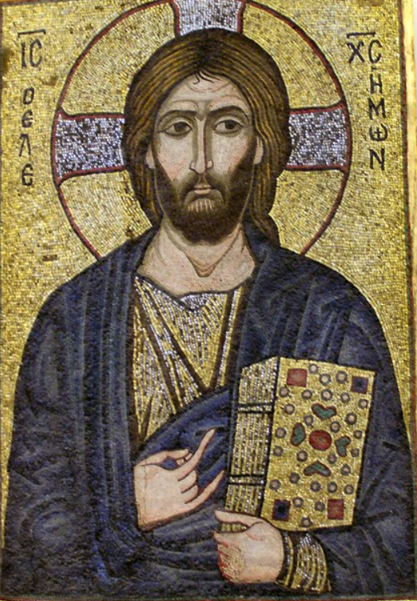
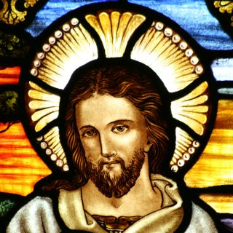
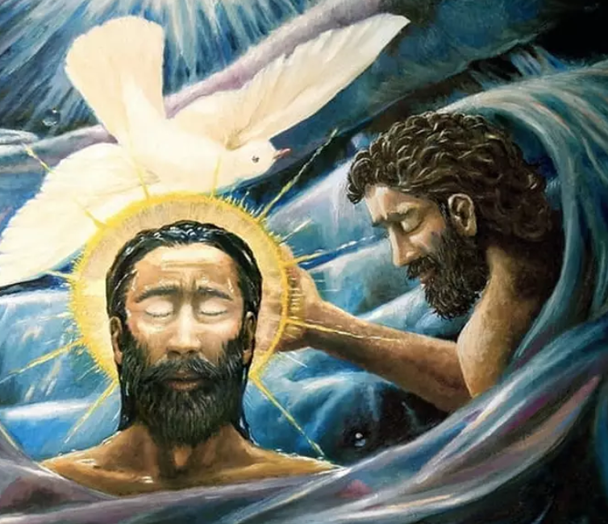

Anglican Assembly of God Lutheran
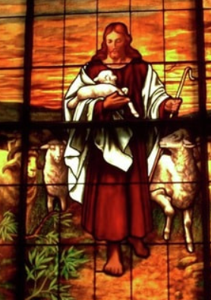
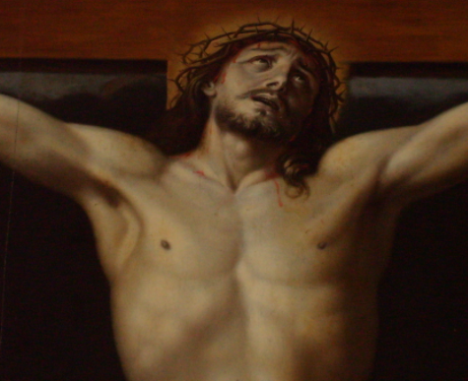

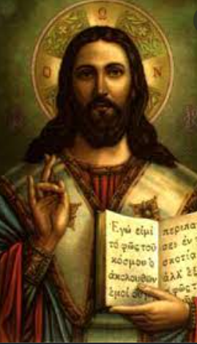

Baptist Catholic Methodist Presbyterian
Notes on Worldviews in Christianity:

We may define a Christian as anyone who commits themselves to following the person and teachings of the first century historical Jesus, who is often given the title of the ‘Christ’ (meaning God’s anointed one). This definition however immediately invites controversy, because there are some who would insist that to be a Christian the person must also be baptised, others that they must believe in the Trinity, and others that no one is truly Christian until they have had a personal encounter with Jesus, and experienced their sins being forgiven. For the purposes of this article then, we will accept that anyone claiming to be a Christian is recognised as that. This keeps the field wide, allows us to be inclusive in our overview of the religion, and reminds us that there is a diversity of worldviews within Christianity.

A world religion Like Judaism and Islam, Christianity is a monotheistic religion which derives from the middle east, and developed out of first century Judaism. It is sometimes referred to as Abrahamic (i.e. tracing its origins back to Abraham, an ancient Mesopotamian tribal leader from about 2000BC). Today Christianity is the world’s largest religion, with 2.4 billion adherents1 in all continents of the world; that is, approx. one third of the world’s population. About half of these affiliate to the Roman Catholic church, and the rest are roughly three quarters protestant and one third Coptic, Greek and Russian Orthodox. Although modern Christianity has typically been considered as Western-European, its decline in Europe, alongside rapid growth in southern countries and Asia, means that by 2050 it will have a very different demographic from that of the nineteenth and twentieth century Church. By then, most Christians will be non-English speaking, and non-European in ethnicity.

In broad terms, a worldview that is Christian examines cultural data and locates them within a pattern of belief that is consistent with the sacred text of Scripture, but also with the broader Christian intellectual tradition.
In other words, whenever we encounter an idea, we ask whether the issue relates variously to how God created the world, how humans through sin have corrupted the world, or how the world through the work of Jesus Christ is in the process of being redeemed and restored.
Developing a Christian worldview is important for the Christ-follower because it tempers the way we interact with and assess the fallen world in which we live. Some Christians fall into the trap of being shocked about beliefs that secular persons express on a given issue. We must remember that worldviews serve the function of eyeglasses, helping a person to focus on the world around him in a meaningful way. Think of a trip to your local optometrist’s office: you are asked to stare at a chart without the aid of corrective lenses. With each new lens, you are asked to choose either A or B. By the time you are finished, you see clearly. Without help, you may struggle to see at all.

The worldviews in Christianity like with the images we have of Jesus is dependent on the social, cultural, political, geographical and historical context we find ourselves in and are influenced by.

To allow children to appreciate this we can expand on an image of Jesus to images of Christians around the world – by showing images to children of practising Christians without telling them any context they will immediately make assumptions about who or what they are seeing. Use the images below to test this out and to explore why they make the comments and observations they do:

Christian Worldviews Images and Notes

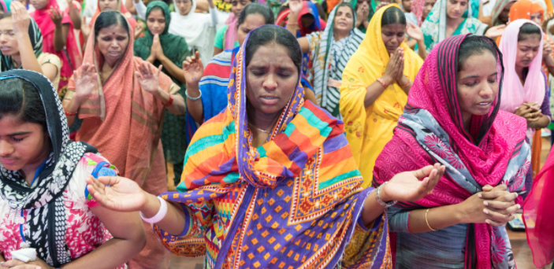

Notes on the image:

Christianity is India's third-largest religion after Hinduism and Islam, just ahead of Sikhism with about 27.8 million (2.78 crore) adherents, constituting 2.3 percent of India's population (2011 census).

The Saint Thomas Christians have also been nicknamed such due to their reverence for Saint Thomas the Apostle, who is said to have brought Christianity to India. The name dates back to the period of Portuguese colonisation. They are also known, especially locally, as Nasrani or Nasrani Mappila.

About 73% of the Christians in India are Catholics. The Catholic Church in India is composed of three individual Churches- Latin, Malabar and Malankara. Christian community includes Syrian Christians, Knanaya Christians, Goan Christians, Tamil Christians, Anglo-Indians, Naga Christians etc.

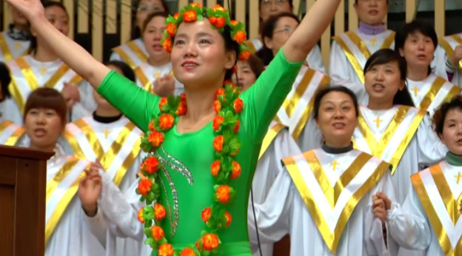

Notes on the image:

Citizens of the People's Republic of China enjoy freedom of religious belief. No state organ, public organization or individual may compel citizens to believe in, or not to believe in, any religion; nor may they discriminate against citizens who believe in, or do not believe in, any religion.

Christianity in China has been present since at least the 7th century and has gained a significant amount of influence during the last 200 years.^{[2]} The Syro-Persian Church of the East (frequently mischaracterized as Nestorianism) appeared in the 7th century, during the Tang dynasty. Catholicism was among the religions patronized by the Mongol emperors in the Yuan dynasty, but did not take root until it was reintroduced in the 16th century by Jesuit missionaries.^{[3]} Starting in the early nineteenth century, Protestant missionaries attracted small but influential followings, and independent Chinese churches followed.
Today, it is estimated that Christianity is the fastest growing religion in China in 1949 there were some 4 million Christians, today this is an estimated 60 million, of which 10-12 million are catholic.

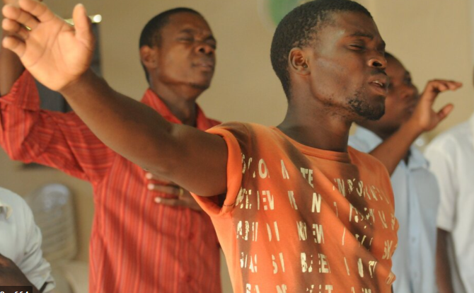

Notes on the image:
According to updated data for 2021, there are now nearly 685 million Christians in Africa, with 760 million expected by 2025. This surpasses earlier estimates of 630 million to 700 million for 2025: "By 2025, that number is expected to nearly double, to somewhere between 630 and 700 million believers.

In the 15th century Christianity came to Sub-Saharan Africa with the arrival of the Portuguese. In the South of the continent the Dutch founded the beginnings of the Dutch Reform Church in 1652.

African worship is often very sensory, lots of music and singing. Often outdoors to large congregations. It is very evangelical in nature.
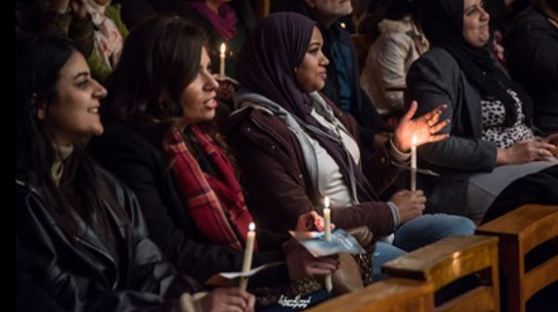

Notes on the image:

According to Pew Research Center 83.43% of the South American population is Christian, although less than half of them are devout.
Christianity was brought to Latin America by the Spanish and Portuguese conquerors of North, Central, and South America in the 16th century.
I t is observed that 81.9% believe in God and 18.1% do not. Gender, age, education level and geographical location have all been cited as variables for irreligion. Among men aged 18–29, those with better education and those from the most progressive, "modern" areas tend towards a lack of belief in God (83% and 89%).

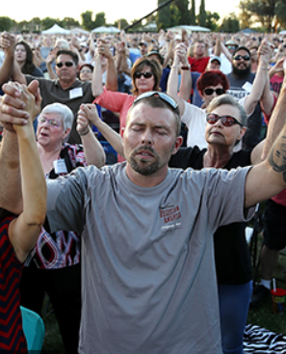
Notes on the image:
In a 2020 survey by the Pew Research Center, 65% of adults in the United States identified themselves as Christians. They were 75% in 2015 70.6% in 2014, 78% in 2012, 81.6% in 2001, and 85% in 1990. About 62% of those polled claim to be members of a church congregation. Roughly 48.9% of Americans are Protestants, 23.0% are Catholics, 1.8% are Mormons (members of The Church of Jesus Christ of Latter-day Saints).^{[28]} Christianity was introduced during the period of European colonization. The United States has the world's largest Christian population.

The five largest Christian denominations in America are:^{[30]}
- The Catholic Church, 68,202,492 members
- The Southern Baptist Convention, 16,136,044 members
- The United Methodist Church, 7,679,850 members
- The Church of Jesus Christ of Latter-day Saints, 6,157,238 members
- The Church of God in Christ, 5,499,875 members

