**RE Planning Cycle Template**

1. Engage

Explore the idea of commitment by thinking of examples in children’s own lives e.g. sport, dancing, clubs (brownies/cubs), family, friends, schoolwork. What things do you have to do to show you are committed? Ask children to bring badges, certificates etc. in to show in advance.

Commitment may involve a public declaration of your intention (an ‘initiation’ ceremony of some kind) but then it also involves living in a certain way every day. You could show examples of birth certificate, graduation certificate, marriage certificate or photos of important ceremonies in your own life.

Ask children to record a response to how they might show commitment – this could be a sentence, picture or verbalisation that someone scribes.

Unit Focus/ Year Groups: Year3 Enquiry 1

**How do Jewish people express commitment to a religion/ worldview in different ways?**

5. Express

Pupils are asked to showcase their learning of how a Jew shows commitment to Judaism through researching some of the rules and laws for some groups of Jews, use the following website to help them: [www.bbc.co.uk/bitesize/articles/zfn792p](http://www.bbc.co.uk/bitesize/articles/zfn792p)

Watch the video a second time and scribe notes with eh children about how Zack lives his life as a Jew in terms of how he worships and what he eats. Pupils to use this information and the information about Mitzvah and Rosh Hashanah to produce a creative response, this could be a Poster, fact file, mind map etc that demonstrates the ways in which a Jew might show their commitment to Judaism. Children to explain their learning by sharing it with the class or in smaller groups.

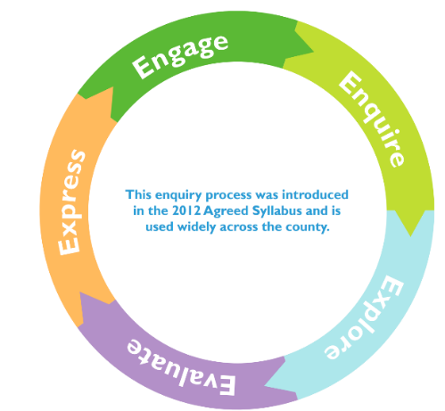

2. Enquire

Show pupils the selection of photos from Resource 3.1. A link to further photos can be found in the Classroom ready resources. Ask:

* What do you think is happening in these pictures?
* Have you ever seen anyone doing these things where you

live?

* Have you ever done anything like these things?
* Why do you think they might be doing these things?

Introduce the fact that Mitzvah Day is one day a year, currently in November, when people around the world come together to give their time to help their community. It started in the UK in 2005 and was the idea of Laura Marks. The day is led by the Jewish community but lots of people from different religious and non-religious communities join in too. Over 40,000 people around the word take part.

Teach pupils that ‘mitzvah’ is a word commonly used in Judaism, and one translation of ‘mitzvah’ is ‘good deed’ – so Mitzvah Day is a day of good deeds.

Ask pupils to watch out for the mitzvot they see being shown around the school, their home and the community. Collect examples.

*4. Evaluate*

Session 1: Jewish homes on Rosh Hashanah (Resource 2.1).

In response to the images, ask pupils for their answers to these questions in order:

* + *What can we see?*
  + *What do we know?*
  + *What do we wonder?*

Explain that each of the images shows what the inside of a Jewish home would look like at Rosh Hashanah, a very special festival for Jewish people.

You may be able to source other photos of Rosh Hashanah celebrations.

Session 2: Watch the film of a Jewish family at Rosh Hashanah ([www.bbc.co.uk/cbeebies/watch/the-lets-go-club-celebrating-rosh-hashanah](http://www.bbc.co.uk/cbeebies/watch/the-lets-go-club-celebrating-rosh-hashanah). What do they find out about Rosh Hashanah? How does this festival show the commitment of a Jew to Judaism? What rituals and practices do they undertake to show their commitment? What does the symbolism mean?

How do we generally celebrate new year in England? What resolutions do we make? Ask the children to think of resolutions they might make and explain why?

3. Explore

Think back to the photos you looked at in Resource 3.1. Ask the pupils to think about what values these actions are showing? For many Jewish people there are three important values and these are shown in the action carried out on Mitzvah Day:

* showing loving kindness (gemilut chasadim)
* repairing the world (tikkun olam)
* justice (tzedek)

Pupils to work in pairs to create a logo for each value. Ask them to write a sentence under the logo or offer a verbal explanation for what each one means. Sentence stems could be used:

* Our logo means …
* An example of this being shown on Mitzvah Day could be …

Next explore that In the Jewish religion, Mitzvah can be developed into a rite of passage ceremony – this is called Bar and Bat Mitzvah. Use the video from <https://truetube.co.uk/film/bat-and-bar-mitzvah> to explore what this means to Jewish young people. Compare and contrast the events, meaning and purpose of the ceremony with Christian baptism from previous learning.

Supplementary Resources

