**RE Planning Cycle Template**

1. Engage

Look at pictures of Christians celebrating together – can the children work out the occasions e.g. Christmas, Easter, Harvest, a Christening, a Wedding etc.

What would the children like to find out from each set of pictures? Make a class question wall displaying each picture and the questions children raise or the things they notice.

Have any of the children taken part in any of the events in the pictures? What do they remember? How did they feel?

Images to use:

Baptism <https://aleteia.org/2020/01/12/baptism-the-spiritual-meaning-of-the-word/>

Wedding <https://www.brides.com/christian-wedding-ceremony-traditions-4798681>

Christmas <https://www.newportbeachindy.com/christmas-eve-and-christmas-day-church-services-in-newport-beach-2/>

Easter <https://www.stmartinleeds.org.uk/easter-flowers-in-church/>

Harvest <https://www.bbc.co.uk/bitesize/guides/zmpqf4j/revision/8>

Unit Focus/ Year Groups:

**How does a celebration bring a Christian Community together? (What are the special times in a Christians life?) Enquiry 2 Year 1**

5. Express

Explore cross-curricular links with Art or Design Technology by creating traditional celebration food/cards/artwork/music for a Christian celebration.

e.g. the baptism cards given at a Baptism service to the child.

Look at examples here: [https://www.watermeadshop.co.uk/epages/es787439.sf/en_GB/?ObjectPath=/Shops/es787439/Categories/Cards/"Sacrament%20Cards"/Baptism_Cards](https://www.watermeadshop.co.uk/epages/es787439.sf/en_GB/?ObjectPath=/Shops/es787439/Categories/Cards/%22Sacrament%20Cards%22/Baptism_Cards)

Can the children write a prayer and some promises for their own baptism card? a community together through shared experience.

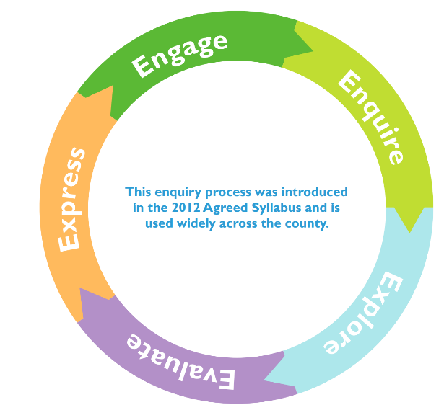

2. Enquire

Explore in this session the concepts behind each Christian celebration and how the community may come together for different reasons. The concepts of Incarnation (Christmas), Salvation (Easter), Thankfulness for creation (Harvest) are the key themes to explore.

RE:quest resources to support this are:

What do Christian’s do to celebrate Jesus birth? <https://request.org.uk/resource/restart/2014/12/04/what-do-christians-do-at-christmas/>

Easter pairs game and why Easter is important to Christians? <https://request.org.uk/resource/restart/2016/02/03/the-easter-story-pairs-game/>

Harvest Festivals

<https://request.org.uk/resource/festivals/other-festivals/harvest/>

For each Christian celebration use the response prompts to help the children make sense of what is happening.

4. Evaluate

Visit the local Church to find out how the local Christian community comes together at Christmas. Interview a church leader about importance of celebrations.

Children to help design a simple celebration in church – what would they want to celebrate? What would they include in the ceremony? What would happen and why? (This could be a mock Christening and would then prepare them for the Express stage of this learning enquiry.)

3. Explore

Look at the different artefacts and symbols connected to each of the Christian celebrations.

Baptism – the baptism candle, the holy water, the role of god parents. Use this website for support: <https://baptismforteachers.weebly.com/the-symbols.html>

Wedding – the rings, the vows, the wedding dress. Use this website to support: <https://www.learnreligions.com/christian-wedding-traditions-701948>

Christingle – the symbols of each element use this video: <https://request.org.uk/resource/restart/2017/11/17/christingle/>

Easter Gardens - <https://request.org.uk/resource/restart/2017/02/23/make-an-easter-garden/>

Can the children choose a celebration and design their own symbol and say what is represents?

Making sense of the celebration: Questions, feelings and responses…

|  |  |  |
| --- | --- | --- |
| **What do we notice in the video?**  **What are people doing?**  **Why do you think they are doing this?** | **How do you think the people feel in the video?**  **What might make them feel that way?** | **What do you want to know more about?** |
|  |  |  |