**RE Planning Cycle Template**

1. **Engage**

Session 1 - Look at peace symbols together, discussing what they mean.

Open discussion to see if children know anything about different religions beliefs in regard to peace.

Depending on the cohort/time available, children could be split into groups to research and feedback or work through each reference to peace and/or conflict:

Christian: Leviticus 19:18, Proverbs 20:3 and Christian: 1 Thessalonians 5:15

Islam: Qur’an 49:10 and 2:208 and Islam: Holy War

Discuss the contrasting views and differences even within a religion.

Discuss how different religions vary their focus on Outer (community) and Inner (yourself) peace.

How might this impact how someone lives their life?

**How and why does religion bring peace and conflict? Year 6 – Enquiry 1**

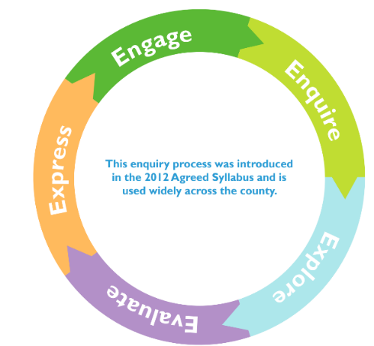

**2/3. Enquire and Explore**

Session 5 - Most Christians believe war should be avoided if possible and only undertaken if all other efforts to resolve an issue by peaceful means have failed. Many see war to be the result of a failure to live by God’s standards. Pacifists such as Quakers believe war is never the answer. Groups of Muslims, Christians etc interpret sacred texts differently and behave in order to encourage and promote peace.

Religion can often be a stronger force than material incentives: it is better at directing behaviour towards social betterment than laws or physical force.

Both Mahatma Ghandi and Martin Luther King Jr conducted non-violent protests based upon religious beliefs. Watch videos and discuss how were the problems resolved peacefully?

<https://www.youtube.com/watch?v=Nh3cncf2MP4>

<https://www.history.com/topics/black-history/martin-luther-king-jr#montgomery-bus-boycott>

Children could think about something they don’t agree with at school. Could they come up with and act out a peaceful protest?

Sum up by explaining that religion teaches tolerance for people of other races and religions. The 10 Commandments in the Bible are the basis of Western ethical and legal systems. Similarly, the 5 Pillars of Islam are the basis for most Muslims’ lifestyles.

**4. Evaluate**

Session 6: Evaluate how members of each religion express their desire for peace, e.g. through charity work, prayer, meditation, treating people/animals in a certain way, being missionaries. Children to research and then present about these.

Discussion/Debate about whether they promote peace or conflict? Is it always clear cut?

Explore and reflect on symbols of peace for different religions and within the world, e.g. peace sign, dove, crescent and star, swastika.

Children could circulate and comment. What do they make you think of and why? Do they promote peace?

**2/3. Enquire and Explore**

Session 2 – Recap the story of David and Goliath with Stories from the bible

<https://www.youtube.com/watch?v=p5AGo3yeHN8>

**or** https://youtu.be/mQa-GseMSI4

Recapping how with God’s help, David defeated Goliath, what do the children think about this when thinking about the Commandment – ‘Though shall not kill’?

Discuss common faith as rallying war cries through ‘Onward Christian Soldiers’ song -Christianity and ‘Allah Akbar’ (‘God is great:’ Muslim); also discuss the phrases ‘for God’s sake’ and ‘violence for peace.’

Discuss how religion can be used as a cover for the evil-hearted. Are the children aware of any incidents from the past and/or present where people have citied their religion as why they did something awful?

Session 3 – Explain that sadly many people have been hurt or even killed in the name of religion.

Using the Malala Fund website <https://malala.org/malalas-story> children to research/discuss Malala Yousafzai’s life, what happened to her and what she continues to achieve.

Discuss details of 9/11 and also in the 11-13th Century when Christianity was becoming powerful, Popes ordered Christian Crusaders to kill lots of Muslims in attempts to win control of Jerusalem (the ‘Holy Land’). These are called ‘holy’ wars.

Explain that it’s important not to group all people of one religious background under one bracket and judge a whole group of people by the actions of a few. Watch video about stereotypes. <https://youtu.be/I1N81MB3EWs0> Discuss the problems with stereotypes. Can the children relate this to different religions?

**2/3. Enquire and Explore**

Session 4

Explain that War is conflict between two or more sides.

Discuss Christian views on war *‘In the Old Testament it states on a few occasions that God encouraged people to go to war to defend themselves’* but also in the New Testament‘Jesus taught that people who followed peace would be rewarded in Heaven – “blessed are the peacemakers”

Discuss, how do wars start? (Land, power, money, religion etc.)

Recap and Explore further Christian Just War and Islam Holy War

Links could be made to wars covered in History e.g. American Civil War, World Wars, Vietnam War, Iraq War etc.

Sum up by explaining that religion can be caught up in these. Religion is not always deeply rooted in every conflict and is at risk of sometimes coming to obscure more deeply rooted causes and motivations.

**5. Express**

Session 7: Explore and discuss how religions are represented in the news, whether this is more from the perspective of peace or conflict.

Look at different news articles and what these mean about the religion, e.g. Malala Yousafzai returning home to where she was shot, Muslim women wearing kippahs to support Jewish women, Hindu priest carrying ‘untouchable’ into a temple.

Examples here:

<https://www.bbc.co.uk/news/world-asia-43603844>

<https://www.globalcitizen.org/en/content/germans-wear-kippahs-oppose-anti-semitism/>

<https://www.bbc.co.uk/news/world-asia-india-43807951>

Can the children write about how the news reports on religion and whether they promote peace or encourage conflict?

Could children re-write a section to inspire peace or conflict?