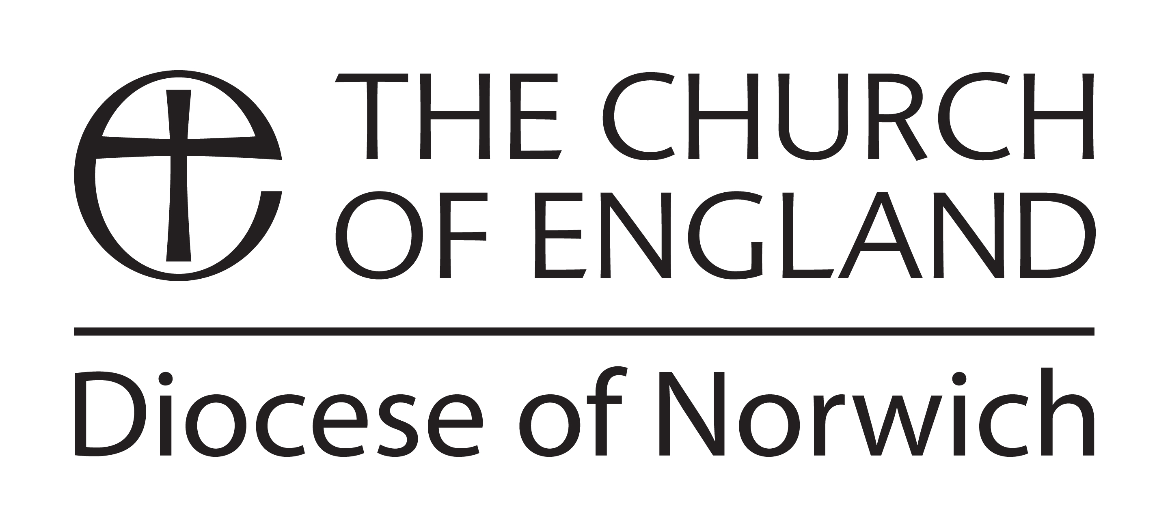
REGISTRATION FOR
CATHEDRAL CONFIRMATION SERVICES 2023

For Bishop’s Office use only:
Confirmation service number:

Saturday 30th March 2024 8.00pm (Deadline: 15th March 2024)

Presiding Bishop: Bishop of Norwich

From the Parish(es) of: …………………………………….………………………………………

In the Deanery of: …………………………………….………………………………………

Name of the person who will be presenting the candidates in the service and to whom information concerning the Confirmation will be sent:

(Please give full postal address including postcode, even if you think we know it!)
Name

Address
Incl. postcode

Phone

Mobile

Email

Please give the total number of Clergy and Lay Readers from your parish(es) who will be robing for the service: ………….

Please list the details of all candidates ON THE FOLLOWING PAGES

If necessary, please include with this form any information concerning mobility problems or disabilities that would be helpful to Cathedral staff.

Completed forms should be returned (by email or post) to:

liturgyandmusic@cathedral.org.uk

The Canon Precentor’s Office, 65 The Close, Norwich NR1 4DH

CANDIDATES AGED 18 YEARS & OVER

Please give FULL names and address (including postcode), underlining the name by which the candidate is known. | Age | Gender | Is the candidate  Baptised? | If not, will the candidate be presented for baptism at the Confirmation service? | For  Bishop’s office use only:  candidate number

CANDIDATES AGED 17 YEARS & YOUNGER*

Please give FULL names and address, including postcode, AND email address, underlining the name by which the candidate is known. | Date of birth | Gender | Is the candidate  baptised? | If not, will the candidate be presented for baptism at the Confirmation service? | For  Bishop’s office use only:  candidate number
Full name:

Address:

Postcode:

Email:

Full name:

Address:

Postcode:

Email:

Full name:

Address:

Postcode:

Email:

Full name:

Address:

Postcode:

Email:

*Please note that the candidate should be 10 years old or over. If younger than 10 years, please consult in writing with the relevant bishop, outlining why you feel the candidate should be confirmed at a younger age.
Contd/… CANDIDATES AGED 17 YEARS & YOUNGER*

Please give FULL names and address, including postcode, AND email address, underlining the name by which the candidate is known. | Date of birth | Gender | Is the candidate  baptised? | If not, will the candidate be presented for baptism at the Confirmation service? | For  Bishop’s office use only:  candidate number
Full name:

Address:

Postcode:

Email:

Full name:

Address:

Postcode:

Email:

Full name:

Address:

Postcode:

Email:

Full name:

Address:

Postcode:

Email:

*Please note that the candidate should be 10 years old or over. If younger than 10 years, please consult in writing with the relevant bishop, outlining why you feel the candidate should be confirmed at a younger age.

