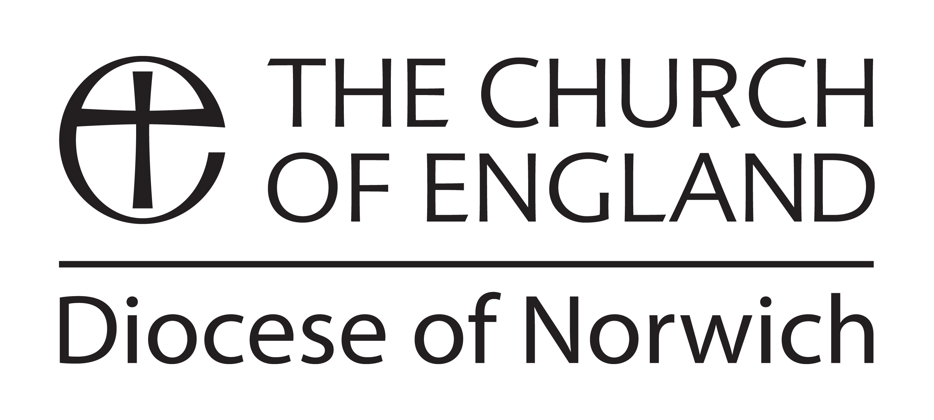

Guidelines for CMD Annual allowance

All licensed clergy and licensed lay workers are eligible to claim up to £450 over a three-year period (currently 2022-2024) to be used in consultation with the Director of Ministry for their own ministerial development.

(Curates in training are not eligible for this grant as their on-going development is covered and funded as part of the IME 4-7 programme.)

The allowance can be used to cover the cost of a retreat, training event, course or coaching.

The allowance may be added to a sabbatical\extended study leave grant of £600, therefore giving up to £1050 to use.

It is not intended that the allowance will cover the cost of travel. Applicants are asked to approach their parish\benefice or other place of ministry to cover this cost wherever possible.

For conferences or study courses where CMD has been billed directly, the cost will be deducted from an individual’s CMD Allowance.

At the end of the conference or course, the Continuing Ministerial Development Officer would be grateful to receive a brief evaluation of it and its helpfulness for on-going ministry.

To apply

Applications must be submitted, and agreement for CMD funding obtained, before attending courses and events. (NB: payments cannot be made retrospectively.)

An application form is available from the Ministry Team Administrator, Marleen Madinda (marleen.madinda@dioceseofnorwich.org or 01603 882338).

Keith James, Archdeacon of Norwich and Continuing Ministerial Development Officer, archdeacon.norwich@dioceseofnorwich.org
Diocesan House, 109 Dereham Road, Easton, Norwich NR9 5ES

[updated January 2023]

