The Bishop’s Lent Appeal 2024 - Bible Study
Introduction

In Lent we look forward to the coming of God’s Kingdom through the Easter story, remembering that the incarnate God sacrificed Himself on a cross to open the door of His Kingdom to us all. But we can only look forward to that kingdom if we really do accept that it is open to us all: rich and poor, young and old, advantaged and disadvantaged; and if we’re prepared to enter it together.

This course of five studies will help us to explore the themes of Lent through the lives and faith of the people of Papua New Guinea (PNG), particularly the Water of Life essential to ordinands and their families at Newton Theological College (NTC) in the Diocese of Popondetta, who, unlike their counterparts in the UK, have no access to piped water supplies and ‘mains’ sewerage facilities.

Due to the mountainous nature of Papua New Guinea all but very local travel is made by air and the limitations and expense of travel mean that students must live on-campus with their families. Family life is centred around the wind-house which is the coolest way to spend the day but sleeping accommodation and toilet facilities are provided in small chalets.
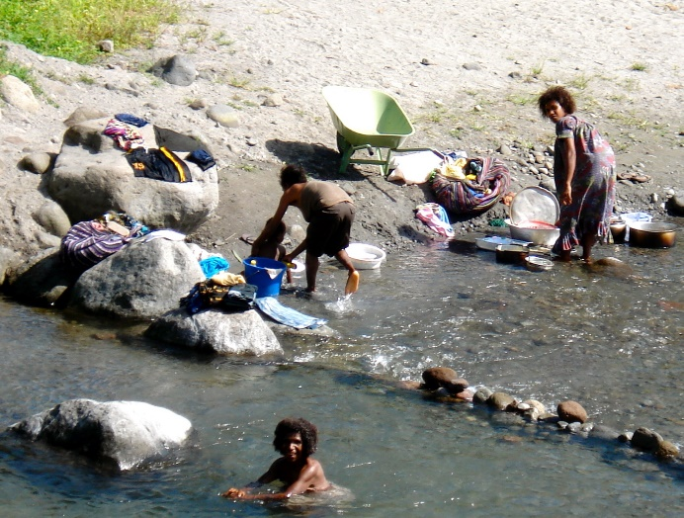
Most of the student houses at Newton College need refurbishment and nearly all need significant repair, but the primary need is to provide them with clean water from rainwater tanks and to reconnect toilets to septic tanks. The sinking of a new bore earlier in 2023 will also supplement the surface water provision.

It will cost around 2,000 PNG Kina (PGK) (around £400) to install a water tank between every two student houses and the 2024 Bishop’s Lent Appeal aims to raise enough to provide twenty-five tanks between fifty student homes.
Figure 1 Village women washing clothes, cooking utensils and themselves in the river near Newton Theological College

The Bishop of Norwich, Graham Usher, writes: “Your donations and fundraising will enable ordinands and their families to thrive, so supporting the next generation of Christian leaders in Papua New Guinea to have the best possible start with their training.”

These five sessions have been prepared by members of the Norwich Diocesan PNG Link Group:

The Revd Phil Charlesworth, Executive Officer and Acting Chair visited PNG in 2009, 2015 and 2023
The Revd Sue Martin, visited PNG as part of a three-nation pilgrimage in 2015
The Revd Sally Theakston, visited PNG as part of a three-nation pilgrimage in 2015

The Revd Lynn Fry, with her husband, Tony, spent three years in PNG working alongside Papuans

You can explore some background material on Papua New Guinea from the Diocesan website at:
https://dofn.org/lent
You can find some general background on PNG at:
http://en.wikipedia.org/wiki/Papua_New_Guinea
The Bible studies for this year’s Lent Project are:
Session 1) Wantok na Wanlain: Many Languages, One Family;
Session 2) Water Use in PNG;
Session 3) Laip Bilong Meri: Women’s Roles in PNG;
Session 4) Children in PNG;
Session 5) The Body of Christ in PNG

You might want to include an act of worship in your own sessions; at the beginning, to divide the session into two periods or as a closing liturgy. Below is a suggested act of worship.

Act of Worship
Some reflective music may be played
This is love, not that we loved God,
but that he loved us and sent his Son.
He is the sacrifice for our sins,
that we might live through him.
If God loves us so much
we ought to love one another.
If we love one another
God lives in us.
Prayers of Penitence
The sacrifice of God is a broken spirit;
a broken and contrite heart God will not despise.
Let us come to the Lord, who is full of compassion,
and acknowledge our transgressions in penitence and faith.
We confess to you our selfishness and lack of love: fill us with your Spirit.
Lord, have mercy. Lord, have mercy.
We confess to you our fear and failure in sharing our faith: fill us with your Spirit.
Christ, have mercy. Christ, have mercy.
We confess to you our stubbornness and lack of trust: fill us with your Spirit.
Lord, have mercy. Lord, have mercy.
May the Father of all mercies
cleanse us from our sins,
and restore us in his image
to the praise and glory of his name,
through Jesus Christ our Lord. Amen.
Reading
Prayers of Intercession
Gracious God, fountain of all wisdom, we pray for all Christian people;
for our bishops Graham, Ian and Jane, for our link Province of Papua New Guinea, for all Christian leaders, and for those who teach and guard the faith …
May the word of Christ dwell richly in our hearts and knit us together in the bond of your love.
Hear us. Hear us, good Lord.
We pray for the leaders of the nations, and for those in authority under them …
Give them the gift of your wisdom, and a right discernment in all things.
Hear us. Hear us, good Lord.
We pray for our … (city/town/village/community);
for those who live and work here, and for those who visit this place …
Speak your word of peace in our midst, and help us to serve one another as Christ has served us.
Hear us. Hear us, good Lord.

We pray for those who do not believe, and yet who long to know you, the very Word of life …
Open their ears to hear your voice and open their hearts to the knowledge of your love in Christ.
Hear us. Hear us, good Lord.
We pray for those bowed down with grief, fear or sickness, especially …
May your living Word bring comfort and healing to all those in need.
Hear us. Hear us, good Lord.
We give thanks for all those who have died in the faith of Christ …
and we rejoice with [N and] all your saints, trusting in the promise of your word fulfilled. Lord of life, hear our prayer, and make us one in heart and mind to serve you with joy for ever. Amen.
Open prayer may be offered and silence is kept
The Lord’s Prayer
Trusting in the compassion of God, as our Saviour taught us, so we pray
Our Father in heaven, hallowed be your name,
your kingdom come, your will be done,
on earth as in heaven.
Give us today our daily bread.
Forgive us our sins, as we forgive those who sin against us.
Lead us not into temptation, but deliver us from evil.
For the kingdom, the power, and the glory are yours
now and for ever. Amen.
Draw your Church together, O God,
into one great company of disciples,
together following our Lord Jesus Christ
into every walk of life,
together serving him in his mission to the world,
and together witnessing to his love
on every continent and island. Amen.

Session 1) Planti Toktok – Wantok na Wanlain
Many Languages – One Language and One Family
by the Revd Phil Charlesworth

Read Acts 2:7-11

Papua New Guinea has over 800 distinct languages for a population of only seven million people. To communicate with someone from another village or region Papua New Guineans need to speak a shared language other than their own. English has become the language of education, but Pidgin is the language of the marketplace. Pidgin is a useful common tongue; it puts strangers on an equal footing, but many subtleties of meaning are lost. Love of family, enjoyment of food, appreciation of music or beauty must all be expressed with one word – laikim (to like).
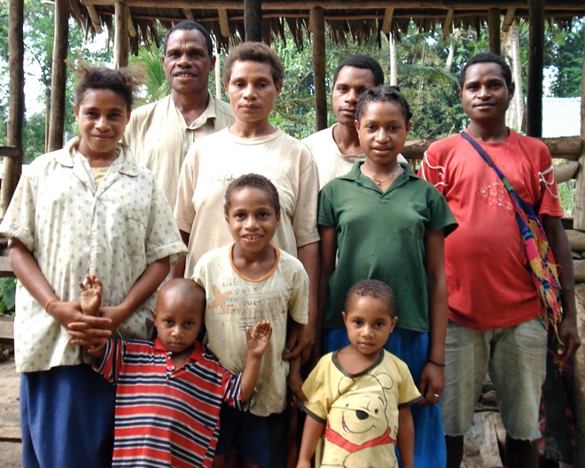
A big challenge for the Church is to find ways of expressing ideas such as, for example, Love of God, Mercy and Compassion, in a way that all may understand, despite limitations of their shared vocabulary.
Figure 2 An ordinand with his family at Newton Theological College

There are other problems of translation too. How can we express such ideas as that of the Good Shepherd, the Lamb of God, and the Lost Sheep, for people who have never seen a sheep? How can we express the concept of a New Jerusalem for people who have lived their whole lives in a remote village in the New Guinea Highlands or the deep jungle? After all, even for people living in modern Britain, some Biblical images feel very foreign (e.g., Temple, Sacrifice, Great High Priest).

The Church must act as interpreter if a people of many languages is to hear the Gospel clearly.

A Christian man, who spoke no Pidgin, once heard a priest reading from a newly translated Hiri Motu Bible for the first time. He was profoundly moved. After a long silence he said, “Now I understand. Jesus is not a foreigner. He speaks my language.”

Think about our understanding of family, nuclear, extended and the Body of Christ.

- Who is my brother? Who is my sister?
- What does it mean to belong to the same family?
- What freedoms and obligations do we have towards members of our Church, our parish, the wider community?
- Who do we include in our own “wantok group”/family?
- Who do we exclude?

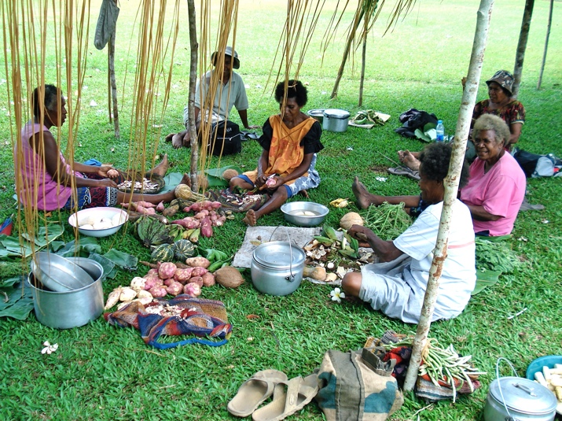
The Papua New Guinea way is to live in extended family networks. Indeed, it is usually the case that most, if not all, of the people in a village are related to one another, if not directly then by marriage. There are no tribes in the real sense of the word. People are bound together by the sharing of a language (wantok) and the family tie (wanlain). In-laws are very important and must be shown great respect and this includes first and second cousins-in-law, uncles and aunts of the spouse and all their relations. It can get very complicated!
Figure 3 Village women preparing the evening meal

Someone will be introduced as “my wantok”, and this means a person important to me because we share the same language, come from the same place. Being someone’s wantok creates an important bond and imposes special responsibilities. A person can expect a wantok to help, regardless of the cost, but must also give help to a wantok when it is asked for. A wantok is not chosen, as a friend might be, but is automatically connected with us by language and place of origin, just as families are.

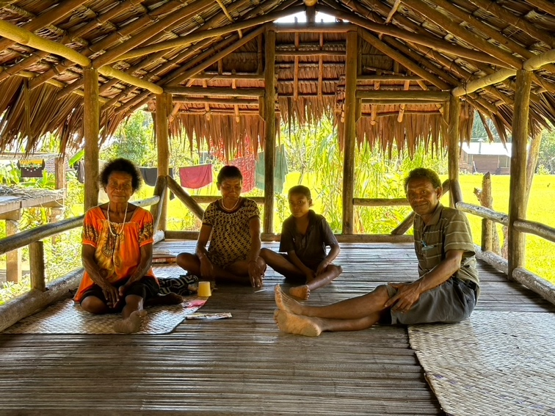
If we have made a friend, we may promote them to the status of wantok. Even when that person was not from the same place, we may choose to treat them AS IF they were. This is a great gift to confer because it means that friend has become someone who has the right to demand our help and the responsibility to give it when asked. When a foreigner is called “wantok” it is a great honour because it means that he or she has been accepted as more than just a friend. Some missionaries have been given that privilege.
Figure 4 An ordinand and his family in their 'wind house'

When a Papua New Guinean is far from home they will look for their “wantoks”, and for Christians the local Church Community will become the main “wantok group” regardless of differences of language and place. One will sometimes hear it said, “Oh, you are an Anglican. So am I. Where are you sleeping? Have you eaten?”

Think about the different groups with whom we need to communicate the Gospel, e.g., Young and Old, Male and Female, Church and Secular Society, Believer and Non-believer, Christians and Other Faiths.

- How do we speak to people different from ourselves?
- How do we learn the right language to use?
- What problems do we have translating the Gospel for our own time and place?
- How did Jesus communicate with other people, e.g., the poor, the outcast, the religious, the tax collectors, prostitutes and fishermen?

Session 2) Water Use in PNG
by the Revd Canon Sally Theakston

There are over 300 references to water in the Bible.

- Each person is invited to share the biblical mention of water which comes first to their mind.
Within the Bible water is seen in many different ways, including as the cause of destruction, as an agent of cleansing or as a symbol of spiritual thirst.
- Think of verses which demonstrate the different ways in which water is portrayed.
Read Isaiah 35:1-7

The desert and the parched land will be glad;
the wilderness will rejoice and blossom.
Like the crocus, ² it will burst into bloom;
it will rejoice greatly and shout for joy.
The glory of Lebanon will be given to it,
the splendour of Carmel and Sharon;
they will see the glory of the Lord,
the splendour of our God.
³ Strengthen the feeble hands,
steady the knees that give way;
⁴ say to those with fearful hearts,
“Be strong, do not fear;
your God will come,
he will come with vengeance;
with divine retribution
he will come to save you.”
⁵ Then will the eyes of the blind be opened
and the ears of the deaf unstopped.
⁶ Then will the lame leap like a deer,
and the mute tongue shout for joy.
Water will gush forth in the wilderness
and streams in the desert.
⁷ The burning sand will become a pool,
the thirsty ground bubbling springs.
In the haunts where jackals once lay,
grass and reeds and papyrus will grow.

- Share any images you have of desert lands or your experience of travelling within a desert.
- What made the desert joyful in the Bible reading and how could this be observed.

Unlike the lands of the Bible, Papua New Guinea has one of the wettest climates in the world. Annual rainfall in many areas exceeds 2,500mm with the heaviest events occurring in the highlands. Nevertheless, PNG faces extremely high vulnerabilities concerning water.

Much of the rural population lives in remote communities struggling with lack of clean water and sanitation, and many have difficulty maintaining basic hygiene practices. The Government’s WASH Policy 2015-2030 (Water, Sanitation and Hygiene) indicated that 89 per cent of people in urban areas and just 33 percent in rural areas had access to safe water. Only 57 percent of urban dwellers and 13 percent of the rural population had access to basic sanitation. 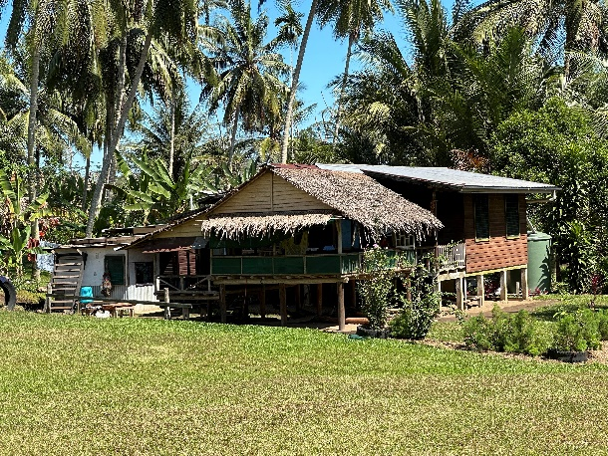 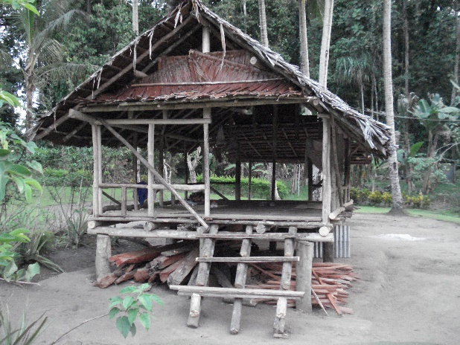
PNG is one of the most disaster-prone countries in the region, with frequent cyclones and flooding events that damage and destroy infrastructure and crops. Waterborne diseases are rampant because the majority of the country’s rural population has drinking unsafe water. UNICEF reports that whilst PNG has made progress in improving access to clean water and sanitation facilities, there is still much work to be done. The population of around 8.5 million people are amongst those with the least access to a safe water supply in the world.
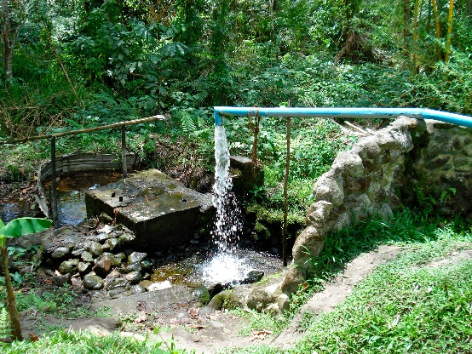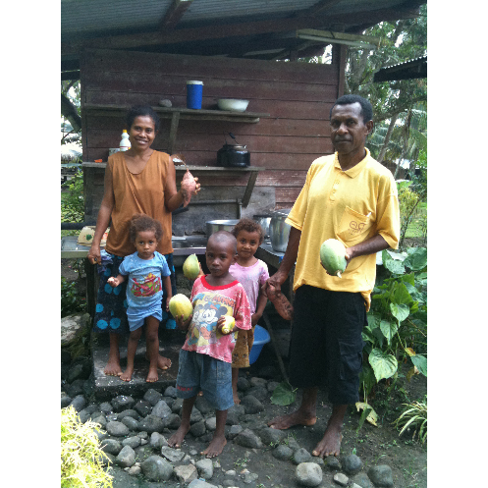
Read Exodus 17:1-4
The whole Israelite community set out from the Desert of Sin, traveling from place to place as the Lord commanded. They camped at Rephidim, but there was no water for the people to drink. ² So they quarrelled with Moses and said, “Give us water to drink.”
Moses replied, “Why do you quarrel with me? Why do you put the Lord to the test?”
³ But the people were thirsty for water there, and they grumbled against Moses. They said, “Why did you bring us up out of Egypt to make us and our children and livestock die of thirst?”
⁴ Then Moses cried out to the Lord, “What am I to do with these people? They are almost ready to stone me.”

- What word or phrase most caught your attention in the passage and why?
- Can you think of occasions when our church communities behave in a similar way?
This year the Bishop’s Lent Appeal is focussed on providing students training for ordination at Newton College, together with their families, with a supply of clean water from rainwater tanks and adequate sanitation by reconnecting toilets to septic tanks. In the UK, we are among the 2 out of 3 people on the planet who have access to safe clean water.

Think about the significance of water in your own life:
- Talk about when were you the last thirsty and what this felt like.
- In what ways have you used water over the past week.
What could you do to cut down on your use of water.

Jesus says, “Everyone who drinks of this water will be thirsty again, but whoever drinks of the water that I will give will never be thirsty again.”
- Commit yourself to praying for the life and work of Newton College, its students and their families.

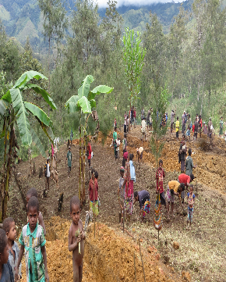

Session 3) Laip Bilong Meri - Women’s’ roles in PNG
By the Revd Lynn Fry

Read Galatians 3:26-29

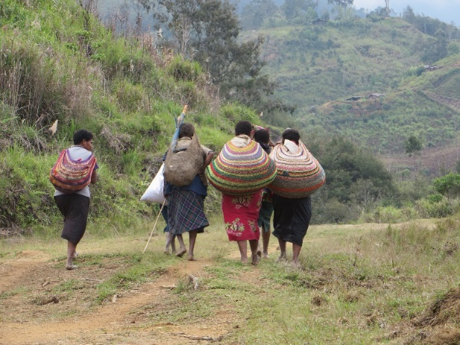
Papua New Guinea has a wonderfully rich cultural life based around the values of the tribe and the family. No-one is left out. When you arrive in a village, you are treated as one of the family. There is a ‘Melanesian’ way. In the Highlands, we experienced traditional gender roles. Women run households. They do all the cooking but not when a pig is involved – on feast days the men slaughter and cook the pig – a bit like the men on the barbecue at home! While holding on to the strength of their traditional cultures, there is an acknowledgement that they need to change and adapt.

What you see and experience is played out in statistics on equality. On the United Nations Gender Equality Index PNG is 143rd out of 162 countries. Bride-price is still used in many parts of the country where compensation is paid to the wife’s family for the loss of a family member in their household. Perceptions of bride-price are used to commodify marriage supporting the idea that a man buys a wife.
There are law and order issues in PNG affecting everyone. UNICEF data states that 43% of women between the ages of 15 to 19 in PNG have experienced physical or sexual violence. Human Rights Watch found that police rarely investigate or pursue criminal charges against perpetrators.

It is also a dangerous place to have a child. In the UK the maternal mortality rate is around 9 women per 100,00 births. In Papua New Guinea it is 215.

Gender-based violence (GBV) is still a major issue for the world. There is GBV in the Bible too but we don’t hear about it in church. The rapes of Dinah, Tamar and the Levite’s concubine are, not surprisingly, not in our Sunday lectionary. But there are other stories of violence that are.
- What do you do with Bible passages that make you feel uncomfortable? Should they be read in church?
- Have you listened to young people in your own communities about gender based violence? Do you think your church is a safe and open space? How can this be enhanced?

I found it delightful to be in a community of women – walking to the river and washing together was a highlight. Strong, compassionate, inclusive and inquisitive. We shared experiences of our life together. While they envied my freedom in the UK, I flourished in their sisterhood.

Many of the women longed for education. Funding from the Norwich Link helped us to buy equipment to set up a training kitchen and a café. It became a training base for women who walked for hours each day to come to class. When we started the Business Studies course, several women joined the class much to the amusement of the men. But respect was built as they proved themselves capable students.
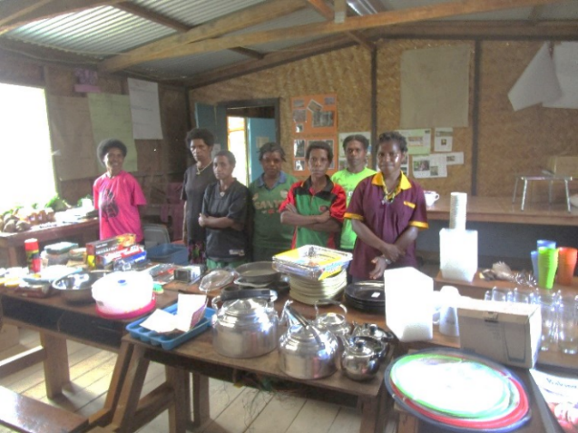
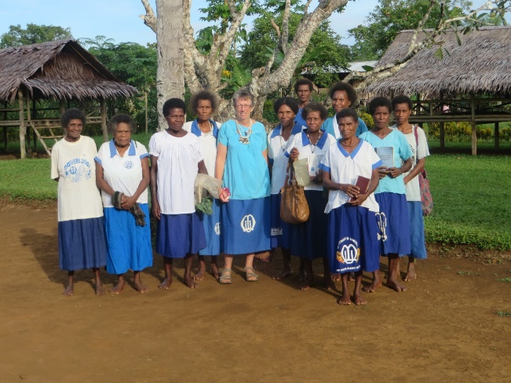
The Mothers Union is a powerful institution in PNG, with influence, where women can flourish. Together they implement programs in literacy and numeracy, health education and supporting small business development.

As Newton Theological College develops to become a training institution for theology, teaching and nursing, it will become a place that has an equal number of male and female students. While women cannot be trained for ordination, the ordinands’ wives are encouraged to attend as many classes as they wish and receive certificates for their work.

It takes courage to step out of traditionally assigned roles. There are stories in the Bible that can help. Abigail (1 Samuel 25) saved her family from a rash decision of her husband. The Hebrew midwives (Exodus 1:15-19) disobeyed the law to kill all Hebrew boys. Mary stopped working in the kitchen so that she could listen to Jesus (Luke 10:38-42).
- Which less well known women in the Bible inspire or resource you?
- Can you hear the voice of women in the Bible?
- Jesus challenged and questioned cultural norms. How does this inspire us?

The kingdom of God is an inclusive place. In it, we rise above all that separates us.
- How can we become more inclusive communities?
- Do we recognise how we exclude others?
- How can we nurture and encourage the gifts of others?

The Magnificat promises a different kind of community. Read it slowly, phrase by phrase (The Voice)

My soul lifts up the Lord! My spirit celebrates God, my Liberator!
For though I am God’s humble servant, God has noticed me.
Now and forever, I will be considered blessed by all generations.
For the Mighty One has done great things for me; holy is God’s name!
From generation to generation,
God’s loving kindness endures
for those who revere Him.
God’s arm has accomplished mighty deeds.
The proud in mind and heart God has sent away in disarray.
The rulers from their high positions of power
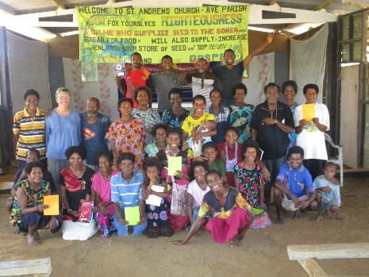
God has brought down low.
And those who were humble and lowly,
God has elevated with dignity.
The hungry— God has filled with fine food.
The rich— God has dismissed with nothing in their hands.
To Israel, God’s servant, God has given help,
As promised to our ancestors,
remembering Abraham and his descendants in mercy forever

- Which phrase resonated with you? Ponder its meaning for you.

Session 4) Children in PNG - The Future of PNG
By the Revd Sue Martin

Children and young people are the life blood for any community in Papua New Guinea. They are the future of the country and of each individual tribe. They are valued and cherished by parents and the wider family. In the rural areas, which still make up most of the people in Papua New Guinea, they are cared for as best as the local community can provide.

Health and education are a lifeline and provide the needs for children as they grow and develop. In our developed world we take for granted the rights for all children to be educated and to have access to good healthcare.

The communities I visited during a pilgrimage in 2015 with the Diocese of Norwich, all saw primary education as a way forward for their children.

The United Nations Convention on the Rights of the Child, article 28, states that ‘ Every child has the right to an education’
https://www.unicef.org.uk/what-we-do/un-convention-child-rights/

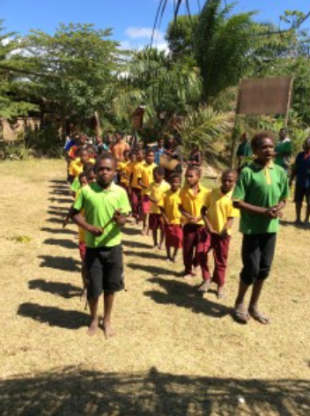
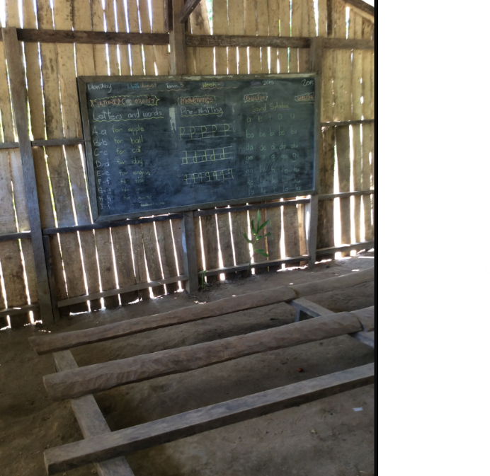

Children make up nearly half of the country’s mainly rural population and, despite many efforts, persistent poverty remains in rural areas where at least 85% of the population live. There are some benefits in living in an isolated village in the rainforest or the highlands, and the South Pacific coastline holds a wealth of marine creatures and miles of beautiful beaches. However, in today’s world, the influence of a modern lifestyle is not far away. Young people have access to social media and IT communications in many places in Papua New Guinea.

Only 35% of children complete primary education and there are no government schemes for Early Years Education or childcare. It is a very different way of life to the UK. Although there are comparisons with our rural areas, a sense of isolation with benefits and problems was also felt in Norfolk a few generations previously.

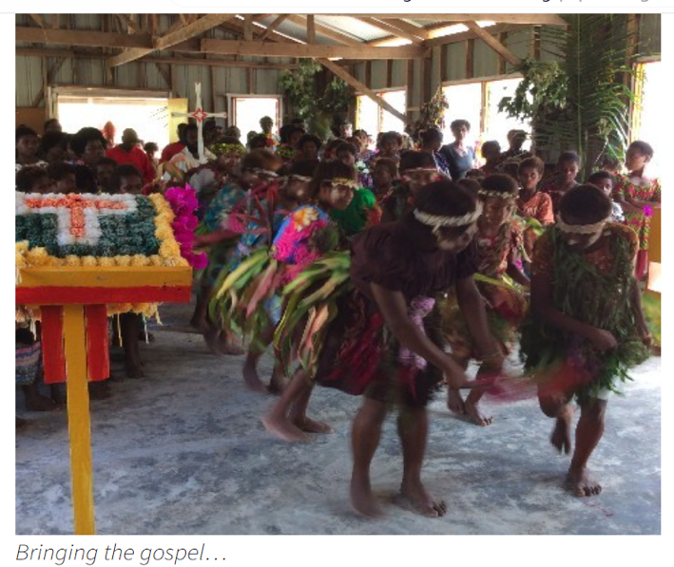
The correlation with access to healthcare is also significant. Immunisation is only taken by 60% of the population and during Covid there were many areas where vaccinations just did not happen because of lack of education and fear. Malnutrition is also a large problem, despite the climate and vegetation providing a wonderful growing environment, almost half of children aged 6-59 months have stunted growth. Many of these facts and more can be found at Unicef in Papua New Guinea.

https://www.unicef.org/png/children-papua-new-guinea

Other world organisations are also closely involved such as The Global Partnership in Education.
https://www.unicef.org/png/children-papua-new-guinea

The Anglican Church in Papua New Guinea is a strong faith-led group where mission and ministry are fundamental to their success, with over 90% of the population going to church each week. Along with the Mothers Union they wonderfully support communities in all areas and especially for children.

Newton Theological College is crucial to the training and sending out of both clergy, wives and families into communities. The college has some wonderful grounds and some facilities, but the water situation is very difficult.

We are aiming to raise money to give a constant water supply to as many of the living units as possible. This will have a follow-on effect to enable the new clergy and families to be in a good position going forward into ministry, which will bring benefits to the children in communities in which they serve.

The Bible has many passages which can support our understanding about children, communities and neighbours, and love.

‘These commandments that I give you today are to be on your heart. Impress them on your children. Talk about them when you sit at home and when you walk along the road, when you lie down and when you get up.’ Deuteronomy 6:7

Then people brought little children to Jesus for him to place his hands on them and pray for them. But the disciples rebuked them. Jesus said, “Let the little children come to me, and do not hinder them, for the kingdom of heaven belongs to such as these.” Matthew 19:13-14

Love the Lord your God with all your heart and with all your soul and with all your mind and with all you strength.’ The second is this: ‘Love your neighbor as yourself. There is no commandment greater than these. Mark 12:31

Thoughts and Reflection questions

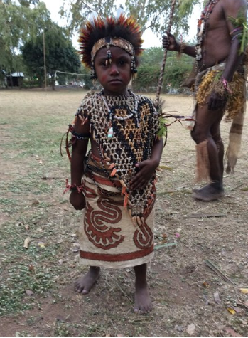
- In the Old Testament families and children are an important part of the understanding from God. Which other figures can you remember that we know as children in the Old Testament and how important does God make them?

- In Matthew Chapter 19:14 Jesus welcome the children to him. Do we always welcome children to ourselves and to the church?

- In Matthew Chapter 12:19 Jesus says that the kingdom of heaven belongs to children. How can we learn from the things children say and do?

- In Mark Chapter 12 one of the scribes calls Jesus ‘teacher’. Think about your own childhood and a teacher who was an important part of your own education.

- In Mark Chapter 12:31, Jesus asks us all to love our neighbour as ourselves. How can we help a neighbour on the other side of the world?

Session 5) Our Interconnected World, All Members of One Body
The Body of Christ in PNG
By the Revd Lynn Fry

Read 1 Corinthians 12:12–27

In the Body of Christ, we are all connected. Brothers and sisters from lands we will never visit are as much part of our family as our neighbours on our street. St Francis was one of the first to talk of our brothers and sisters as other than humans. In his Canticle of the Creatures he speaks of the moon and the stars, fire and earth as part of our family. In this time of climate emergency, we are called to widen our care for each other to care for the smallest insect and the unnoticed flower – all parts of our interconnected world. Bishop Graham has said “Christians are called to be a people of hope; to live in harmony with our world; to treasure God’s creation and to love our global neighbours.”

They say that the closer you are to the soil, the more likely that it is that your life will be impacted by climate change. Where we lived in Simbai in the mountains in Papua New Guinea, the vast majority of people were subsistence farmers. Their diet consisted mainly of kaukau (a starchy type of sweet potato) and greens, with pork a rare treat on festival days. When the planes stopped coming to the airstrip, Tony and I were seriously concerned about what we would eat. I would go the market each day, hoping to find some vegetables or eggs, but mostly it would be small kaukau and bush greens. The Simbai people had a saying – you put your hands in the soil in the morning and you have food to put on the fire at night. It was a precarious life. They were very connected to their food gardens. Whole families of 20 to 30 of all ages go together to plant kaukau for the next year. They knew the patterns of the seasons. One teacher said ‘it is time to plant the beans when the sun rises between those 2 mountains’.
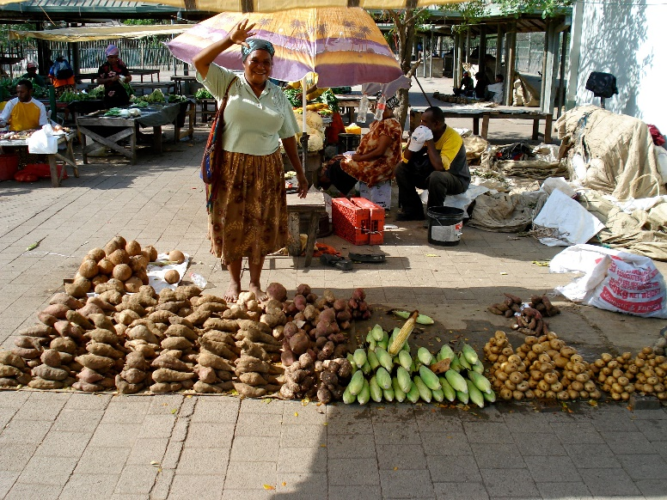

The students at Newton College and their families study in the mornings and in the afternoon they tend to their food gardens. It is their principal source of food. The first task they have when they arrive is to visit the piece of land they have been given and plant the three sisters: beans, corn and pumpkin which form much of their diet and that of many subsistence farmers around the world.

- How disconnected do you feel from food production?
- Do you know what foods are in season in the UK now?

Our friends on the coast had additional problems. The palm oil production further up the river seriously impacted their food production. Oil palms are planted in straight lines with nothing growing underneath for ease of collecting the palm nut. River banks that once were protected by natural vegetation are stripped bare and no longer work as flood protection. When the rains came the flood waters would sweep down the river washing away the food gardens planted on the rich soil close to the river. In addition, leakage of fertiliser, herbicides and pesticides had reduced much of the marine life limiting an important source of protein.
- When you buy things in the shop, how much attention do you pay to where it has come from and what is in it?
- Although they had very little, our friends shared what they had with generosity and joy. How difficult do we find it to share things we need for ourselves?

Some quotes from Laudate Deum, Pope Francis’ follow up to Laudate Si:
African bishops stated that climate change makes manifest “a tragic and striking example of structural sin”.
When human beings claim to take God’s place, they become their own worst enemies.

- When you read things like this, how does it make you feel?
- Where do you see your faith help you to think about climate change?
- What further steps can you take to improve your carbon footprint?

CANTICLE OF THE CREATURES, St Francis

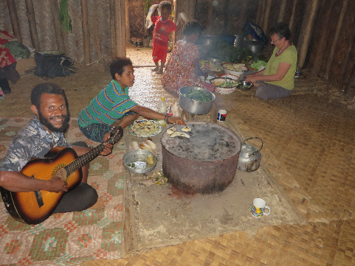
Most High, all-powerful, good Lord,
Yours are the praises, the glory, and the honour, and all blessing.
To You alone, Most High, do they belong,
and no human is worthy to mention Your name.
Praised be You, my Lord, with all Your creatures,
especially Brother Sun,
Who is the day and through whom You give us light.
And he is beautiful and radiant with great splendour;
and bears a likeness of You, Most High One.
Praised be You, my Lord, through Sister Moon and the stars,
in heaven You formed them clear and precious and beautiful.
Praised be You, my Lord, through Brother Wind,
and through the air, cloudy and serene, and every kind of weather,
through whom You give sustenance to Your creatures.
Praised be You, my Lord, through Sister Water,
who is very useful and humble and precious and chaste.
Praised be You, my Lord, through Brother Fire,
through whom You light the night,
and he is beautiful and playful and robust and strong.
Praised be You, my Lord, through our Sister Mother-Earth,
who sustains and governs us,
and who produces various fruit with coloured flowers and herbs.
Praised be You, my Lord, through those who give pardon for Your
love, and bear infirmity and tribulation.
Blessed are those who endure in peace
for by You, Most High, shall they be crowned.
Praised be You, my Lord, through our Sister Bodily-Death,
from whom no one living can escape.
Woe to those who die in mortal sin.
Blessed are those whom death will find in Your most holy will,
for the second death shall do them no harm.
Praise and bless my Lord and give Him thanks
and serve Him with great humility.

- Praised are you by all your creatures. How can we regain that attitude of praise to the natural word and all that is in it – human and non-human?

- As we approach Easter, we recall again the story of Jesus’ death on the cross and his bursting to life again. What stories of resurrection about Mother-Earth would you like to be able to tell?

With thanks to:
the Revd Phil Charlesworth, the Revd Sue Martin, the Revd Sally Theakston and the Revd Lynn Fry for writing the content for this Bible study and providing the pictures.

