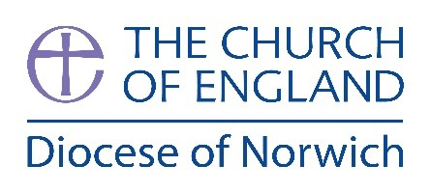

Net Zero Carbon Officer

Working hours: Full time, 35 hours per week (Consideration will be given to applicants wishing to work part time, ideally with a minimum of 28 hours per week.)
Hybrid Working may be considered (60% of working time to be undertaken at the Diocesan Office).
Contract: Initial 24 month fixed term contract
Salary: £35,000 - £40,000 per annum, subject to experience and qualifications
Benefits: Hybrid and flexible working schemes available, pension scheme with a 5% contribution by NDBF, in-service life cover, 25 days holiday, (rising to 28 days after 5 years continuous service) plus 3 fixed days at Christmas.

The Norwich Diocesan Board of Finance (NDBF) is working towards reaching Net Zero Carbon by 2030 and to incorporate sustainable working practices across all its operations. This includes churches, parsonage houses, churchyards and curtilage land and investment land and housing. A key aim will be to reduce the emissions from energy consumption year-on-year across the Diocese.

Role Duties
- To work within the Diocesan vision and strategy to achieve its Net Zero Target, identifying funding and outlining any anticipated developments and improvements necessary to deliver the strategy
- To have lead responsibility for coordinating work to implement the Diocesan Net Zero Carbon Action Plan partnering with colleagues from the Diocesan Board of Finance as well as the Multi Academy Trusts, Norwich Cathedral and TEIs.
- Review the building and land assets within the Diocese, and identify the sources of carbon emissions and develop a methodology for the collection of emissions data
- Respond to the growing number of inquiries and requests from clergy and parishes for guidance on Net Zero Carbon policy – including planning policy – working with colleagues in the Church Care and Development (DAC) team
Criteria
- Building services professional, relevant degree or professional qualification/s in heritage management, sustainability, or project management
- Proven practical experience in the management, development, and conservation of the built environment with a focus on sustainability
- An understanding of and commitment to working with a range of building types, including churches, halls, and clergy houses, to improve their energy efficiency and work towards Net Zero Carbon
- Knowledgeable and passionate about environmental issues and climate change

For more information, please visit the Net Zero Carbon website. The job description and further information on how to apply are available from the website. Completed application forms should be returned to jobs@chelmsford.anglican.org by Thursday 2 November.

Closing Date: Thursday 2 November
Interviews: Monday 13 November

Please be advised we reserve the right to close the role early and we cannot consider candidates who do not complete and return a completed application form.

Please refer to the relevant Eastern Region Diocesan Privacy Policies for guidance on how we will process your data.

The HR Team at the Diocese of Chelmsford are administering the recruitment processes for a number of Net Carbon Zero vacancies across the East of England Dioceses of the Church of England.

