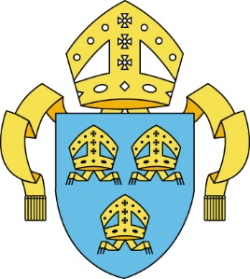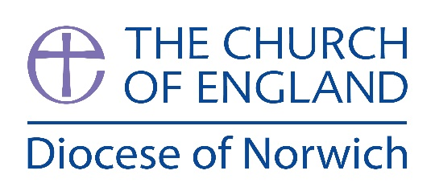
CONFIRMATIONS

Date of Service
Venue
Candidates from Parish/Benefice
Confirmed by Bishop
Form completed by
Ages | Number Confirmed
 | Males | Females | TOTAL
Under 12 years
12 - 15 years
16 - 19 years
20 and over
TOTAL
Please complete the above form within 2 weeks of the service.
The data collected is for:
The Church of England Research & Statistics
Please send the completed form to:
Brenna Wells, Bishop’s House, Norwich, NR3 1SB
brenna.wells@dioceseofnorwich.org

