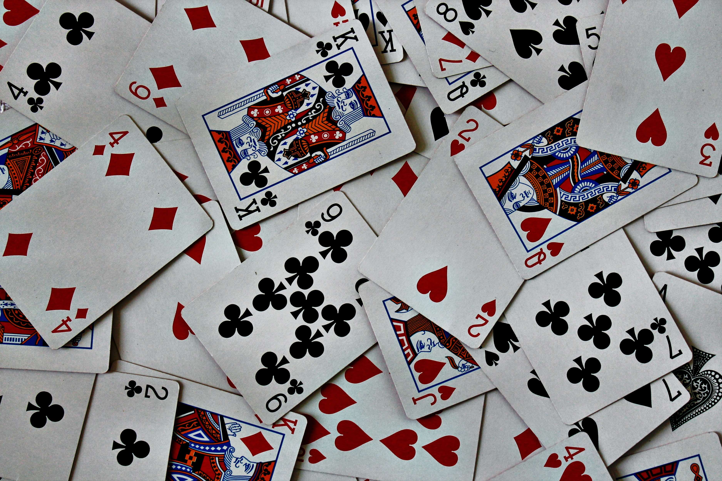

Know Cards
From Peter Worley's 40 Lessons to Get Children Thinking

Watch: https://bit.ly/2ZikFpb

Watch the video and pause it when you get to the first question:

Did you get it right? Let's imagine that you did get it right both times. Did you know where the black card was? Yes, not or are you unsure? Can you say why?

Unpause the video and watch until you get to the next question:
Someone says: “I don’t know where the back card is because it’s always a 50/50. It’s always a guess.” But what if there were two black cards in the video would you know where the black card was then?

Someone says: “I don’t think I know where the black card is because you might be lying about where it is.” Should we test this idea? Unpause the video to see the next scenario: Did you know where the black card is now?

Unpause the video and watch until you get to the next question: What about if you can see where I put the cards. Do you know where the black card is now?

Unpause the video and watch until the end. Can you know something 100% for sure?

Can you give an example of something you know 100% for certain?

