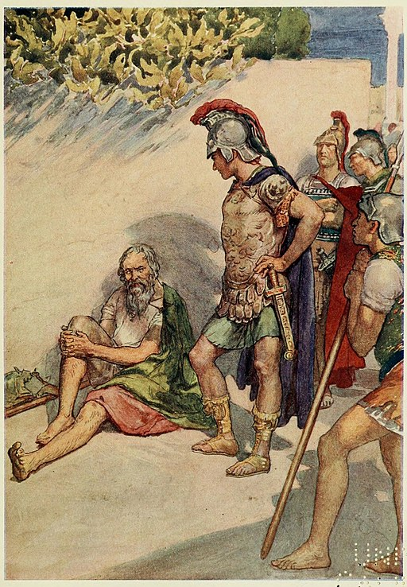

Listen to the story twice

A Dog’s Life

from Peter Worley's 40 Lessons to Get Children Thinking

Listen: https://bit.ly/2LhtMya

Have a listen to story above and then try to answer the following questions.

Starter Question: Why did Diogenes throw a party and give all his stuff away?

Diogenes gave all of his things away because…

Questions for thinking: Do you think Alexander is right to want to be like Diogenes? If you had to choose, would you be Alexander the Great or Diogenes the Cynic? Why?
I would choose to be…

Would you be happy if you had all of the things in the world that you had ever wanted? Can you explain why you would or wouldn’t be happy?

Let’s think about the opposite: Do you think you would be happy if you lived like Diogenes? With a just a cloak, a stick, a cup and a barrel?

Do you think that you would be happier with more stuff, or less stuff? Can you say why you would be happier?

