Religious Education and Worldviews

Knowledge Organiser to support the Norfolk Agreed Syllabus

Year Group: 5

Enquiry: 3

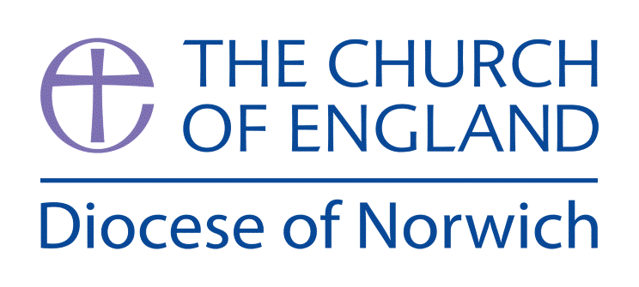

**What can we learn about the world/ knowledge/ meaning of life from the great philosophers?**

**(Intention) What we intend to cover in our learning: (Topic web of concepts here)**

Session 1: Examine the work of Socrates present in the work of Plato and the ‘Analogy of the Cave’ discussing the idea that true knowledge, for Plato/Socrates comes from some other place, a kind of heavenly realm where all true knowledge originates. The idea could be illustrated by creating a shadow puppet theatre to demonstrate how distorted ‘shadows’ can become and how they can be misinterpreted. Misunderstanding and ignorance are the only reasons for evil in the Socratic view of the world.

Session 2: Look at the similarities and differences between Plato’s eternal soul and that found in Christianity.

Session 3: Examine the idea of karma and reincarnation in Buddhism - a more complex examination might include the idea of ‘no soul’ found in Buddhism meaning that there is, essentially no ‘self’

Session 4: Look at the writings of Descartes and the concept of ‘Cartesian Doubt’, examine the idea that if ‘I’ can be deceived into thinking ‘I’ am sitting in my chair at home then ‘I’ must exist in order to be deceived. This runs directly counter to Buddhist teaching.

Session 5: Look at the concepts of punishment of the soul in Christianity (Hell and Heaven), Buddhism (Karma, Dharma and Nirvana) and the re-joining of the soul with that eternal truth described by Plato.

Session 6: Look back at the Analogy of the Cave and the idea of the Philosopher who comes back to tell everyone what he has discovered - draw parallels between this former cave-dwelling philosopher, Socrates, Siddhartha and Jesus. Watch <https://www.youtube.com/watch?v=69F7GhASOdM>

**(Implementation) Key words I will use and need to know:**

Corporeal Karma Reincarnation

Eternal Philosophers Soul

Incorporeal Philosophy Self

**(Implementation) Key information we will learn:**

* The ways different philosophers or religions understand abstract concepts, including varying views about the existence of the soul in classical Greek Philosophy.
* The complex nature of concepts such as truth, reality and identity found in Buddhism, Christianity and Plato.
* The work of one or two key philosophers such as Socrates/Plato and Descartes.
* Consideration of consequences of action in relation to karma.

**(Implementation) Things to do and find out at home:**

Learn about Socrates and what he has helped us to understand – watch the video [www.youtube.com/watch?v=7y8EC6QoNaY](http://www.youtube.com/watch?v=7y8EC6QoNaY) and make notes on who Socrates was.

Read about Plato here: <https://kids.britannica.com/kids/article/Plato/476303>

Read about Socrates here:

<https://kids.britannica.com/kids/article/Socrates/476319>

Read about Descartes here:

<https://kids.britannica.com/students/article/René-Descartes/273969>

**(Implementation) Some key information you can find more out about:**

* The ways different philosophers or religions understand abstract concepts, including varying views about the existence of the soul in classical Greek Philosophy, an introduction to this can be viewed at [www.theschooloflife.com/thebookoflife/what-is-philosophy-and-whats-it-for/](http://www.theschooloflife.com/thebookoflife/what-is-philosophy-and-whats-it-for/)
* The complex nature of concepts such as truth, reality and identity found in Buddhism, Christianity and Plato. You can explore some of these concepts at <https://ethics.org.au/ethics-explainer-platos-cave/> [www.theschooloflife.com/thebookoflife/know-yourself/](http://www.theschooloflife.com/thebookoflife/know-yourself/) [www.abdabrs.com/buddhism-beliefs-and-teachings.html](http://www.abdabrs.com/buddhism-beliefs-and-teachings.html) and
* The work of one or two key philosophers such as Socrates/Plato and Descartes. Explore Plato in this video [www.youtube.com/watch?v=VDiyQub6vpw](http://www.youtube.com/watch?v=VDiyQub6vpw)
* Consideration of consequences of action in relation to karma. Explore Karma in this video [www.youtube.com/watch?v=YMat0aJ-8fc](http://www.youtube.com/watch?v=YMat0aJ-8fc) and the consequences of actions here [www.bbc.co.uk/programmes/p02n5v2q](http://www.bbc.co.uk/programmes/p02n5v2q)

**(Impact) The RE Age Related Expectations we will cover and be assessed against:**

**Philosophy**

1. **The Nature of knowledge, meaning and existence** In verbal and written work explain why people including philosophers have different ways of understanding the concept of justice. E.g. using class discussion where they might try and define a concept
2. **How and whether things make sense** Use different pieces of evidence they have explored to form a conclusion about whether they believe in God or not.
3. **Issues of right and wrong, good and bad** Explain a range of answers to the question ‘is it possible for something to always be right?’ showing that there are many different opinions about this.

**(Impact) What we will aim to do at the end of our learning:**

By the end of our learning we will

* Explain some of the ways different philosophers or religions understand abstract concepts, including varying views about the existence of the soul in classical Greek Philosophy.
* Explain different philosophical and religious answers to questions about the world around them and the existence of the ‘self’ and or soul.
* Have an understanding of the Analogy of the Cave and what it says about existence and knowledge.
* Understand the relationship between the concept of a corporeal and incorporeal world.