RE Planning Cycle Template
Unit Focus/ Year Groups: Yr6 Enquiry 3
What does it mean to be human? Is being happy the greatest purpose in life?
- Engage
- Unpick the key vocab / happy/ purpose of life.
- Introduce the concepts of physical happiness and mental happiness by drawing around two people from the class – in one body shape ask pupils to write / draw all of the things that makes them physically happy e.g. food/ exercise/ exciting experiences etc. in the second body shape all of the things that might make people mentally happy – relationships, believing in God, memories of good times, confidence in who they are etc.
- Introduce that different people have different views on being happy – Christians believe that they have a soul and that they shouldn’t commit sin (ref to Adam and Eve – the Fall from God’s Grace) and they need to follow adhere to the 10 commandments, others e.g. Plato believed that we humans lived in two forms the physical body and the eternal soul – the physical body changes over time as does happiness but the eternal soul stays the same and we see a copy of the perfect form in our world. St Augustine saw it more linked and that good and evil exist in the world equally and we have to choose the right path to follow as this will affect what happens to us after death. Humanists do not believe in life after death so have a different view.

5. Express
- Watch the Stephen Fry video on humanists and happiness : How Can I be Happy? https://youtu.be/Y3wraQXSSjE
- Discuss the big questions from the start of the learning sequence, make notes on for / against arguments.
- Children offered a range of responses to the questions:
  - Complete the sheet: How might a Humanist respond?
  - Draw an info poster with the views of happiness from a Humanist / Christian viewpoint
  - Create a Venn diagram to show the similarities and difference between the views of happiness from a Humanist / Christian viewpoint
- OR – ask children to present an argument for the class debate on the big questions, either record the debate or produce photographs with post it note pupil comments. You may start with a poll of views at the start and then again at the end after the debate to see if views change.

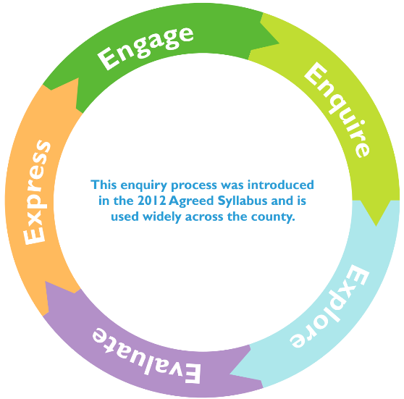
2. Enquire
- Warm up the children’s philosophical thinking by exploring the book: and use the resource sheet from Thought Adventures (Philosophy Foundation) Yr5 A Dog’s Life (Happiness) listen to the story first here: https://bit.ly/2LhtMya
- Watch the Humanist video What are the ingredients to being happy? https://youtu.be/AnHc_OcAEKY - do the children agree / disagree?
- Discuss the Christian view of being happy: children to speak to the local vicar about what it means to be happy as a Christian.
- What questions are raised for the children from hearing the Humanist / Christian perspectives on happiness – note these down to be explored.

4. Evaluate
- Explore the idea of Utilitarianism and being happy – use the webpage https://request.org.uk/resource/c03e9c14c5c74937aff9b6829e2d87/ that explains what this concept is.
- Explore and evaluate the concept of awe and wonder – use Wonder the Humanist Perspective (Dr Alice Roberts) to evaluate the Humanist worldview on happiness, compare this to the Christian view from Dr Wiseman about Creation (Taken from Understanding Christianity Unit2b.2 – resource sheet 4.
- Introduce the concept of Hedonism and the Hedonistic Calculus – how Jeremy Bentham created a way to calculate happiness by listing all of the pleasures on one side of a page and all of the pain it might cause on the other. If you subtract the pain from the happiness and there is more happiness left then it is the best source to use. Does this idea work with Christianity and sin? Or with Humanists choosing the best way to live from experience?
3. Explore
- Follow the Understanding Humanist Unit – The One Life (11+), explore the concepts of Humanists believe we have one life and we should make the most of it (mortality), having the capacity to make life meaningful without the need for God, pursuing happiness.
- Complete the tasks linked to Humanist approach to life (PPT) – pupils complete the Ingredients for Happiness Activity (7+) and Rivers of Life Activity (11+) and the Humanist philosopher Bertrand Russell.
- Compare this to the Christian belief of heaven, living life as a Christian – look, use the videos https://request.org.uk/resource/restart/2020/03/26/bible-quest-fall/ and https://request.org.uk/resource/986c7dd5fb8b2a8395f582195888af/

Essential Teacher Knowledge and Further Information:
Hedonism / Hedonistic Calculus – this can be a very adult concept and may seem frightening to teach primary children. However, if we stick tot eh basic principles that hedonism is an ethical aspect of philosophy that explore the idea of undertaking something or making a decision based on the pleasure it gives or provides. Hedonistic Calculus is merely the approach to determining if the amount of pleasure outweighs the possible pain it may cause to others and is there to help us think about the physical aspect of happiness and the mental / other worldly aspect of happiness (links to belief, sin, Christianity and Humanism).
The concept of Utilitarianism is linked to Jeremy Benjamin who did not think that God decided on what actions people take are good or bad. He though the Hedonistic Calculus of weighing up the pleasure / good over the pain/bad was the way people and animals lived their life. The desire to be happy and have pleasure and avoid pain driving human nature. This is also explored in a Christian context with resources from RE:quest as indicated in the planning.
The context of the purpose of life is explored in two strands the worldview of Humanists and the belief in their being only one life and death marked the end of it, therefore we should live our lives in the best way we can and to be the happiest we can for ourselves and other human beings. The second view is the Christian belief in God as the creator of all, that He created Adam & Eve who were tempted to sin and were cast out of the Garden of Eden, framing man’s fall from God’s grace. That Christian’s pursuit of happiness is to adhere to the teachings of God in the Bible, such as the Ten Commandments and that they consider (as did Plato) that not only is their physical happiness but also real happiness through their eternal soul that will ascend to heaven if they are good on earth. A range of resources from Understanding Humanism, Understanding Christianity and RE:quest explore and compare these worldviews.

Useful Reading:
- Collins World Religions KS3: Christianity
- Understanding Christianity UKS2 Unit 2B.2
- Collins Knowing Religions: KS3 Philosophy & Ethics
- Dorling Kindersley: The Philosophy Book p72/72 & 174

