RE Planning Cycle Template
Unit Focus/ Year Groups:
Yr5 Enquiry 3: What can we learn about the world/knowledge/ meaning of life from the great philosophers?
- Engage
- Unpack the enquiry question – make sure the children know what world / knowledge/ meaning of life / philosopher mean.
- Introduce the philosophers –Socrates Plato – watch the following videos to induct the children into who they are: www.youtube.com/watch?v=7y8EC6QoNaY (Socrates), www.youtube.com/watch?v=4Xoi873zOWw (Plato).
- Introduce the concept of Socrates – misunderstanding and ignorance led to evil / bad things. Link this this to the concept of knowledge – play Chinese whispers to demonstrate how a something can be easily distorted and become untrue.
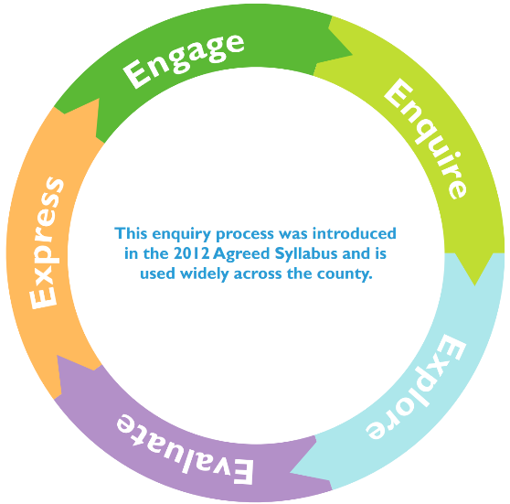
3. Explore
- Compare the Christian view of life after death to that of Buddhism and reincarnation. Consider the path to enlightenment, the four noble truths and the eightfold path (=Dharma). Each offer an answer to the meaning of life for Buddhists. www.bbc.co.uk/bitesize/topics/zh4mrj6/articles/zdbvjhv www.bbc.co.uk/bitesize/topics/zh4mrj6/articles/zvtxgwx
- Explore the idea of no self and no soul in Buddhism through the story of Kisagotami and the Mustard Seed (see notes). https://buddhiststories.wordpress.com/2012/11/03/kisa-gotami-and-the-mustard-seed/
4. Evaluate
- Explore that some people find it hard to believe in a supernatural power (God) and they question if it is real and the world / knowledge is real as a result. Use the Philosophy Foundation Thought Adventure Knowledge Resource and this video https://bit.ly/2ZikFpb.
- Compare the ideas from the knowledge task above with the faith Christians have in going to heaven and Buddhists have with reincarnation – also the idea of Heaven / Hell and Karma, Dharma and Nirvana. Why do they think these religions have such views? What does it tell them about the meaning of life for people of these religions? Create a Venn diagram to sort the beliefs and knowledge of the meaning of life.
2. Enquire
- Consider how Plato believed in two key ideas life was both physical and metaphysical – the eternal soul. How this links to Christianity and the concept of Salvation.
- Explore the stages of the cross from Understanding Christianity Unit 2B and use resource sheet 6 alongside images of the stations found at: www.catholictradition.org/Children/stations-cross.htm consider the belief of Christian’s that when you die you go to heaven.
- What questions about the world and the meaning of life does it raise for Christians?
5. Express
- Watch the video on Plato Cave https://youtu.be/69F7GhASOdM
- Discuss what it means for the prisoner in the cave and the experiences he has when he leaves of the world and what life might mean?
- How might the world look different if the prisoner had met a Christian? A Buddhist? What might he learn from them about their view of the purpose of the world? How might he describe it to the other prisoners in the cave? Can the children make a response to show the different views of the world and it’s meaning by:
  - Creating two different pictures of the world through the different religions eyes and the significance of it.
  - List the main points and similarities and differences.
  - Show how knowledge and belief can be the same but also different and explain that knowledge can be through experience as well as in writing by writing their own version of the cave story or creating a story board or cartoon strip.
Essential Teacher Knowledge and Further Information:
It can seem a daunting task to teach this unit – however the best advice it to keep it simple and stick to the basic concepts:
- Start with the two Greek Philosopher Socrates and Plato. Here it is important to begin to explore the concept of knowledge and how Socrates never recorded in writing his own knowledge and ideas, Plato his student recorded lots in the form of essays, stories and poems – we interpret these to determine the knowledge he had as well as the ideas he developed about the world.
- Use Plato as a bridge of his thinking of life in the physical but also spiritual sense (metaphysical) and his ide of the eternal soul sitting parallel to Christianity believing in a similar concept with the idea our soul will go to heaven after we die of we have lived a good and meaningful life physically on earth.
- Link from this concept the Christian concept of Salvation – which provides the Christian context of the meaning of life as a Christian. Following the stations of the cross provides the story and insight into this belief in biblical teachings.
- As a direct comparison is Buddhism and the view that there is no one self or soul but multiples hence the concept of reincarnation. The linear study of the path to enlightenment through the four nobles and eightfold path (forming the Dhrama) need considering- determining the Buddhist view of the meaning of life.
- Revisiting knowledge and belief at this point is useful and using the Knowledge thought adventure from the Philosophy Foundation will equip pupils with the concepts of knowledge and belief the connections but also the faith some have in what they belove without fact.
- Once knowledge, belief and faith have been understood it is useful to then draw learning together and make evaluative comparisons and differences before looking at how to express a response to the big enquiry question.

Useful reading:
- Collins KS3 World Religions : Buddhism
- Understanding Christianity UKS2 Unit 2B.6 – Salvation
- BBC Bitesize Fact File on Buddhism and associated videos
- BBC Northern Ireland Buddhism Facts KS3 /4

