**RE Planning Cycle Template**

Unit Focus/ Year Groups:

Yr4 – Enquiry 1: What do we mean by truth? Is Seeing Believing? (Multi/ Sikhism)

1. Engage

Introduce the Big Question – what do the children define to be true? Do we need evidence or belief? Watch the Humanist video of *What is truth?* (<https://youtu.be/ONZSKm7U_5g>) discuss how people who follow a religion have a belief not necessarily based on evidence, humanists base their knowledge based on evidence = truth. Introduce the concept that science is limited though and there are things it is not yet able to answer as it is still developing. Look at the questions activity that determines what science can and cannot answer: (<https://understandinghumanism.org.uk/wp-content/uploads/2021/10/Science-and-religion-questions-activity.pdf>) Introduce the concept of Axioms are a logical answer that is has no proof. Which of the questions can be answered using Axioms – often how a religion may be seen.

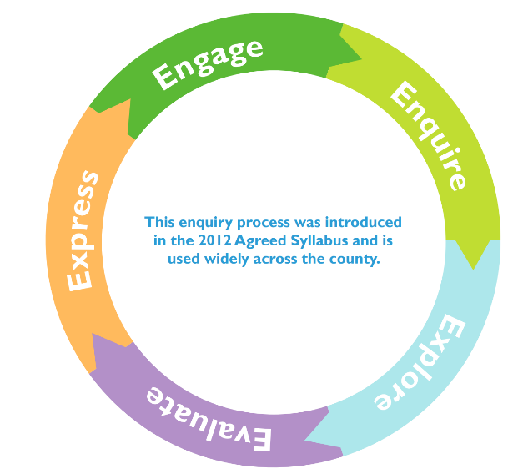

2. Enquire

Watch the video from TrueTube : <https://s3-eu-west-1.amazonaws.com/media.truetube.co.uk/TT1210/legacy.mp4> based on depending on the circumstances you are born in determines the beliefs you may have. That circumstances can create different views or opinions on how we live, interact and behave. Sometimes we ask questions that we don’t know where to find answers out.

Look at three images – what questions do they raise for the children? Do they know how and where they can find answers to them or are there no evidence based answers? Introduce the ideas of personal experience / authority/ instinct / science.

3. Explore

Explore the concept of beliefs and evidence further by using the activity: <https://understandinghumanism.org.uk/wp-content/uploads/2021/10/Beliefs-and-evidence.pdf> explore the introduced in Enquire session – truth or knowledge is based on four types of evidence personal experience / authority/ instinct / science.

Provide the class with a evidence scenario where they need to determine the best form of truth / evidence in a court case (use activity : <https://understandinghumanism.org.uk/wp-content/uploads/2021/10/The-Trial.pdf>) how did they determine the best form of evidence – did they al agree?

4. Evaluate

In this session we will consider the Christian perspective of God and the Sikhi. Look at the story of Creation from Genesis to see Christian’s believe God the Creator (use video <https://youtu.be/QJjzfXVdjGI> based on Genesis for Christianity) Look at the Sikhi concept of God as a never ending (BBC video [www.bbc.co.uk/bitesize/guides/znnmtv4/video](http://www.bbc.co.uk/bitesize/guides/znnmtv4/video) ).

What is similar and different about these two concepts of God? What forms of evidence would be used to form this belief? personal experience / authority/ instinct / science.

5. Express

Explore the concept of truth is present through forms – some is belief based (axioms) and some is evidence based (personal experience / authority/ instinct / science). Use elements of the PPT Understanding the World to revisit and discuss these concepts.

Provide the class with three statements and ask the children to decide how they might answer each one? What would they argue? Why? What evidence might they use from the learning sequence?

Ask the class to express their ideas in ways they feel most confident e.g. writing responses in the speech bubbles for each statement. Designing a poster, recording their explanation for each.

Finish the session with the idea of being curious, by wondering and asking questions by watching the Philip Pullman video: <https://youtu.be/LNhb6hXSxMY>