**RE Planning Cycle Template**

1. Engage

Watch the short video (2mins) that introduces children to what philosophy is: [www.youtube.com/watch?v=pZcDe5fHlv8](http://www.youtube.com/watch?v=pZcDe5fHlv8) Look at the word ‘philosophy’ and translate it from Greek to English (or other languages spoken in your setting) to see that it means ‘love of wisdom’.

Discuss the difference between knowledge and wisdom; by following the session plan from Philosophyinks website explore knowing and believing: <https://389b63a7-ab3d-4047-80f7-f828b2b645a6.filesusr.com/ugd/340eca_35759eb92850494ba712b1a32990af73.pdf>

Unit Focus/ Year Groups: (Yr3 Enquiry 3)

What is Philosophy? How do people make moral decisions?

(Christianity / Humanist)

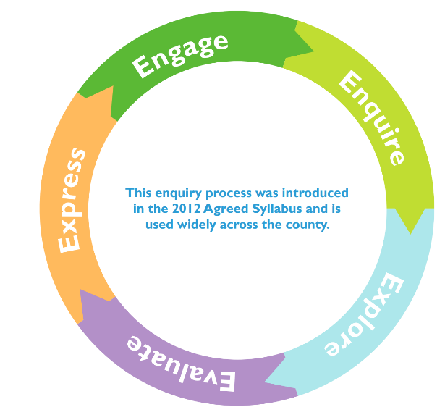

2. Enquire

Introduce the two ways of finding out something: empirical (physically observable) and theoretical (not reliant on physical evidence). Demonstrate this by looking at the PPT from Understanding Humanism – Understanding the world (slides 1-9 focus on curiosity, questions and evidence) access it here: <https://understandinghumanism.org.uk/wp-content/uploads/2021/11/Understanding-the-world-5.pptx>

Bring out a box with a question mark on it. Ask the children what could be in there and how they might find out. The children may say they could open the box and see, or weigh the box (empirical) or they may have a theory about what a teacher might put in a box (theoretical). You may want to use the categories ‘Knowing’ and ‘Believing’ instead. Can they prove their ideas? Is the concept of ‘belief’ actually relevant in this task? Can the children write a Tweet for an empirical or theoretical reason?

3. Explore

Start the session by considering how true an answer might be and how do we work this out – play the P4C How true is my answers? Game <https://p4c.com/future-truth/> Think about Christianity – the Bible is the source of authority – i.e. where the teachings of the beliefs for Christians come from. But this is a book of a collection of stories can we prove them? Or do Christians have a faith / trust and therefore believe? Look at the Gospels from the new testament and how these are the ‘teachings of life’ Christians follow. Look at the following parables as a double entry journal activity to work out their teachings: Good Samaritan / Hidden Treasure / Prodigal Son / Building on the Rock and Sand / Pharisee and Publican. (You could do this as a class activity – silent discussion).

Explore Humanists ethics – explore moral dilemmas, start with watching how humanists decide what is right and wrong by watching the short video by Stephen Fry <https://youtu.be/pZnDImejvj8> and complete the activity: <https://understandinghumanism.org.uk/wp-content/uploads/2021/10/Moral-dilemmas-5-7.pdf>

4. Evaluate

Explore the idea of morality coming from lessons learned in your own life or from history, look at the Humanist approach to morality to explore morality without the presence of a supernatural being. Look at what might be employed to make moral decisions. Watch a short video of Humanists explaining how they work out right and wrong: <https://youtu.be/nqsT04Uy4mA> undertake the moral dilemmas activity - <https://understandinghumanism.org.uk/wp-content/uploads/2021/10/Moral-dilemmas-11.pdf>

Compare this to what would happen if Christians introduce the idea of the new commandment of Jesus from John 13:34-35 ‘Love one another. As I have loved you, so you must love one another’. What would this mean in practise? Explore this idea as a basis for moral decisions. Does acting with love always lead to a good outcome? You may even want to talk about good intentions versus good outcomes. Can you apply this principle to the moral dilemmas explored through Humanism – does it change any of the outcomes? What is the same?

5. Express

Look at Aesop’s Fable – the Fox and the Stalk – watch the video here: <https://youtu.be/XsAcoXIGFcs>

Use this to explore the activity from Understanding Humanism- <https://understandinghumanism.org.uk/wp-content/uploads/2021/10/The-fox-and-the-stork.pdf>

Ask the children to choose a dilemma from the list provided and create a modern day Aesop’s fable / new Bible Parable. They can present this in a way they wish e.g. draw, write, act. They need to explain what they have included to illustrate and teach from and what the moral message is.