**RE Planning Cycle Template**

Unit Focus/ Year Groups: **Two Enquiry 5**

**Why do people have different views about the idea of God?**

*Ref UCP (Understanding Christianity) 1.1 and Understanding Humanism – Humans Unit (5+)*

1. Engage

Look at the big question. What do they understand by the word God? Look at the big frieze and Panels Creation, Fall, Incarnation, Salvation, Kingdom of God. Get the children to look at each panel and make observations about what is happening and what it might tell you about God.

Creation – God the Creator, The Fall – God the Judge, Incarnation – God on Earth being a human, Salvation – God the saviour, here to save us and help. Now they know some of the different concepts of who God is – what do they think God might look like? Would God look different in different places on the big frieze?

Ask them to draw and write about the image they have of God, where did they get their ideas from? How do they know? What clues about God did they use from the big frieze? Compare each child’s ideas then introduce the idea different religions have different ideas about God and some people do not believe there is a God and they are known as atheists. Finish by looking at the video from Understanding Humanism: <https://www.bbc.co.uk/bitesize/topics/znk647h/articles/zmqpkmn>

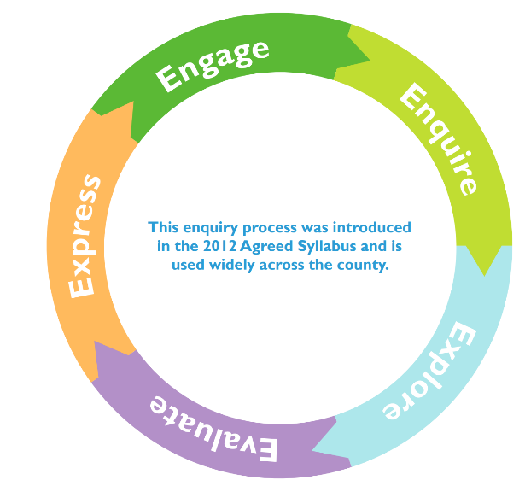

3. Explore

3.1 Christianity – Use the National Geographic video: <https://youtu.be/LvL3YXa0n2M> to introduce children to the concept of Christianity. Explore the story of the prodigal sone – a story Jesus used to show people that God is like a father and can be loving and forgiving. Use UCP resource 1.1 Making Sense of the Text (Core Learning Section) to explore this. Introduce the concept of God has hidden attributes / powers and complete the hidden message box activity using resource sheet 1.1.

3.2 Islam – Use the (ages 5-7) NATRE resource: What do Muslim’s believe about God and complete Activity 3 – How do Muslim’s know what God is like? How might the 99 names help Muslims know their God?

3.3 Humanism – Explore the information sheet Where do we come from? (Understanding Humanism – Humans 5+), discuss how Humanists still manage to know good and bad and be good people without the need for a God to teach them. Choose and complete one of the Good and Bad activities from this unit to illustrate Human nature.

4. Evaluate

Read stories/prayers from different Christian denominations and consider what they tell people about the idea of God. Some useful videos are: <https://youtu.be/ZrdlXOk_QdQ> <https://youtu.be/HW0DzGEoa1Y> <https://youtu.be/dv8dHsxjLd8> and <https://youtu.be/gGpKaoEQJl8>

Compare this to how Hindus Explain who Brahman? Use the (ages 5-7) NATRE resource: What do Hindus understand about the idea of a supreme being? Activity 2 One Supreme Being + Resource Sheet 4.1. Children choose one of the analogies, draw a picture of it and annotate to show how Hindus would see this representation of Brahman.

5. Express

Revisit: [www.bbc.co.uk/bitesize/topics/znk647h/articles/zmqpkmn](http://www.bbc.co.uk/bitesize/topics/znk647h/articles/zmqpkmn)

Another good resource is: [www.humanism.scot/wp-content/uploads/2015/09/Caring-for-our-world-primary-resources-from-HSS.pdf](http://www.humanism.scot/wp-content/uploads/2015/09/Caring-for-our-world-primary-resources-from-HSS.pdf)

Use this as comparative basis for the religious views of God previously explored. Ask the children to revisit their pictures from the previous sessions. What do they now think about different ideas about God(s) and why? What has / has not changed?

Assess the children in the final express piece by answering the bog enquiry question: **Why do people have different views about the idea of God?**

Children to choose two different concepts or representations of God from different religions and worldviews explored in the enquiry. Can they talk about why the believer sees the God in the way they do? Can they explain how this helps them live their life? This could be done as a flip activity, image or concept that flips up with an explanation underneath.

2. Enquire

Look at the responses the children gave to each panel of the big frieze, recap on the different ways Christian’s see God. Recap on the belief of Humanists. Unpack the idea that the word God is a name. Show the children a series of images (PPT attached) use the language from the vocab list to link to each image and ask the children to generate I wonders about each image or observations.

Focus on three core areas Christianity, Islam and Humanism. These will form the core teaching in the Explore and Evaluate stages of the enquiry.