**RE Planning Cycle Template**

1. Engage

Introduce the Big Question and discuss the word Universe – what does it mean. Look at images of the universe (star constellations) then drill down to planets and then to earth. A good website to use for this is: [www.sciencekids.co.nz/pictures/space.html](http://www.sciencekids.co.nz/pictures/space.html) What ‘I wonders…’ do these raise?

Spend some time experiencing nature. If possible, walk barefoot on grass or sand. Look closely at flowers and insects. Lie underneath some trees and watch the sunlight filter through the leaves. What words can pupils use to describe the experiences, and their feelings? What ‘I wonders…’ do these experiences create?

Introduce the concept that different religions have stories to explain how the world and the universe came to be. That we will be focusing on Christianity and Hinduism and what these religions believe to have happened.

Unit Focus/ Year Groups: Year 1 Enquiry 5

**How did the universe come to be?** (Christian / Hindu)

*Ref Understanding Christianity Unit 1.2 Who made the world?*

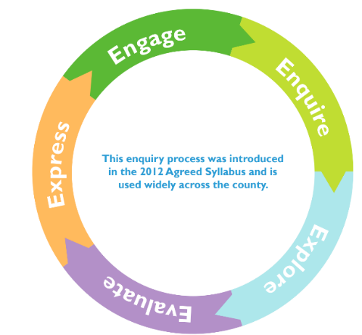

5. Express

Ask pupils: If someone believes God/ Brahma made the world, what might they say about it? What might they say to this Creator? Their comments might start with ‘I like… Thank you for... I wonder why... Please can you... It’s amazing that…’ Record these ideas on sticky notes and include them in a display.

• If pupils could ask the world-maker any questions, what questions would they ask?

• To make a connection between Christian ideas of God as Creator and the importance for everyone (not just Christians) of being grateful for what we have, you might like to try this experiential activity:

*Have some fruit (grapes, for example) in the class. Get pupils to think about how the fruit grew. It needs light, water, to bud, to flower, bee pollination, fruit growing, harvesting, transporting — and here we have the fruit. So when the pupils eat one, how should they eat it? Quickly, without a thought? Or slowly, touching, feeling, tasting — aware of all the sensations, appreciating how wonderful it is. Ask them to hold the fruit, to stroke it, to sniff it; they should put it in their mouths and feel their teeth and tongue on it before biting — and feeling the juice spurt. Which words do pupils use to describe this experience? Compare with how we usually tend to eat without noticing. It might make us be a bit more grateful for our food*.

• How does this idea apply to all the food pupils eat? Get pupils to take two tokens or pebbles into the dining hall. Before eating, place one token in the centre of the table and talk to other pupils about how important it is to enjoy the food, and why. For example, ‘I will really enjoy... because...’. After the food has been enjoyed, think about one person they really need to thank for it: for example, dinner supervisors, cooks, farmers, shopkeepers, and God. They put the token in the middle of the table, or give it to the relevant person if they’re present, and say, ‘I want to thank... because...‘.

• Remind pupils of the link between the Christian’s / Hindu’s answer to the key question, How did the Universe come to be? (i.e. God), and the importance of being thankful.

4. Evaluate

In these sessions we will explore the impact of humans on the world and universe that we live in.

If God/ Brahma made the world, how should people live? (what can we learn from Vishnu’s power to care for the world?) What do pupils think? One way is by being thankful to God, the Creator.

• Talk about how Christians think that God provides everything we need to survive (land, water, air, sunlight, food to grow, living animals and people), so humans should thank God above all. This Creator is so amazing that Christians want to praise God as well as thank him, saying how wonderful they think he is. Ask pupils to come up with some thank-you and praising sentences that Christians might say. They can use sentence-starters like ‘Creator God, thank you for… O God you are amazing because…’ Record these on sticky notes.

• One time of year when Christians think about God as Creator and say thank you is Harvest. Your school will probably have a Harvest Festival. How is this a way of saying thank you? Look at some harvest prayers and hymns. Ask pupils to choose the line in a song which they think is most important for Christians, and say why.

• Recall the idea that Christians believe God created the world, so they should be thankful. One key way for Christians to show thankfulness to God is for them to be generous to those with less. In Matthew 10:8, Jesus said to his followers, ‘Freely you have received, freely give.’ Talk about how Christians might share the resources offered at harvest. Find out what some churches do with their harvest offerings: for example, taking it into the community, or giving it to food banks. What does the school do, and why?

• If Harvest is an annual event, how do Christians remember to be thankful to the Creator every day? One way is by saying ‘grace’ before meals. Find out some grace prayers, and see if pupils can make up some ideas for Christians. What difference does it make if you say something every day? Pupils are often told to say please and thank you. Why is that?

3. Explore

Collect together all the words pupils can come up with to describe the two Creation stories, compare the similarities and differences.

Ask the key question: Who made the world? (in each story)

The answer that Christians (and others) give is, ‘God did’. Not everyone thinks this, of course. Have a look at the ‘big story’ frieze; ask which part of the picture shows creation and say how (they will need to look closely!). Point out that ‘Creation’ is just the start of a ‘big story’ for the Bible and, Christians say, for humans too!

Spend some of the session recapping on comparing the two creation stories heard and the similarities and differences. Which do the children think is more realistic and why?

2. Enquire

2.1 Christianity

Explore the Christian accounts of creation in Genesis 1-2. A good version of this can be accessed here: <https://youtu.be/vmzYaCFHSX0> What is their response to the story — feelings, ideas, questions? Then focus on this question: what does the story tell us about what God is like? (For example: big, amazing, powerful, exciting, clever, patient.)

Explore the story in different ways. For example, choose two or three of the following:

• choose music to express each of the days of creation; get pupils to do dance moves that reflect the music and what is created.

• draw and role play: imagine pupils are the first animals, birds or fish!

• look at some poems (Steve Turner for example, see Resources) and learn to recite one — the rhythm and repetition helps, which is partly why the Genesis account is structured with all the repetitions (it was morning..., it was evening..., the third day...).

• Get pupils to come up with key words for the story (two or three per day), draw them, and order them, so that they can practise retelling the story. Put these alongside some images for each day, recalling them each time you tell the story.

2.2 Hinduism

Explore one of the Hindu stories of creation (eg, Vishnu and the Lotus Flower). A good version of this can be accessed here: <https://youtu.be/ixY4pfb4iuE> What does this story tell us about what Hindus believe about creation? What do the children find interesting? Why? Ask the children to retell the story using some of the key vocabulary on this knowledge organiser. Explore the story using similar ideas as to the Christian creation story (above).