A Guide to Capital Funding and Building Maintenance for Voluntary Schools

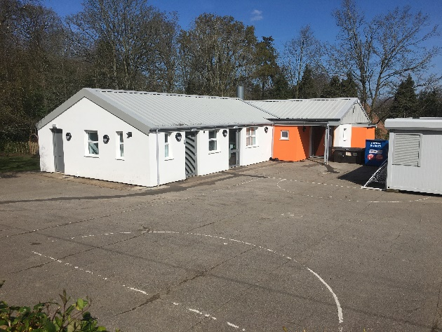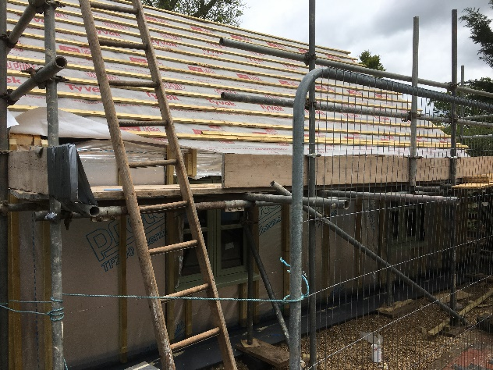
A Brief History of Church Schools
The founding of the National Society in 1811 marked the start of the Church of England’s involvement in Education. Following that, the 1841 Schools’ Sites Act encouraged a philanthropic climate of giving which established of many of the church schools that we know today. May of these schools were set up on trusts, on the understanding that if the school use ever ceased, the property would revert back to the donor. Trusts deeds set out the objectives, appointing the local Incumbent and Churchwarden in the role of trustees. During the 20th century some have been vested in the Diocese, many others are unchanged. The 1981 DBE Measure has invested greater responsibility for the Diocese in this respect, easing the burden from the clergy. Consequently, modern Church schools have simpler arrangements, where the sites are automatically vested in the Diocese.
Voluntary Schools - Governing Body responsibility
Governing Bodies (GB’s) are responsible for the day-to-day management of their school site, and all the associated statutory duties that come with it, on behalf of the school trustees. Schools will appoint a Governor specifically to oversee this area of building stewardship. Governors should utilise an Asset Management Plan for logging building issues, and resolution planning. Governors are responsible for ensuring the school building is safe and legally compliant. Many sign-up to a maintenance contract that includes building compliance management, to benefit from the professional expertise, and for peace of mind.
Condition Surveys
It’s recommended that schools commission a full condition survey every 5 years. Indeed, to access School Condition Allocation (SCA) funding, you will be required to present a condition survey as to access funding to ensure due thought and consideration has been given to the building as a whole. If you would like to purchase a condition survey, please either contact your maintenance provider, or ask the Diocese for more information. The cost of a school condition survey starts at around £500, increasing depending on the size of the premises.
Condition Data Collection Survey
The Condition Data Collection Survey (CDC) is a national quinquennial survey of schools undertaken by the Department of Education (DfE). Not to be confused with a full condition survey, the CDC survey is primarily designed to provide information to the treasury to inform future funding decisions in government. However, notwithstanding this, it may be a useful source of information for your Asset Management Plan.
Building Maintenance
The Diocese strongly recommend all schools sign up to a maintenance programme. Experience has shown that certain events will not be covered by your insurance policy, and a maintenance scheme can offer a valuable defence against unforeseen problems and provide strength in numbers when dealing with unforeseen issues that can arise. Many schools choose to buy in to the BMPP scheme, offered by NPS (in conjunction with NCC). Other options do exist. Unfortunately, the Diocese do not have a maintenance scheme to offer this year.
Devolved Formula Capital (DFC)
Devolved Formula Capital (DFC) is a school level funding, common across all schools. For Voluntary Aided (VA) schools, DFC is allocated in 90% terms, schools must fund the other 10%. Whilst some schools have the option of accumulating DFC to undertake larger capital projects, VA schools are required to use their formula capital within three years of its allocation, otherwise the Department for Education (DfE) can recall funds. In some circumstances VA schools can apply for a 4th year extension, or loan unused funds to schools with specific building plans. Please contact the Diocese for more information.
DFC is always reserved for capital purposes such as funding new buildings/facilities, ICT equipment, capital repairs and refurbishment in accordance with priorities set by each school and in accordance with their asset management plan. Schools should ensure their DFC is used appropriately, please refer to Diocese webpage for guidance on Capital/Revenue items.
VA (DFC) Pooling Scheme
The ‘Pooling Scheme’ is available for Voluntary Aided schools. DFC funds are centrally banked and accessed via the Diocese. For Pooling members, the Diocese will undertake a range of services on your behalf, such as the DfE year-end assurance returns, tracking the three-year rule and quarterly 10% invoicing. We will also send you a quarterly pooling statement. To access your funding please request a project form from the School Estate and Finance Officer.
If you would like to find out more, please request an information pack. If you have a new School Business Manager, and Diocese Officer would be pleased to come out and explain the processes in more detail.
School Condition Allocation (SCA)
SCA is a county level funding for maintained schools, accessed via your responsible body.
The Diocese send SCA proposal forms to Voluntary Aided schools in the summer, for return by October half term; for projects commencing in the following funding year. We prioritise those proposals enabling schools to remain ‘Safe, Warm and Dry’. These might include re-roofing projects, boiler replacements, and boundary and access improvements. Proposals to extend and adapt existing budlings may be considered, as well as proposals that enable a lower carbon future such as building insulation, double glazing and low carbon heat sources. Please refer to the “Prioritisation of SCA Proposals” for more guidance. The Diocese School Estates and Capital Funding (SECF) Committee review all new proposals taking into account a range of factors that include eligibility, priority factor, school size, SCA allocation history, and value for money.
If your proposal will take a lot of work, for example requiring statutory (planning and building control) approvals, you may be asked to ringfence some DFC to fund professional fees required to develop your scheme to a position of readiness. The SECF committee will require the scheme to have been worked through to an advanced stage before considering the allocation of funding fully, but we can provide a realistic “heads up” beforehand to reduce the change of any abortive fees. If your project is later successful and goes ahead, the Diocese are able to refund these early costs with SCA funding.
As SCA is allocated to VA schools in 90% terms, we recommend VA schools continue to budget and fundraise their 10%, so they are always prepared for any unforeseen issues, that may arise. You may also consider approaching your maintenance provider or LA for a contribution. In exceptional circumstance, the Diocese may consider spreading the 10% repayments over a three-year period to assist with budgeting.
VC schools’ access SCA funding differently, via the county council. The Diocese can put you in touch with the appropriate council Officer.

Compliance Checks (VA schools)
From April 2021, in conjunction with the launch of SCA funding, Diocese are required to undertake an annual buildings compliance & monitoring process. The form consists of a questionnaire and a detailed compliance checklist. If you are a member of a recognised maintenance service that covers buildings compliance, you will only need to complete the questionnaire section. Forms are sent out to schools in the spring, for return by 31st August.
VA Schools and VAT
The HMRC guidance states the VA Governing Body is not permitted to reclaim VAT on capital expenditure, due to its “exempt charity” status. Therefore, the DfE uplift capital allocations made to VA schools by way to balance this out the disadvantage. As Governing Bodies are an exempt charity, they are permitted to seek VAT exemption on applicable building/development types and supplies, please contact the Diocese for more information.
Spire Property Consultants
Spire are a trading subsidiary of the Diocese, consisting of a team of architects and surveyors, providing advice to the Diocese and Schools. If you have a building proposal that is extensive its likely that Spire will be available to assist to get your project into a position of readiness. Spire also provide a range of property services independently of the Diocese. To find out more please visit their website Spire Property Consultants.

School building resources are available from the Diocese Website https://www.dioceseofnorwich.org/schools/school-buildings-sites/
For DFC enquiries, please contact Ben Tooke- Finance Officer ben.tooke@dioceseornorwich.org, for more information on premises management and SCA capital funding, please contact Sam Witton – Schools’ Estates & Finance Officer samuel.witton@dioceseofnorwich.org (Tel.) 01603 882321.
Diocese Academies should contact Howard Nelson - Chief Operating Officer, howard.nelson@dneat.org.

