Bless all who are suffering through illness, infirmity, anxiety
or grief, especially those who are known to us – our friends
and our families…
Father, accept our praise And receive these prayers

Gathering our prayers and praises into one, as our Saviour
taught us so we pray:

Our Father who art in heaven,
hallowed be Thy name,
Thy kingdom come,
Thy will be done,
on earth as it is in heaven.
Give us this day our daily bread
And forgive us our trespasses,
as we forgive those who
trespass against us.
And lead us not into temptation,
but deliver us from evil.
For thine is the kingdom,
the power and the glory
For ever and ever. Amen.

Hymn 4:

Blessing

May God the Father of our Lord Jesus Christ, Who is the source of all goodness and growth, pour his blessings upon all things created,
and upon you his children,
that you may use his gifts to his glory
and the welfare of all peoples. And the blessing….

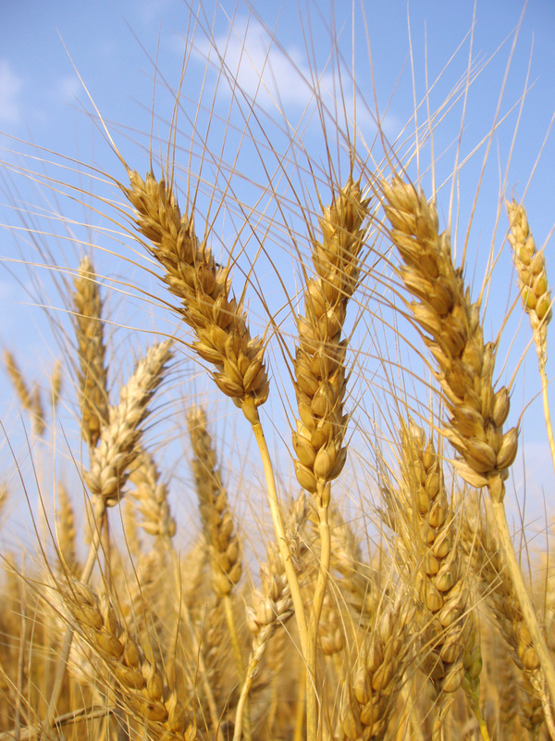

HARVEST THANKSGIVING SERVICE

Welcome

Opening hymn:

Grace, mercy and peace be with you
And also with you

We meet in the presence of God
Who brought life to all creation

Loving Lord, we have come to worship you. Help
us to pray to you in faith, to sing your praise with
gratitude, and to listen to your word with
eagerness, through Jesus Christ our Lord, Amen.

Confession

God our Father, we are sorry for the times when we have
Used your gifts carelessly, and acted ungratefully.
Hear our prayer, and in your mercy: Forgive us and help us.

We enjoy the fruits of the harvest, but sometimes forget
that you have given them to us.
Father, in your mercy: Forgive us and help us.

We belong to a people who are full and satisfied, but ignore the
cry of the hungry,
Father, in your mercy: Forgive us and help us

We store up goods for ourselves alone, as if there were no
God and no heaven,
Father, in your mercy: Forgive us and help us.

Absolution:

May God who loved the world so much that he sent his Son to
be our Saviour forgive you your sins, and make you holy to serve
Him in the world, Through Jesus Christ our Lord, Amen.

Blessed is the Lord
For he has heard the voice of our prayers

Therefore shall our hearts dance for joy
And in our song will we praise our God

Hymn 2:

First Reading:

Second Reading:

Talk

Hymn 3:

Prayers

Thanking our Creator God for all his blessings, we bring
Him our prayers and requests, saying,
Father, accept our praise and receive these prayers.

For the beauty of the hills and mountains,
For the richness of forest and farmland, and for the bustle
of town and city, we thank you Lord.

Bless all who work to provide for our needs and enjoyment,
and those who care for this wonderful world, especially the arable farmers and the farmers who keep livestock and all those who work on the land.
Father, accept our praise and receive these prayers.

For the peace of the river, the power of the sea, and the fish that live in them, we thank you Lord.

Bless all who work on them to harness their power and bring us food, especially those who risk their lives fishing in the open seas.
Father, accept our praise and receive these prayers.

For the produce of farms and gardens, for rain and water to
sustain growth, and for all we eat and drink, we thank you Lord.

Bless all who live in situations of drought and starvation, for
whom living is a struggle to survive, especially those who live in countries where there is famine or flood; hurricanes or earthquakes.
Father, accept our praise and receive these prayers.

