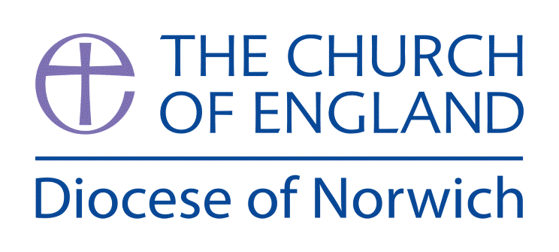

**How do beliefs shape identity for Muslims?**

**(Intention) What we intend to cover in our learning: (Topic web of concepts here)**

Session 1 & 2: **The Social History of Islam (studying sources and connections)**

* Start by exploring a timeline of Islam (see sources to explore). Looking at Islam through a historical lens at first to identify its origins and current position as a major world religion.
* Look at the first two Muslim traditions, in particular the split between Sunni and Shia after the death of the Prophet Muhammad (see notes). Introducing major differences between them since the civil war that occurred because of it such as the transnational hierarchical nature of Shia Islam versus the lack of hierarchy in Sunni Islam.
* Look at the various geopolitical conflicts that arise because of such schisms (across other religions, if possible) and use this to introduce and explore the mystical tradition of Sufi Islam to the class (see notes). Sufi Islam can be found in both Sunni and Shia traditions and often bridges the gap between them.

**Children to write what they Know, What they want to find out on the KWL grids using the information and clips above as well as picture clues (see KWL sheet)**

Session 2 & 3: **How beliefs shape the views of Muslims and how they impact, influence and change lives.**

* After looking at what has split Islam explore the things that provide common ground for all Muslims. Explore The Five Pillars of Islam, namely:

1. Shahadah: sincerely reciting the Muslim profession of faith,
2. Salat: performing ritual prayers in the proper way five times each day,
3. Zakat: paying an alms (or charity) tax to benefit the poor and the needy,
4. Sawm: fasting during the month of Ramadan,
5. Hajj: pilgrimage to Mecca.

**Create a life plan for a Muslim person to ensure they adhere to all Five Pillars.**

Session 4 & 5: **How theological connections can be made between Islamic belief, actions and sacred texts.**

* Explore Ramadan and the importance of fasting during this period. <https://www.bbc.com/teach/classclips-video/ramadan-and-eidulfitr/zdv7pg8>
* Look at the concept of Intention in Islam exploring what it means to Muslims. Explore the quote: “Allah will not call you to account for thoughtlessness in your oaths, but for the intention in your hearts; and He is Oft-forgiving, Most Forbearing.” Chapter 2 The Cow سور ة البقر ة - Al-Baqara: Verse 225.

**Children to take this quote and consider how it influences and shapes a Muslim’s daily life and how Ramadan is an example of this.**

Session 9: **How do beliefs shape identity for Muslims?**

By completing an alien fact file to explain how the Five Pillars of Islam, The Qu’ran and the role of the mosque impact and shapes their daily lives.

Session 8: **The reliability and authenticity of Islamic texts (Qu’ran / Hadith)**

* Look at the Qur'an and explore its origin as the holy book of Islam. Using quotes from the Qur’an such as: “It may be that you dislike a thing which is good for you and that you like a thing which is bad for you. Allah knows but you do not know.” (**Surah Al-Baqarah 2:216)** Look at the moral implications of following the laws of Islam and how they may conflict or complement life in the various different countries Muslims live it today.
* Explore the role of the Hadith as a source of religious law and moral guidance and its impact on Islam. Explore some of the contentious issues between the two books (see notes).

**Children to explore some of the scared text and determine how Muslims must lead their life as a result.**

Session 6 & 7: **The mosque as a central part of daily life.**

* Explore the place of a Mosque or Masjid in Islam - visit your local Mosque and explore the building or refer to a clip that explains its importance:

<https://www.bbc.com/teach/class-clips-video/themosque/zmctvk7>

* Explore the role and importance of the Jummah Prayers and the impact these have on Muslims in their daily life.

**Children to make a mind map of the roles and importance of a mosque in the daily lives of Muslims.**

**(Implementation) Key words I will use and need to know:**

Eid Hadith Hadjira Jummah Prayer

Mecca Medina Qu’ran Ramadan Shia

Sufi Sunni The Prophet Muhammad Mosque

Islam Muslim Shahadah Salat Zakat

Sawm Hajj Eid Jummah Iman

**(Implementation) Key knowledge we will learn:**

* The ways in which the Qur’an and Hadith form a source of authority.
* Key distinctions between the three main Muslim traditions (Sunni, Shia and Sufi).
* Muslim perspectives on moral issues including the idea of ‘intention’.
* The role of the Masjid (mosque).
* The significance and impact of Five Pillars of Islam.
* The importance of Ramadan, the two Eid festivals and Jummah Prayers.

**(Implementation) Things to do and find out at home:**

* A great websites to find out about Islam is:

<https://www.bbc.co.uk/bitesize/topics/zj3d7ty/resources/1> (6 short clips about Islam)

<https://www.bbc.co.uk/teach/class-clips-video/religious-education-ks2-my-life-my-religion-what-is-islam/zbmrwty>

* Why not design Islamic patterns – here are a few places you can find out about them: <https://en.wikipedia.org/wiki/Islamic_geometric_patterns>
* Why not find out information about some of the countries Islam is the main religion; Pakistan, Indonesia, Maldives and Bangladesh.

**(Implementation) Some key pictures and facts linked to Hinduism:**

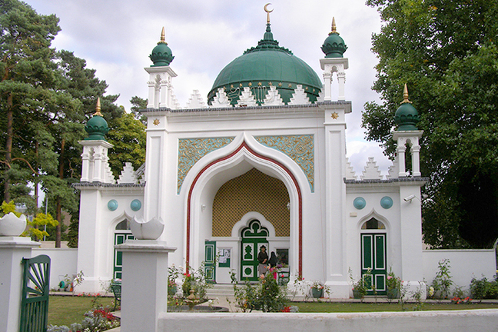

Are all Mosques the same?

Do Mosques look different in different places around the world?

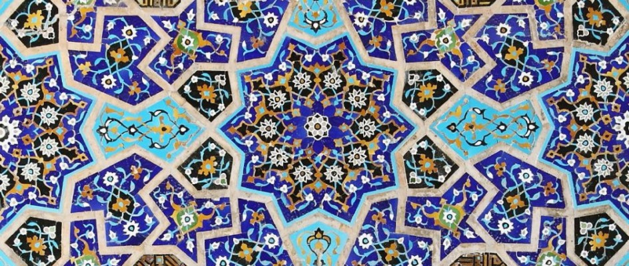

Why can you not have ‘living beings’ in Islamic art?

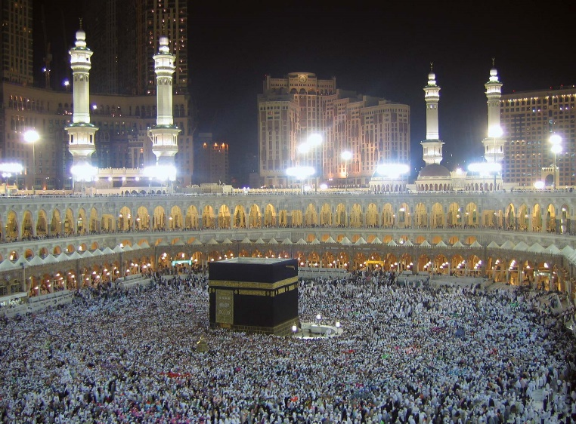

**Why is the Hajj so important to a Muslim?**

**What does it involve?**

**Where does it happen?**

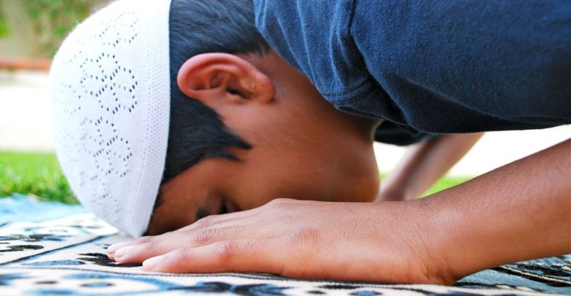

**Why is prayer important to Muslims?**

**How often do they pray each day?**

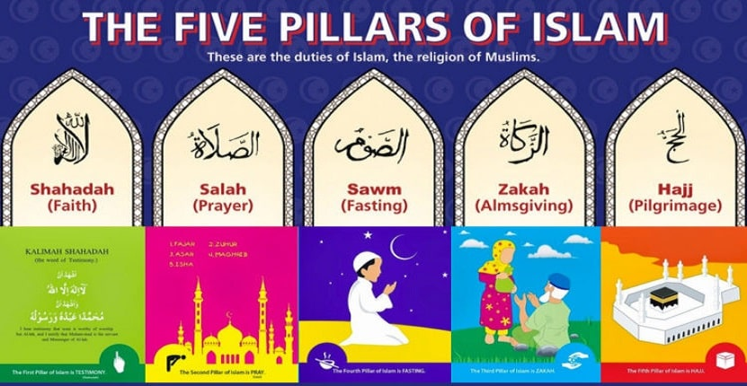**What do they do during prayer?**

**What are the five pillars of Islam?**

**How do they shape the daily lives of Muslims?**

(Implementation) Some key information you can find more out about:

* **The ways in which the Qur’an and Hadith form a source of authority. More info here:** [**www.bbc.co.uk/bitesize/guides/zh6ncdm/revision/2**](http://www.bbc.co.uk/bitesize/guides/zh6ncdm/revision/2)
* **Key distinctions between the three main Muslim traditions (Sunni, Shia and Sufi).** [**https://youtu.be/1ogmikc239E**](https://youtu.be/1ogmikc239E)
* **The role of the Masjid (mosque).** [**https://youtu.be/PjHNNPwfOWA**](https://youtu.be/PjHNNPwfOWA)
* **The significance and impact of Five Pillars of Islam.** [**www.bbc.co.uk/teach/class-clips-video/religious-studies-ks1-the-five-pillars-of-islam/zv84jhv**](http://www.bbc.co.uk/teach/class-clips-video/religious-studies-ks1-the-five-pillars-of-islam/zv84jhv)
* **The importance of Ramadan, the two Eid festivals and Jummah.** [**www.bbc.co.uk/bitesize/clips/z434wmn**](http://www.bbc.co.uk/bitesize/clips/z434wmn)

**(Impact) What we will aim to do at the end of our learning:**

* Explain different sources of authority and the connections with beliefs.
* Begin to discuss the reliability and authenticity of texts that are authoritative for a group of believers.
* Explain connections different beliefs being studied and link them to sources of authority using theological terms.
* Explain and discuss how beliefs shape the way ______ view the world in which they live and how they view others.
* Begin to analyse and evaluate how beliefs impact on, influence and change individual lives, communities and society, and how individuals, communities and society can also shape beliefs.

**(Impact) The RE Age Related Expectations we will cover and be assessed against:**

**Social/ Human Sciences**

**B. Diverse ways in which people practice and express beliefs**

Begin to analyse and evaluate the varying ways in which religions and beliefs are practised locally, nationally and globally (both within and between religions/worldviews) with reference to at least two different religions/worldviews.

**C. The ways in which beliefs shape individual identity, and impact on communities and society and vice versa**

Begin to analyse and evaluate how beliefs impact on, influence and change individual lives, communities and society, and how individuals, communities and society can also shape beliefs.