Religious Education and Worldviews

Knowledge Organiser to support the Norfolk Agreed Syllabus

Year Group: 6

Enquiry: 4

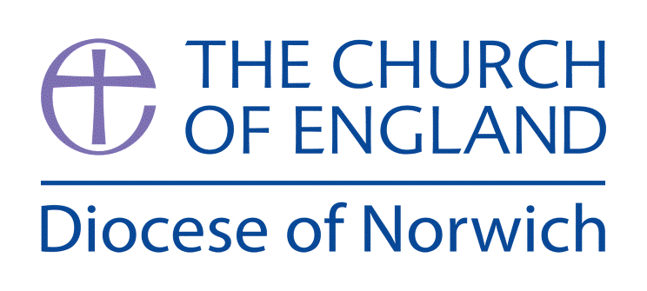

**Creation and science: conflicting or complementary?**

**(Intention) What we intend to cover in our learning: (Topic web of concepts here)**

Session 1: Explore real images of the world, including space, earth, people, animals, etc. What do children think of these? How do they make you feel or think? Where do they think these things came from? Write a short poem, using 5 senses, to describe one of the pictures of the world/creation.

Session 2: Explore Psalm 8, what are the similarities between this and the poem they wrote? Which parts of the Psalm are about God and which are about people? How does it describe God, e.g. powerful – how/why?

Session 3: Explore Genesis 1:1-2:3 (suggest The Message version). Summarise what happened on each day. Think about the genre of this chapter, how could it be a poem, report or a story? Decide which genre they think it is individually and prove how it could be this.

Session 4: Read a scientific account of how the world was created – cosmology (the beginning of the universe) and evolution (the development of living things). Compare these in detail to Genesis 1, are there any similarities?

Session 5: Think of some questions we wanted answered about the world, e.g. where do dinosaurs fit in? What is the point of the world? Using Genesis and cosmology explanations, how could the questions be answered differently?

Session 6: Explore some famous scientists’ opinions, can they believe in both science and creation? Dawkins, Einstein, Newton, Pasteur, Taylor, Kelvin, Chopra, Shapley, Wiseman. If possible, find a Christian scientist to come and talk to class. Can the children write / discuss how you can have a theological belief but also be a scientist?

**(Implementation) Key words I will use and need to know:**

Big Bang Theory Cosmology

Creation theory Evidence Evolution

Genesis

**(Implementation) Key information we will learn:**

* Creation: Christian belief that humans are made in God’s image, by God.
* Theistic Evolution: Awareness of the relationship between the Genesis narratives and scientific explanations.
* Scientific Theory: The Big Bang Theory.
* Textual theology: consideration of the genre of Genesis.
* Logic: debates about whether some things can be proven.

**(Implementation) Things to do and find out at home:**

* Explore different versions of the creation story by researching them from different bibles or on the internet. What do you notice to be the same or different?
* Write a list of pros and cons for the big bang vs creation story.
* Make a poster to promote one or both views.

**(Implementation) Some key information you can find more out about:**

* Creation: Christian belief that humans are made in God’s image, by God. A great video to introduce this is: <https://youtu.be/ZZPfCWV81pE>
* Theistic Evolution: Awareness of the relationship between the Genesis narratives and scientific explanations. More information can be found here: [www.discovery.org/a/10091/](http://www.discovery.org/a/10091/)
* Scientific Theory: The Big Bang Theory. A short introductory video is: <https://youtu.be/wtDTWYBTAGQ>
* Textual theology: consideration of the genre of Genesis. Some good information can be accessed here [www.theologyforkids.org](http://www.theologyforkids.org)

**(Impact) What we will aim to do at the end of our learning:**

By the end of our learning we will

* Begin to analyse and evaluate different ideas of how the universe came to be, including The Big Bang and Biblical accounts of creation.
* Explain the connections and divergence between different theories, and how they may fit together or disagree entirely.
* Begin to analyse the reliability of the sources of the different ideas of how the universe came to be.

**(Impact) The RE Age Related Expectations we will cover and be assessed against:**

**Theology**

**A. Where beliefs come from**

Explain different sources of authority and the connections with beliefs.

Begin to discuss the reliability and authenticity of texts that are authoritative for a group of believers.

**C. How beliefs relate to each other**

Explain connections different beliefs being studied and link them to sources of authority using theological terms

Explain the key theological similarities and differences between and within religions and worldviews

**D. How beliefs shape the way believers see the world and each other**

Explain and discuss how beliefs shape the way ______ view the world in which they live and how they view others