Religious Education and Worldviews

Knowledge Organiser to support the Norfolk Agreed Syllabus

Year Group: 6

Enquiry: 3

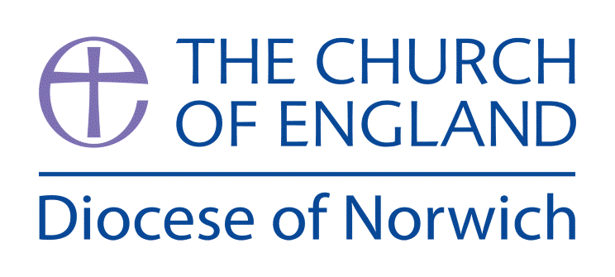

**What does it mean to be Human? Is the being happy the greatest purpose in life?**

**(Intention) What we intend to cover in our learning: (Topic web of concepts here)**

Session 1: Look at the work of St. Augustine as a bridge between the work of Plato and Christianity. Look at the qualities of the soul and that of the body. Using an outline of the body fill it with qualities associated with the body’s finite existence and the qualities the soul might have if it is eternal.

Session 2: Discuss the kinds of things Christians view as being sinful and ask whether they are considered to be sinful by those of other religions and none. Is there a link between the law and Christianity for example?

Session 3: Referring to the Christian martyrs and how they suffered in this world - how would Christians interpret these acts of suffering? (Consider the link with the Four Noble Truths found in Buddhism).

Session 4: Look at the Humanist worldview in detail looking at what it is to live a good life without the need to think about the soul or everlasting punishments. Examine the quote; ‘Happiness is the only good. The place to be happy is here. The time to be happy is now. The way to be happy is to make others so.’ Robert Ingorsoll, The Great Agnostic.

Session 5: Examine the work of Jeremy Bentham and John Stuart Mill, is ‘pleasure the only good and pain the only evil’1 Look at the Hedonic Calculus as a way of making moral decisions.

Session 6: Using the ideas of Christian morality, based on the existence of the soul and the possibility of damnation, compare them to the ideas found in Utilitarianism and Humanism - which ensures ‘good life’?

**(Implementation) Key words I will use and need to know:**

Hedonic Calculus Platonic Utilitarianism

Hedonism Reason Saint

Humanist Soul Purpose

**(Implementation) Key information we will learn:**

* St. Augustine’s ideas on sin as a defect rather than an effect - referring to Socrates and Plato’s work stating that ignorance is the cause of sin.
* Theological understandings of right and wrong.
* Moral issues such as poverty and wealth, peace and conflict or justice and injustice - looking at Christian attitudes to suffering.
* Humanist use of empathy and reason when making moral decisions rather than thinking about sin and the afterlife.
* What is Utilitarianism? And how does this relate to making moral decisions.

**(Implementation) Things to do and find out at home:**

Explore what it means to be a good Christian by watching this video: https:// [www.youtube.com/watch?v=DnEKhI-saAc](http://www.youtube.com/watch?v=DnEKhI-saAc) and making a poster with he key ideas.

Explore what it means to be a Humanist by watching this video: <https://humanism.org.uk/humanism/humanism-basics/> and compare what is the same and different to being a Christian - write list of similarities and differences.

**(Implementation) Some key information you can find more out about:**

* St. Augustine’s ideas on sin as a defect rather than an effect - referring to Socrates and Plato’s work stating that ignorance is the cause of sin. Information about this can be read at [www.bbc.co.uk/religion/religions/christianity/beliefs/originalsin_1.shtml](http://www.bbc.co.uk/religion/religions/christianity/beliefs/originalsin_1.shtml)
* Theological understandings of right and wrong - viewing St. Augustine’s ideas. You can find out more at [www.youtube.com/watch?v=bMaSjAlWZ00](http://www.youtube.com/watch?v=bMaSjAlWZ00)
* Moral issues such as poverty and wealth, peace and conflict or justice and injustice - looking at Christian attitudes to suffering after St. Augustine’s City of God in which he argues that suffering in this life is of little consequence when considering the Last Judgement. You can find out more here <https://maypoleofwisdom.com/the-city-of-god/>
* Humanist use of empathy and reason when making moral decisions rather than thinking about sin and the afterlife. You can access more information at <https://umanism.org.uk/humanism/> and Utilitarianism <https://learningrmps.com/2016/12/12/how-do-non-religious-people-make-decisions/>

**(Impact) The RE Age Related Expectations we will cover and be assessed against:**

**Philosophy**

1. **The Nature of knowledge, meaning and existence** Begin to analyse and evaluate a range of philosophical answers to questions about the world around them, including questions relating to meaning and existence. Begin to analyse and evaluate different ways in which philosophers understand abstract concepts.
2. **How and whether things make sense** Begin to analyse and evaluate whether a position or argument is coherent and logical and show increasing awareness of divergence of opinion. Use well-chosen pieces of evidence to support and counter a particular argument
3. **Issues of right and wrong, good and bad** Begin to analyse and evaluate a range of different answers to ethical and moral questions/issues, showing an understanding of the connections between beliefs, practices and behaviour.

**(Impact) What we will aim to do at the end of our learning:**

By the end of our learning we will

* Begin to analyse and evaluate a range of philosophical answers to questions about the world around them, including questions relating to meaning and existence: looking at St. Augustine as an example of a Christian Philosopher.
* Begin to analyse and evaluate different ways in which philosophers understand humanness incorporating what it means to live a ‘good’ life.
* Use well-chosen pieces of evidence to support and counter a particular argument.