Religious Education and Worldviews
Knowledge Organiser to support the Norfolk Agreed Syllabus
Year Group: 6
Enquiry: 2
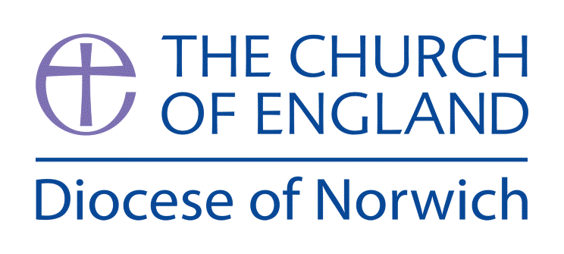

How do Buddhists explain suffering in the world?

(Intention) What we intend to cover in our learning: (Topic web of concepts here)

Session 1: Explore the story of the Buddha and his discovery of the Four Noble Truths namely; Dukkha - the truth of suffering, Samudaya - the truth of the origin of suffering, Nirodha - the truth of the end of suffering, Magga - the truth of the path to the end of suffering. Note that suffering and the ending of it are central to Buddhism.
Engage

Session 2: Explore what the Buddha taught in order to reduce suffering in the world and study the Eightfold Path, namely: Right Understanding, Right Intention, Right Speech, Right Action, Right Livelihood, Right Effort, Right Mindfulness, Right Concentration. In addition to these actions there are also Five Precepts found in Buddhism (see notes No.1)
Enquire and Explore

Session 3: Look at quotes from the Buddha such as “It is more important to prevent animal suffering, rather than sit to contemplate the evils of the universe praying in the company of priests.” (Gautama Buddha) and look at what kind of a religion Buddhism is in comparison to the other major world religions.

Session 4: Explore the concept of reincarnation found in Buddhism. Discuss the ultimate goal to be free of the cycle of birth, death and rebirth by attaining Nirvana. Explore this concept and how it is attained.
Session 5: Explore the idea of Right Intention: “What we are today comes from our thoughts of yesterday, and our present thoughts build our life of tomorrow: our life is the creation of our mind. If a man speaks or acts with an impure mind, suffering will follow him as the wheel of the cart follows the beast that draws the cart. If a man speaks or acts with a pure mind, joy follows him as his own shadow.” (Gautama Buddha) What does this mean for how a Buddhist should live?

Evaluate
Session 6: Explore the concept of Karma for Buddhists. What are the moral implications for someone with a belief in Karma? Explore how this relates to suffering and its cessation in the world. • Explore the place of God or gods in the Buddhist tradition and how it is practiced without a Creator God but that some gods or divine deities are present as in the doctrine of Samsara (see notes No.2 for ideas around mistaking gods for creators).

Express
Session 7: Look at the Jakata Tales as stories with morals found in Buddhism. Explore them and their meanings through the creation of pictures, animations or retellings of the stories (see notes No.3).

(Implementation) Key words I will use and need to know:
Buddha Deities Dukka Eightfold Path Five Precepts Karma Magga Nirodha Nirvana Reincarnation Samsara Samudaya

(Implementation) Key information we will learn:
- The varying beliefs about God, the Buddha, the Four Noble Truths, the cycle of birth, death and rebirth and the Five Precepts.
- The use of Jakata Tales as a source of moral guidance.
- The different views about the nature of knowledge, meaning and existence.
- Buddhist perspectives on moral issues and consideration of the consequences of action in relation to Karma.

(Implementation) Things to do and find out at home:

- Research Buddhism using this website: www.bbc.co.uk/bitesize/topics/zh4mrj6/articles/zdbvjhv
- Explore Buddhism for children here:
www.buddhismforkids.net
- Explore the practices of Buddhism here:
www.bbc.co.uk/bitesize/guides/zkdbcj6/revision/5

(Implementation) Some key information you can find more out about:
- The varying beliefs about God, the Buddha, the Four Noble Truths, the cycle of birth, death and rebirth and the Five Precepts. More information can be found here: www.bbc.co.uk/religion/religions/buddhism/beliefs/fournobletruths_1.shtml
- The use of Jakata Tales as a source of moral guidance. A good video to use is here: https://youtu.be/HQwgp0eOM4U
- The different views about the nature of knowledge, meaning and existence. www.bbc.co.uk/bitesize/guides/zs6ncdm/revision/3
- Buddhist perspectives on moral issues and consideration of the consequences of action in relation to Karma. https://matrixdisclosure.com/theory-karma-actions-results/

(Impact) What we will aim to do at the end of our learning:
By the end of our learning we will
- Explain and discuss how beliefs shape the way Buddhists view the world in which they live and how they view others.
- Begin to analyse and evaluate a range of different answers to ethical and moral questions/issues, showing an understanding of the connections between beliefs, practices and behaviour.
- Begin to analyse and evaluate a range of philosophical answers to questions about the world around them, including questions relating to meaning and existence.
- Begin to analyse and evaluate how beliefs impact on, influence and change individual lives, communities and society, and how individuals, communities and society can also shape beliefs.

(Impact) The RE Age Related Expectations we will cover and be assessed against:
Theology

C. How beliefs relate to each other
Explain connections different beliefs being studied and link them to sources of authority using theological terms
Explain the key theological similarities and differences between and within religions and worldviews

D. How beliefs shape the way believers see the world and each other
Explain and discuss how beliefs shape the way ______ view the world in which they live and how they view others

Supplementary Guidance:

The Five Precepts are abstention from: killing living beings, theft, sexual misconduct, falsehood and intoxication.

• According to Peter Harvey, Buddhism assumes that the universe has no ultimate beginning to it, and thus sees no need for a creator God. In the early texts of Buddhism, the nearest term to this concept is "Great Brahma" (MahaBrahma) such as in Digha Nikaya 1.18.[3] However "[w]hile being kind and compassionate, none of the brahmās are world-creators."[6]

In the Pali canon, Buddhism includes the concept of reborn gods.[7] According to this theory, periodically the physical world system ends and beings of that world system are reborn as gods in lower heavens. This too ends, according to Buddhist cosmology, and god Mahabrahma is then born, who is alone. He longs for the presence of others, and the others gods are reborn as his ministers and companions.[7] Mahabrahma, states the Buddhist Canon, forgets his past lives, and falsely believes himself to be the Creator, Maker, All-seeing, the Lord. This belief, state the Buddhist texts, is then shared by other gods. Eventually, however one of the gods die and is reborn as human with the power to remember his previous life.[3] He teaches what he remembers from his previous life in lower heaven, that Mahabrahma is the Creator. It is this that leads to the human belief in Creator, according to the Pali Canon.[3]

According to Harvey, "[a]fter a long period, the three lowest form heavens appear, and a Streaming Radiance god dies and is reborn there as a Great Brahmā."[8] Then "other Streaming Radiance gods die and happen to be reborn, due to their karma, as his ministers and retinue."[9] The retinue erroneously believes Mahabrahma created them.[9] When one of these ministers "eventually dies and is reborn as a human, he develops the power to remember his previous life, and consequently teaches that Great Brahmā is the eternal creator of all beings."[6] https://en.wikipedia.org/wiki/Creator_in_Buddhism

• The tale of ‘King Goodness the Great’ is a good point to start but it does contain some violent scenes despite its message about the refusal to cause harm, and so other tales might be sought out. Tales such as the ‘Whatnot Tree’ and ‘A Huge Lump of Gold’ are good starting points. These can be compared to the Parables in the Bible or even Aesop’s Fables to discuss the instructive nature of stories

