Religious Education and Worldviews
Knowledge Organiser to support the Norfolk Agreed Syllabus
Year Group: 5
Enquiry: 5
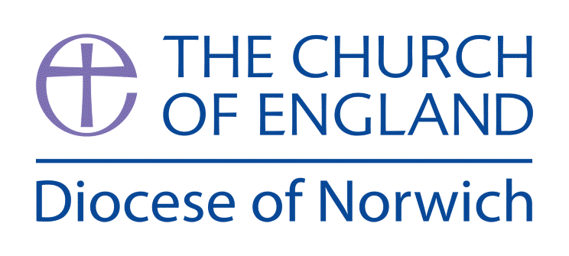

What do Hindus Believe? How do they express their faith?

(Intention) What we intend to cover in our learning: (Topic web of concepts here)

Session 1 and 2: Looking first at the key concepts of Samsara, Karma and Ahimsa explore how a belief in reincarnation might change attitudes towards other beings. If other animals may have once been people and vice versa how might this influence the value a believer might place upon them?
Engage

Session 3: Look at the goal of Moksha in Hinduism discuss what this means and how a believer might attain this.
Enquire and Explore

Session 4: Explore what it is to live a good life in Hinduism. Explore the Four Paths: Knowledge, Meditation, Devotion and Good Works and make a list of rules that could be followed.

Session 5: Explore the life and work of great Hindu figures such Mahatma Gandhi and the impact of Ahimsa on his peaceful protests during the British rule of India.
Discuss the reality of India today as a Hindu nation and see whether the caste system is still observed.

Session 6 and 7: Explore questions about the nature of a caste system. Explore the story of Arjuna and Krishna in the Bhagavad Gita. Explore the Vedas and the Ramayana to explore the concept of Dharma (duty). Look to the concepts of Brahman and Atman. Explore the concept of the ‘Self’ Atman and the ‘Supreme Self’ Brahman through an illustration of a drop of water in the ocean. Explore the concept that all souls are part of one genderless being of pure reality.

Evaluate

Session 8: – Write a for / against argument as to why Ghandi was a good / bad example of the Hindu ideal of ahimsa. Alternatively create a debate and children work on for / against arguments and record this as the record.

Express

(Implementation) Key words I will use and need to know:

Hindu Hinduism Religion World View Faith
Brahma Mandir Temple God Goddess
Dharma Ahimsa Karma Murti Samsara
Moksha Worship Ritual Sacred India

(Implementation) Key information we will learn:
- Hindus believe in in a God with many faces Brahma.
- Hindus believe truth is eternal.
- Hindus strive to achieve dharma – the right way of living (duties, rights, laws, behaviour and virtues.
- Karma – how Hindus act for others and themselves.
- Murti –an image, statue of the divine and seen as a deity.
- Samsara – the cycle of birth, death and rebirth
- Moksha – is when the soul passes through many lives.
- Hindus worship in a Mandir, where they make offerings to a murti, which is a statue of God or a goddess. Hindu temples are dedicated to different gods and goddesses.
- Who Mahatma Gandhi was and why he influenced the concept of ahimsa – a total avoidance of harming any living thing by deeds, words and actions.

(Implementation) Things to do and find out at home:

A really good website to look at for information on Hinduism:
https://kids.kiddle.co/Hinduism

Information on Hindu Gods:
https://kids.kiddle.co/Hindu_gods

Why not design your own Hindu God?
Could you make your own murti?
Could you write your own story of a Hindu God?

Look at some Hindu art and design some of your own – search images on google of Hindu art.

(Implementation) Some key information you can find more out about:
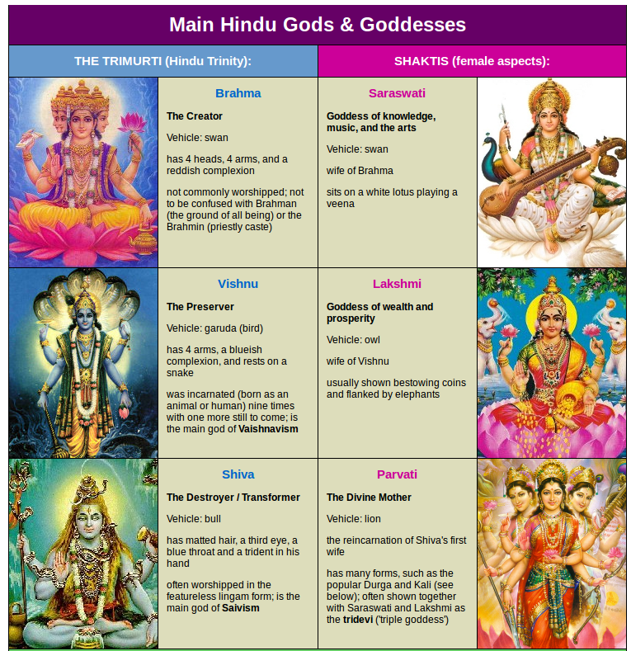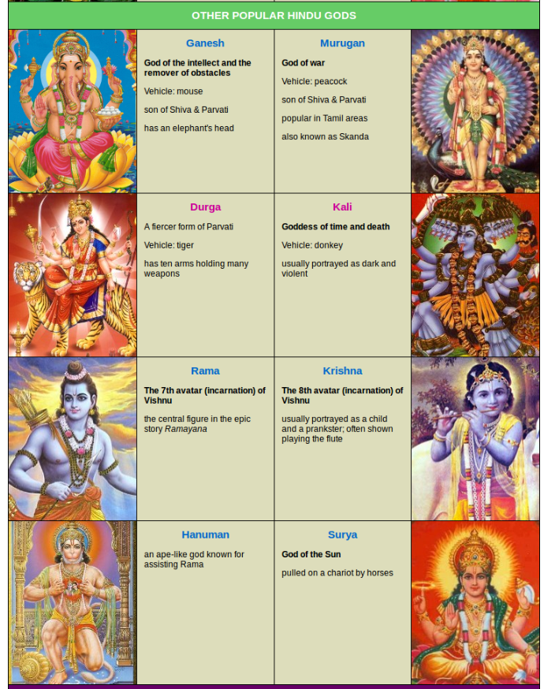

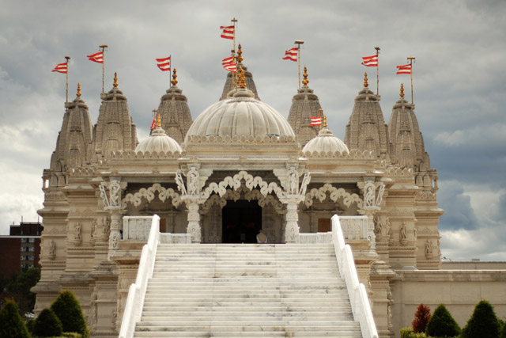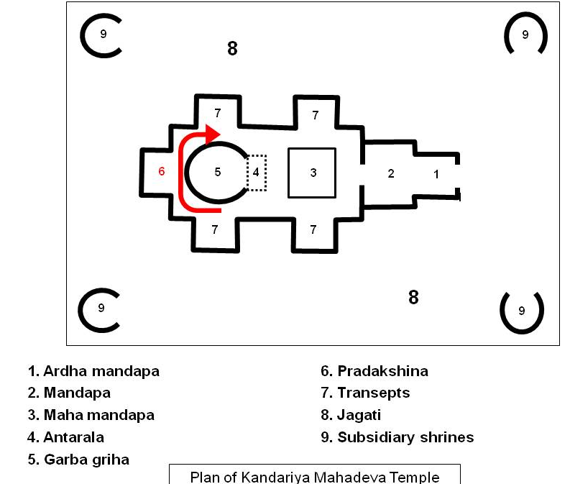
A mandir A plan of a mandir

(Implementation) Some key information you can find more out about:

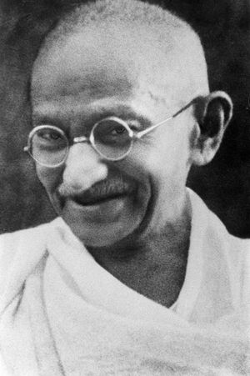Mohandas Gandhi is one of the most famous leaders and champions for justice in the world. His principles and firm belief in non-violence have been followed by many other important civil rights leaders including Martin Luther King, Jr. and Nelson Mandela. His renown is such that he is mostly just referred to by the single name "Gandhi".
Where did Mohandas Gandhi grow up?
Mohandas was born in Porbandar, India on October 2, 1869. He came from an upper class family and his father was a leader in the local community. As was tradition where he grew up, Mohandas' parents arranged a marriage for him at the age of 13. Both the arranged marriage and the young age may seem strange to some of us, but it was the normal way of doing things where he grew up.
Mohandas' parents wanted him to become a barrister, which is a type of lawyer. As a result, when he was 19 years old Mohandas traveled to England where he studied law at the University College London. Three years later he returned to India and started his own law practice. Unfortunately, Mohandas' law practice wasn't successful, so he took a job with an Indian Law firm and moved to South Africa to work out of the South African law office. It was in South Africa where Gandhi would experience racial prejudice against Indians and would begin his work in civil rights.
What did Gandhi do?
Once back in India, Gandhi led the fight for Indian independence from the British Empire. He organized several non-violent civil disobedience campaigns. During these campaigns, large groups of the Indian population would do things like refusing to work, sitting in the streets, boycotting the courts, and more. Each of these protests may seem small by themselves, but when most of the population does them at once, they can have an enormous impact.
Gandhi was put in prison several times for organizing these protests. He would often fast (not eat) while he was in prison. The British government would eventually have to release him because the Indian people had grown to love Gandhi. The British were scared what would happen if they let him die.
One of Gandhi's most successful protests was called the Salt March. When Britain put a tax on salt, Gandhi decided to walk 241 miles to the sea in Dandi to make his own salt. Thousands of Indians joined him in his march.
Gandhi also fought for civil rights and liberties among Indian people.
Did he have other names?
Mohandas Gandhi is often called Mahatma Gandhi. Mahatma is a term that means Great Soul. It's a religious title sort of like "Saint" in Christianity. In India he is called the Father of the Nation and also Bapu, which means father.
How did Mohandas die?
Gandhi was assassinated on January 30, 1948. He was shot by a terrorist while attending a prayer meeting.

Mahatma Gandhi – Biography

(Impact) What we will aim to do at the end of our learning:
By the end of our learning we will
- Describe different sources of authority and how they link with beliefs.
- Describe a range of different interpretations of sources of authority and consider the reliability of these sources for a group of believers.
- Describe ways in which beliefs shape the way Hindus view the world in which they live and how they view others.
- Explain a range of answers to ethical and moral questions and issues, drawing conclusions and showing awareness of diversity of opinion and why there are differences.
- Explain how beliefs impact on and influence individual lives, communities and society, and how individuals, communities and society can also shape beliefs.

(Impact) The RE Age Related Expectations we will cover and be assessed against: Human/Social Sciences

- The diverse nature of religion
Explain the different ways in which the terms ‘religion’ and ‘’belief’ are used by followers from within a religion or worldview and those from outside it.
Show awareness that talking about religion and belief can be complex.
- Diverse ways in which people practice and express beliefs
Explain some of the varying ways in which religions and beliefs are practised locally and nationally (both within and between religions/worldviews) with reference to at least two different religions/worldviews

- The ways in which beliefs shape individual identity, and impact on communities and society and vice versa
Explain how beliefs impact on and influence individual lives, communities and society, and how individuals, communities and society can also shape beliefs.

Supplementary Resources:

True Tube Video: (Exploring Hinduism)
https://www.truetube.co.uk/film/alien-abduction-hinduism

True Tube Video: (The Mandir)
https://www.truetube.co.uk/film/holy-cribs-mandir

True Tube Video: (Faith in action)
https://www.truetube.co.uk/film/my-faith-jai

