Religious Education and Worldviews
Knowledge Organiser to support the Norfolk Agreed Syllabus
Year Group: 5
Enquiry: 4
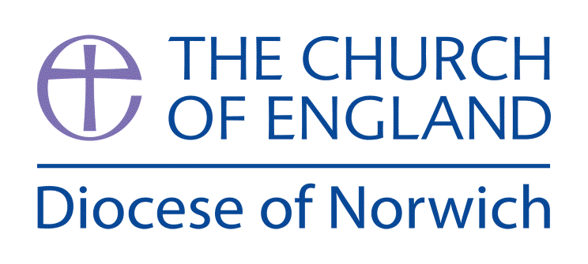

What difference does the resurrection make to Christians?

(Intention) What we intend to cover in our learning: (Topic web of concepts here)

Session 1: Show a range of pictures of birthday celebrations. What do you think is happening in these pictures? Celebrations, like birthdays, mark important occasions and are a time to remember important events too. What things do you think might be worth holding a celebration about? What other things do you celebrate in your family or school or religion? Why are they worth celebrating?
What things do Christians think are worth celebrating?

Engage

Session 2: Watch https://www.youtube.com/watch?v=nleiAfrp2kY&t=25s . Look at statements about Easter (see Resources) and discuss questions. Introduce the ‘Big Question’. Collect questions that they have (KWL Chart) to look at again in Evaluate part. Note the children’s questions on an ‘I Wonder Wall’ and add answers and evidence throughout the enquiry.

Enquire and Explore
Session 3: Compare the different Gospel accounts of the death and resurrection of Jesus, ie, Matthew, Mark, Luke, John. Children could explore one account in a group and report back to the whole class, listening to the contributions of other groups and noting similarities/differences.

Session 4: Read Luke 24 and create a drama script for it, then complete hot-seating
for different characters within it and identify the evidence within it for the resurrection.
Session 5: Study the significance of each of Good Friday and Easter Sunday and how they are also celebrated in different ways by Christians. Look at church services, songs and verses used – compare and contrast. How do these two days express Christian beliefs?

Session 6: Is Easter a festival of new life or sacrifice? https://www.youtube.com/watch?v=cZ4gQniUVO8 Children to collect evidence for a Silent Debate
Sacrifice and Atonement: https://www.youtube.com/watch?v=G_OlRWGLdnw&t=294s
Forgiveness: https://www.youtube.com/watch?v=Sdyjkt6HOtk (watch up to 58 seconds)

Evaluate
Session 7: Return to questions from Session 2. Have they all been answered? Add answers to the ‘I Wonder Wall’ and highlight connections. Ensure children are able to confidently use the Key Words. Use Silent Debate technique to Evaluate their understanding.

Express
Session 8: Children to write a leaflet explaining the Christian belief in the Resurrection of Jesus for non-believers.

(Implementation) Key words I will use and need to know:
Crucifixion Easter Sunday Eternal life
Forgiveness Good Friday Gospel
Redemption Resurrection Sacrifice Salvation

(Implementation) Key information we will learn:
- Jesus: As God incarnate, also known as the Son of God. Christian belief that Jesus fulfilled prophecies about the Messiah.
- Salvation: Gospel accounts of Jesus’ death and resurrection and the various interpretations of these accounts in terms of the meaning of salvation (e.g. forgiveness, sacrifice, redemption).
- Textual theology: consideration of genre, author, content, reliability and audience in relation to the Gospels and resurrection of Jesus .
- Festivals: the diverse ways in which people celebrate festivals such as Easter.

(Implementation) Things to do and find out at home:

What is Easter? https://www.youtube.com/watch?v=MK2o-mhBfuc&list=PLcvEcrsF_9zLNjB-h9xjVlhgG8f0fjk-9&index=3&t=5s

The Story of Easter https://www.youtube.com/watch?v=HL8R158Ujp4&t=3s

A very special Easter – children talk about Easter
https://www.youtube.com/watch?v=zY2NH8Wpoog

(Implementation) Some key information you can find more out about:

- Jesus: As God incarnate, also known as the Son of God. Christian belief that Jesus fulfilled prophecies about the Messiah. https://www.youtube.com/watch?v=3dEh25pduQ8&t=2s
- Salvation: Gospel accounts of Jesus’ death and resurrection and the various interpretations of these accounts in terms of the meaning of salvation (e.g. forgiveness, sacrifice, redemption). https://www.youtube.com/watch?v=NDL3Eq5YWjA&t=42s
- Textual theology: consideration of genre, author, content, reliability and audience in relation to the Gospels and resurrection of Jesus. https://www.youtube.com/watch?v=RaucATa9ufQ&t=489s
- Festivals: the diverse ways in which people celebrate festivals such as Easter.
https://www.youtube.com/watch?v=MK2o-mhBfuc&t=7s

(Impact) What we will aim to do at the end of our learning:
By the end of our learning we will:
- Describe the similarities and differences between the Gospel accounts of Jesus’ death and resurrection.
- Describe the connections between sacrifice in the OT and NT and the link to Jesus as the ultimate sacrifice.
- Describe the significance of resurrection and how it shapes how Christians see the world and others.
- Describe how the resurrection effects how Christians might live their lives.

(Impact) The RE Age Related Expectations we will cover and be assessed against:
Theology
- Where beliefs come from Describe a range of different interpretations of sources of authority and consider the reliability of these sources for a group of believers.

- How beliefs relate to each other Describe the connections between different beliefs being studied and link them to sources of authority.

- How beliefs shape the way believers see the world and each other Describe ways in which beliefs shape the way Christians view the world in which they live and how they view others.

Supplementary Ideas:

Resurrection Accounts from the New Testament Gospels:

Matthew https://www.biblegateway.com/passage/?search=Matthew%2028%3A1-10&version=ESV

Mark https://www.biblegateway.com/passage/?search=Mark%2016&version=NLT

Luke https://www.biblegateway.com/passage/?search=Luke%2024&version=NIV

John https://www.biblegateway.com/passage/?search=John%2020&version=NLT

The Four Gospels: a Quick Overview (teacher information) https://www.youtube.com/watch?v=RaucATa9ufQ

Vocabulary

Sacrifice – the act of giving something precious to another person or God.

Atonement – a person atones when they show they are sorry for doing something wrong.

Salvation - the healing of a broken relationship between people and God.

Resurrection – The Christian belief that Jesus rose from the dead on the third day after the crucifixion.

Forgiveness – to pardon someone for something that they have done wrong.

Redemption – atonement for sins; the idea of being saved from sin or evil.

God’s Story: The Good News https://www.youtube.com/watch?v=nleiAfrp2kY&t=25s

Saddleback Kids: The Story of Easter https://www.youtube.com/playlist?list=PLYn06r4leL_RguA_6LO-11rkjEsNb21oa

Session 2 Resource:

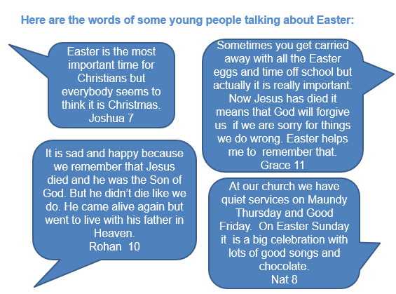

Questions:

Why is Easter the most important festival for Christians?

What surprises pupils about what these young Christians say about Easter?

What did pupils already know?

How can they find out about the significance of Easter in their own community?

What questions would you like to ask some Christians about Easter?

(Resource taken from Wiltshire Agreed Syllabus)

Silent Debate/Discussion technique

Engage

Question: Is Easter a festival of new life or sacrifice?

Deliver

Explain to everyone that the activity involves responding to the stimulus by writing or drawing their thoughts and questions around it and sharing their thinking. Different coloured pens can be used for each student so you can easily differentiate their thoughts.

Children to work in pairs or threes.

Copy and Paste

After 10 minutes, one student from each group travels silently around the room visiting other groups and is allowed to ‘steal’ ideas to then bring back and add into their own Big Paper.

Break

Silence is broken after another 5-10 minutes and students can talk about their ideas and discuss verbally.

Debrief
As a class, delve into the content and discuss ideas, reactions and responses written on the Big Papers.
To end the activity you can display the Big Papers on walls or across tables and hold a ‘Gallery Walk’ for students to view in silence.

